Dear teachers，

I hope this email finds you well. I am writing this email because our school has received an invitation from East China Normal University to invite our community members to participate in their upcoming 17th International Culture Festival for the coming weekend.

Our school has been diligently working towards establishing partnerships with a diverse range of universities for years to achieve our MPP and have our efforts recognised. Through these collaborations, we aim to foster cooperation and mutual growth.

If you're looking for a city exploration destination this weekend, you can look no further than this cultural festival. It's an experience you simply can't afford to miss.

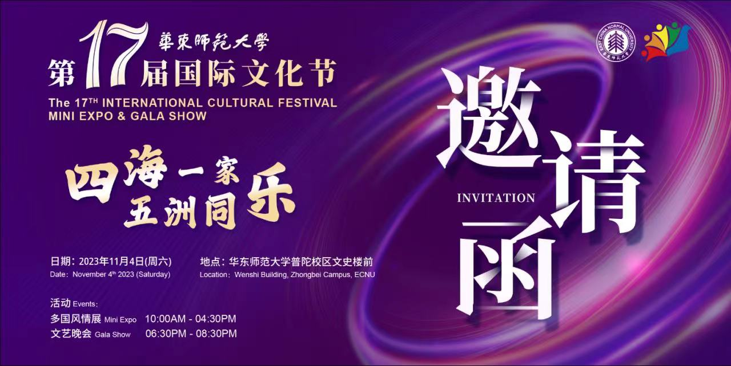

I have attached a map from CP to ECNU for your reference.

Address: 3663 Zhongshan North Road 中山北路3663号
