Yew Yew’s Expectations for Lockdown/Evacuation
Yew Yew says… | - Use your wisdom to make wise decisions based on the teachers’ instructions.  - 根据老师的指示，运用你的智慧做出明智的决定
Yew Yew says…  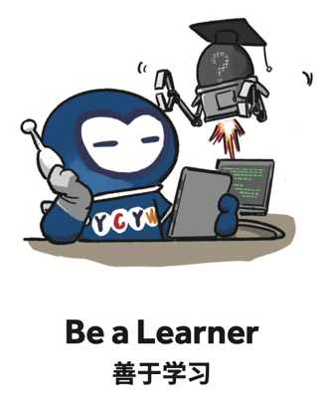 | - Complete each task with excellence  - 出色完成每一项任务
Yew Yew says… | - Stay calm and practice detachment by experiencing our feelings without allowing them to control us.  - 保持冷静，通过体验我们的感觉来保持淡然，能控制我们的情绪
Yew Yew says… | - Trust in others and respond accordingly.  - 信任他人并做出相应的回应。
Yew Yew says…  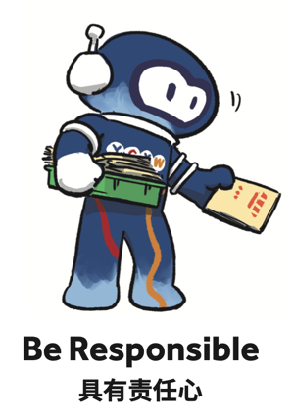 | - Follow the plan step by step in an orderly manner.  - Doing helpful things that make a difference to others.  - 按照计划一步一步有序地进行  - 做对他人有益的事情

