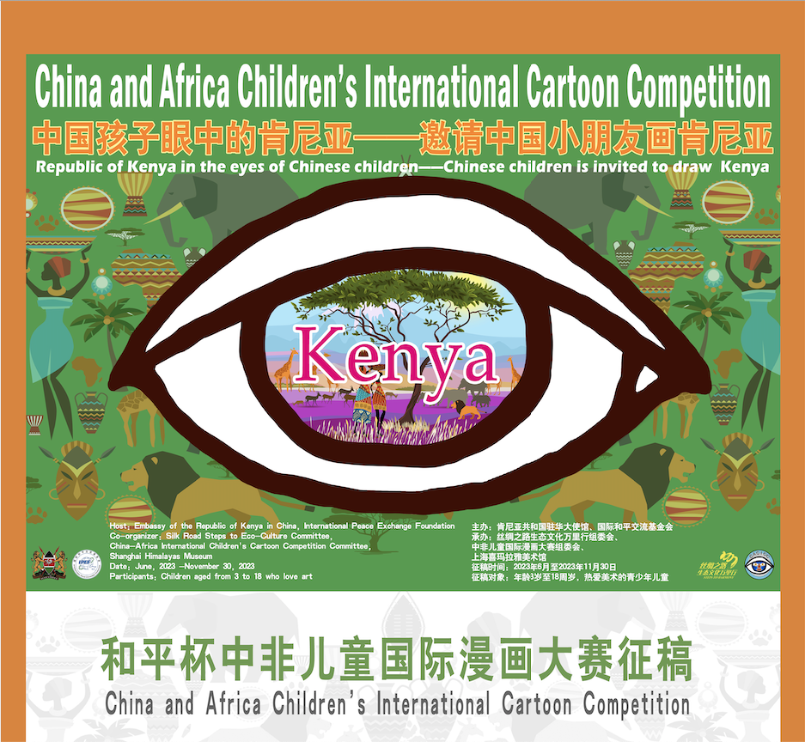

I. Activity Name
Peace Cup China-Africa Children's International Comics Competition - Kenya Station

II. Creation Theme
1. Kenya in the eyes of Chinese children
2. China in the eyes of Kenyan children

III. Activity Introduction
This trip to East Africa is an unusual trip, more like a wild adventure. Whether it is the horned horse rushing Tianhe crossing or the red clouds composed of flamingo flying, it is enough for you to see a different country and a different animal world. The China-Africa International Children's Cartoon Competition in Kenya continues the perspective of children in Egypt and Morocco, focussing on each other, including Kenyan lions, elephants, giraffes, zebras, chimpanzees, hippos and other wild animals known as the animal kingdom, and Chinese giant pandas, golden monkeys, white fin dolphins, South China tigers, red ibis, Yangzi crocodile, red-crowned crane, peacock pheasant and other national treasure-level animals are focussed on the big picture of a global village. Let these elements collide with the shocking heart, stimulate the inspiration of creation, and enlighten the beautiful memories. Through the theme of the Adventures of the Animal Kingdom, we call for ecological protection awareness, cultivate and love for animals from an early age, and have a good long-cherished wish to walk with animals.

IV. Activity Details
1. Painting types: creative painting, watercolour painting, gouache painting, ink painting, oil painting, printmaking, cartoon, etc.;
2. Age of solicitation: 3 to 18 years old, young people who love art (regardless of nationality).
3. This competition adheres to the principle of public welfare and does not charge registration fees, participation fees and evaluation fees.

V. Activity Schedule
Collection time: June to November 30, 2023.

VI. Work Requirements

1. Specifications: paper paintings.
2. Size: 4K (393mm×546mm) or 8K (420mm×297mm).
3. Materials: There is no limit on the form of expression.
4. Copyright:
1 ) The copyright of the entries belongs to the organising committee of the competition, and the author has the right of authorship.
The organising committee of the competition has the right to retain the work and use it in relevant activities (including exhibition, publicity, publishing, production of derivatives, etc.) without additional remuneration.
2 ) Participants should ensure that the entries must be original.
3) Participants shall ensure that the works submitted by them do not infringe the rights and interests of third parties (including copyright, portrait rights, reputation rights, privacy rights and other legitimate rights and interests). All responsibilities arising from the works or entries shall be borne by the participants themselves.

VII. Participation in the competition

1. Chinese children send pictures of works to email: childrensart@himalayasmuseum.org
2. Email title format: "Registration for the International Competition of Chinese Children - a name + participating group + title of the work + contact information", and upload the photos of the work to the attachment. For example, "Chinese Children's International Comics Registration - Yi Wangming + Children's Group + Animal Kingdom Adventures + 136xx".
3. Picture requirements: Send complete high-definition photos of works. The format is JPG, the file size is not less than 3M and not more than 10M, and the work drawings cannot be watermarked.
4. Email content: 30 to 200 words of creative instructions must be submitted.
5. Exhibition of award-winning works: The original shall be delivered on time in accordance with the regulations of the organising committee. Those who do not deliver as required shall be deemed to have automatically given up the award and exhibition qualification.

VIII. Selection method

1. Selection principles: the principle of fair, just and open competition, which is required to meet the theme of the competition and meet the characteristics of age; encourage children to express their true feelings; encourage creative forms of expression.

2. Selection form
1) Establish an expert committee:
The organising committee of the competition will invite professionals from relevant fields in China and Kenya as special invited experts to guide the review of the competition. The expert steering committee is hired by the organising committee of the competition and works under the leadership of the organising committee. The expert steering committee independently evaluates the entries according to the evaluation rules.
2) Selection method:
The selection of the competition is conducted by online evaluation by experts.

IX. Reward Method

1. Personal award setting
The competition is divided according to age: children's group (3-6 years old); children's group (7-12 years old); youth group (13-18 years old).
Each age group is set up: gold, silver, bronze and excellent.
There are also special awards for the competition: 1 Peace Award, 2 Silk Road Awards, 3 Best Friendship Awards, 3 Best Art Awards, 3 Most Connotation Awards, 3 Best Creative Awards, 3 Best Colour Awards, 3 Most Dynamic Awards, and 3 Most Potential Awards.
All the candidates can obtain the electronic certificate issued by the competition.
Participants in the exhibition and award ceremony of the competition can get the paper certificate issued by the competition and the corresponding trophies, medals, etc. (exhibition and award ceremony are charged separately).
The top 100 award-winning authors of the competition will be invited to attend the award ceremony and obtain a double certificate of the title of "Chinese Youth International Cultural Exchange Messenger".

2. Organisation unit award setting
The organising committee specially awarded the "Advanced Unit of Organisational Work" award to outstanding organisational units.
Award conditions: Organise more than 100 students to participate in the competition, and the unit can win the Excellent Organisational Unit Award.

3. Instructor Award Setting
Special first, second and third prizes of "Outstanding Teachers" will be awarded to excellent teachers with honorary certificates;
Award conditions: First prize (each teacher tutors at least 30 students to participate in the competition, and the total number of winning students is not less than
5 with gold prize winners); second prize (each teacher tutors at least 20 students to participate in the competition, and the total number of winning students is not less than 5 and there are silver prize winners); third prize (each teacher tutors at least 10 students to participate in the competition, and the total number of winning students is not less than 5 and there are bronze prize winners).

X. Organisation
Organiser: International Peace Exchange Foundation; Embassy of the Republic of Kenya in China.
Organizer: Silk Road Ecological Culture Wanli Travel Organising Committee;
Organising Committee of China-Africa International Children's Comics Competition; Shanghai sima Rajah Art Museum.

XI. Contact information of the organising committee of the competition
Customer service WeChat: HimalayasCHDMuseum; CACICC2020.

