Emergency Procedures

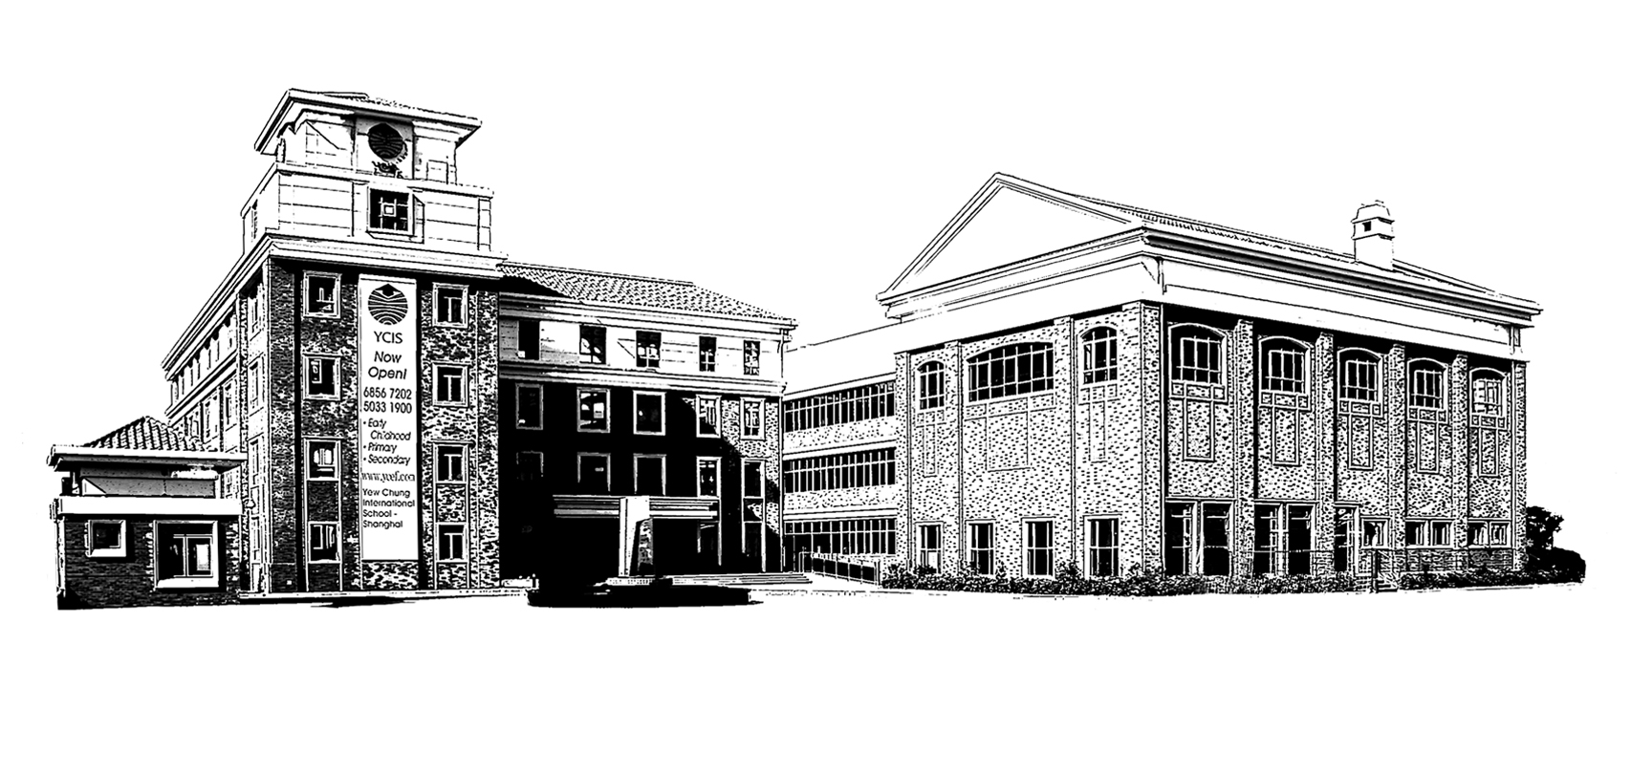
A & B Buildings
Regency Park Campus

Updated October 2023

I. Classroom Evacuation Procedures

All persons in the school will take part in Emergency Evacuation practices. No exceptions will be permitted. All staff and visitors will follow the posted exit instructions. Evacuation route floor plans and Evacuation Procedures Booklets will be located next to the door of all rooms in Regency Park Campus.

Once an alarm is sounded,
- Students are to line up in an orderly manner at the classroom doors.
- Students will not change shoes or collect bags or coats.
- One teacher will lead the way and the other teacher will be the last one in the line. If only one teacher is in the class, they are to lead the way
- The last class teacher out should ensure that the classroom door is closed and lights are left off.
- Teachers should encourage students to not talk, push or run and as long as it is possible, follow the pre-designed route.

Important points to remember:
- Control and order are more important than speed in ensuring the orderly movement of all students in the hallways along a pre-designed route.
- Teachers must be very observant and should check the outside hallway areas for smoke and determine exit routes.
- “Floor Cleared’ Signs to be placed on each floor. Year leaders or team member to take sign to evacuation area once floor has been checked
- Do not use the elevator in an evacuation.
- Use (but do not reply to unless an emergency) the RP Emergency WeChat if students are missing or class in undesignated area.

K4 and Primary students and teachers will gather on the Field for roll call. K2-K3 classes are to gather in the safe area outside the Hua Mu Rd entrance by the A Building. For the purpose of evacuation drills, the students will gather inside the gate.

The Office Administrator will hand out packs containing clip-on badges to identify children, teachers and non-academic staff. See Appendix 4 for a list of who reports to the Evacuation Marshall and who is responsible for each role. Members of the Health and Safety committee will need to be prepared to take on any of the roles if the designated people are unavailable.

If students are not with their normal class, they must go outside with the teacher who is teaching them at that time and then report to their class teachers and join their class. Once class teachers arrive at the designated area, one of the Office Staff members will hand an Emergency Kit to class teachers. In the Kit there will be a name badge for each child and these need to be handed to each student in the class after all students have been accounted for. All teachers will also receive a name badge. Supply Teachers will wear the name badge of the teacher they are replacing. Once all students have been accounted for, the teacher will hold up a green sign, indicating that all members of their class are present. If one or more students are missing, then the teachers will hold up a red sign. At this point the Student Marshall will approach the teacher and record the missing student/s. They in turn will inform the Fire Marshall.

During evacuation, all teachers and administrators shall ensure that students who are not with their class join the nearest line making an exit. Once clear of the building, with permission of the teacher in charge, they shall rejoin their own class, report to the teacher, and take their place in line.
Designated sweepers will ensure that no students remain in classrooms, lavatories or other rooms in the buildings. Once they have checked their floor, they should pass the ‘cleared floor’ sign to the evacuation Marshall.
The Evacuation Marshalls from each building will be responsible for the overall Evacuation and will be identified by wearing a bright jacket. The Evacuation Marshalls in each area shall communicate with each other via radio absent children or classes, and the current state of the emergency procedure.

Staff and students are not to return to the building until the “all clear” signal is given. If an emergency necessitates removal of personnel from the premises, classes will be led out of the nearest gate. Staff / Students will then proceed to Seasons Villas (exact location TBC) and attendance will be taken.

All members of staff are requested to bring to the attention of administration any and all hazardous or dangerous scenarios involving student safety.

II. Emergency Procedures

FIRE, BOMB THREATS, UNSAFE BUILDING

  - Notification of Evacuation
    - A continuously ringing bell or siren
    - Office Administrator to contact emergency Authorities
Police: Ph. 110
Ambulance: Ph. 120
Fire Brigade: Ph. 119

- Classroom Evacuation
- Teacher moves students in a quiet and orderly manner via nearest stairs.
- Students follow teacher to Assembly Area using nearest safe exits. (See Appendix 2)
- Sweepers check that all rooms are empty.
- School nurse brings First Aid materials to the Assembly Area.
- Emergency Kits to be handed out, attendance taken by class teachers.
- Class teachers report to Student Marshalls
- Student Marshalls report to Evacuation Marshall, indicating any missing students/staff

- Office Evacuation
- Office Administrator coordinates the evacuation of administration area.
- Class Registers, Name Badges, Bus Lists and Check Out forms to be taken to Assembly Area (Classroom Emergency Kit).
- Academic staff list taken to Student Marshalls

- Assembly Area
- Classes line up in designated area (See Appendix 1).
- Specialists return students to class teachers.

- Search / Rescue
- For a missing student and / or staff, Security staff will conduct a search only if safe to do so.

- First -Aid
- Nurse / first aid team conducts first aid as necessary.

- Child / Staff Comfort / Needs
- Until time to safely re-enter building, Comfort Needs Team (School Nurse, teachers and Ayis) attends to water, toilet and child concerns.

- Building Integrity Inspection
- Administrator / Designee in conjunction with local emergency authorities confirms safety of building before administrator / designee signals a return to the building.

- Haven
Should the assembly area be unsuitable, the alternate off-campus haven is in Seasons Villas (exact location TBC) compound.

- Parent Notice
- In the event a building is unsafe or school is closed, parents will be notified by phone, email, SMS, WeChat.
- Students will be sent home on the buses as close to their regular departure time as possible. Students will be sent home early on buses only after parent notification is confirmed.
- Century Park Campus office staff would take on the role of informing parents if the Regency Park office needed to be evacuated

  - Parent / Child Reunification / Check out Procedure
- Signs will designate parent/child meeting area monitored by the building security or designee. (In English and Chinese)
- When parents/carer collect their child after an emergency evacuation, the teacher will make a record in their class list/collect badge. Parents/Carer will be asked to show their security card.
- Each child’s name badge will include contact details.
- Students not picked up or sent home on buses will be attended to by the Class teachers and any other available staff. Administrator / Designee and volunteer staff will not leave school premises until all students are accounted for and safely returned to their parents. Administrator / designee will check with transportation to confirm all children returned to their homes before leaving the school premises. Drivers must report back about their transportation status.
- Staff will be provided with safe transportation to their residences. If deemed unsafe, staff will remain within the school compound until transport is safe.

  - Bus Procedures
- If the bus drivers determine it is unsafe to proceed, children will be returned to school.
- If unsafe to return to school, the bus driver will proceed to a safe public area (hotel, police station, post office) and remain with the children. YCIS-Shanghai and Police authorities will be informed as soon as possible.

OTHER EMERGENCIES

The procedures outlined above will be followed in all emergencies with the following additions:

    - Intruder – See Lockdown Procedures

    - Streets Unsafe – Teachers will remain with students in classrooms until conditions are safe for children to be sent home. Administrators / Designee will make every effort to inform staff members at other school sites, keep them informed of developments and assist with concerns about staff family members. Teachers will use established check out procedures for any child whose parents come to take them home. All Staff and students will remain at school until it is determined safe to leave by administrator / designee.

    - Windstorms & power outages – Teachers will remain with students in classrooms until directed otherwise by administrator / emergency team designee. If necessary, staff will notify parents to come to pick up children.

    - Earthquakes – Students and staff will drop and cover until shaking ends. Evacuation bell or teacher judgment will initiate evacuation procedure outlined above. Teachers will determine evacuation routes are safe before leading children to the assembly area. Downed power lines should not be crossed or approached.

NON SCHOOL HOURS EMERGENCY

In the event of an emergency outside school hours that leads to closure of school the following will apply:
- Information and instructions will be conveyed through text message, WeChat and email when available.
- Staff will report to school to supervise students not contacted, if safe to do so.
- Buses will follow normal routes if possible to notify students of school closure. Students unable to return home will be brought to school until parents can be notified or supervised until the end of the school day then returned home as per normal schedule.
- Emergency WeChat group used for informing staff members of an emergency.
- Staff will be directed to keep pertinent documents on hand if necessary (passport, visa, ID card etc.).

APPENDIX 1a
Liu Shan Rd柳杉路

A Building Hongqiao
虹桥校舍A楼
花木路Hua Mu Rd

The Shire
小山丘

Basketball
Court
篮球场

The Field
椭圆操场
The Track
跑道
Drivers and Engineers
司机和工程师

Any ECE classes
Librarian, IT & Accounts , nurse图书馆、电脑部、财务部、护士

K4
Marshalls 指挥员

Y1
Supporting Div. 校务部
Co-Principals 校长
Coordinators 主任
POP
家长联络人

Y2
Admissions
注册部

Y3

Specialist / EAL Teachers
单科教师
Y4

Office Staff
教务处

Catering Staff餐厅员工

If you exit from the doors outside 1D classroom follow this route to lining up area
If you exit from the doors from the Admissions Reception Room follow this route to lining up area
If you exit from the doors near the school office, please use the track to go to lining up area

School Building B
教学大楼 B

APPENDIX 2

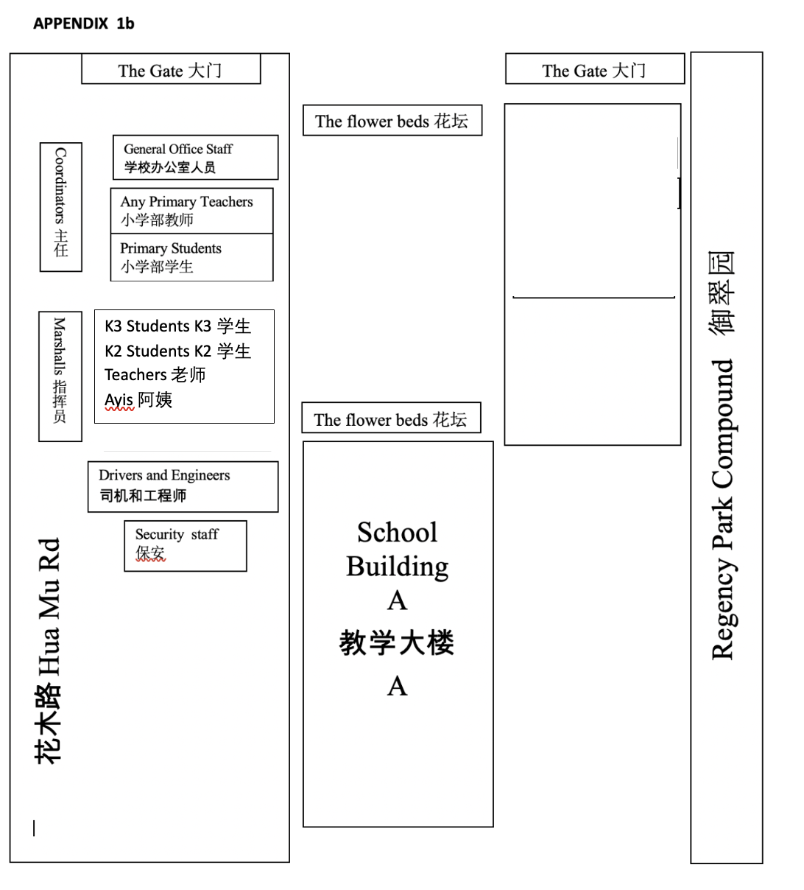

APPENDIX 3

Police Tel: 110

Ambulance Tel: 120

Fire Brigade Tel: 119

CLASS EMERGENCY KIT (for each class) CONTENTS:

  - CLASS LIST / WITH SPACE FOR SIGN OUT
  - NAME BADGES
  - TRANSPORTATION LIST
  - BLANK ACCIDENT REPORT FORMS
  - EMERGENCY PHONE NUMBERS

EMERGENCY KITS ARE LOCATED IN THE OFFICE AND WILL BE DISTRIBUTED TO CLASS TEACHERS AT THE ASSEMBLY AREA.

NB - A Separate Kit will contain Name Badges of Teachers and Non-academic staff (Office, IT and Library)- handled by Office Administrator.

APPENDIX 4
Evacuation Marshall’s Checklist

Person reporting | All clear  Tick | Role  Evacuation Marshall to list any unaccounted absences
Evacuation Marshall:  Pri:  Co-Head of Primary Yr.1 ,2, 3 - Jon Banks  LS & CE Coordinator – Marc Lawrence  Primary Head of Chinese – Carrie Qian  ECE:  ECE International Coordinator-Juliette Broomhall  ECE Chinese Coordinator – Rainbow Duan  ECE Student Support Coordinator – Miriam Shah |  | The lead person from each box below reports to Evacuation Marshall. Evacuation Marshall to ensure that all students and staff are accounted for, and to determine when safe for students to return to class, or whether emergency services need contacting
Student & Staff Marshall  Pri:  Students and Co-Teachers:  K – Y2: Kathleen Wu/Derek Anderson  Y3 & 4: Jamie Hoel/Carrie Qian  Staff: Marc Lawrence/Emma Dodds  ECE:  ECE Curriculum Coordinator – Miriam Shah  ECE Chinese Coordinator- Rainbow Duan |  | Student Marshall to check that all teachers are holding up green card, and report to Evacuation Marshall. Inform Evacuation Marshall if any students or classes are missing.  Staff Marshall to check that all staff groups are holding up green card, and report to Evacuation Marshall. Inform Evacuation Marshall if any staff members are unaccounted for
A Building:  ECE (basement):  Hayes Han  Elaina Li  ECE (1st Floor):  International K2 Leader  Chinese K2 leader  K2 Teacher  ECE (2nd Floor):  International K3 Leader  Chinese K3 leader  K3 Teacher |  | The floor sweepers will collect the sweeping sign from the wall and once cleared present it to the Marshall. Escort all visitors out to the meeting area.  Ensure all toilets on the floor are clear (knock loudly and call out as you enter them to check.  (Reporting – 1st floor clear)
B Building:
1st Floor Sweeper – K4 Classrooms, Reception, Toilets:
International K4 Leader
Chinese K4 leader
K4 Teacher

1st Floor Sweepers – Y1
Classrooms, Cafeteria,
International Y1 Leader
Chinese Y1 leader
Y1 Teacher
Sweeper – 2nd Floor  Pri:  International Y2 Leader  Chinese Y2 leader  Y2 Teacher |  | (Reporting – 2nd floor clear)
Sweeper – 3rd Floor  International Y3 Leader  Chinese Y3 leader  Y3 Teacher |  | (Reporting – 3rd floor clear)
Sweeper – 4th Floor  International Y4 Leader  Chinese Y4 leader  Y4 Teacher |  | (Reporting – 4th floor clear)
Office Marshall  Pri Office Administrator –  Karen Zhao  Viki Fei  ECE – Elain Wang |  | Reporting – Office and Non-Teaching Staff e.g. IT, Library are accounted for. Hold up green/red sign to notify staff marshall
Food Service Marshall  Chartwells Manager  Chartwells Assistant Manager |  | (Reporting – Chartwells staff accounted for)  Hold up green/red sign to notify Staff Marshall of status
Support Division Marshall  Support Division Supervisor  Support Division Assistant Adminstrator |  | (Reporting – Ayis, Drivers, Engineers are accounted for) Hold up green/red sign to notify Staff Marshall of status
Search & Rescue Team  Security Personnel |  | (Search for any missing students and return to teachers at designated area).
Contact made with ECE/Primary |  | Report classes/students in other areas of the school/All Clear Given

N.B. Where more than one person is listed in the role, they have joint responsibility. Where one person is absent, the other person/people take over full responsibility of that role.

APPENDIX 5

SUMMARY OF ROLES

1. Head of Security provides:
- Provides visitors’ log to the Evacuation Marshall
- Guards do a final check of the grounds

2. Security Staff: Guards attend each gate to prevent entry of public or assist emergency services to enter campus. Gates must be unlocked. Extra Guards move to assembly area.

3. Sweepers: Floor sweepers report status of Floors to Evacuation Marshall. The floor sweeper will collect the sweeping sign from the wall and once cleared present it to the Marshall. All visitors must also be escorted out to the meeting area during an evacuation – even if it is a drill.
Ensure all toilets on the floor have also been cleared, call out as you enter them to check.

Teaching Staff:
With a class: Move with students in silent orderly manner to assembly area.
With no class: Assemble in area. Report presence to Student Marshall.
Class Teacher: Open Emergency Kit (provided by Office staff) and account for students. Notify Student Marshall of student status by showing the appropriate coloured signs (green all present, red: person unaccounted for). If sign is unavailable report directly to Student Marshall. Students to have ID attached once class is accounted for.

5. Evacuation Marshalls: Receive status reports from the Students Marshalls and Staff Marshal. Account with Student and Staff Marshals and floor sweepers. The Evacuation Marshalls must collect check list from the Emergency Kit (take their checklist with them). The Evacuation Marshalls, in collaboration with each other, will decide whether emergency services need to be contacted. The Evacuation Marshalls will make the decision about when it is safe for the students and staff to return to class.

6. Office Marshall: Transport documents to assembly area.
- Emergency Evacuation Class Packs for ECE and Primary classes
- Staff lists for Coordinators (Emergency Phone Tree)
- Account for all non-academic staff and report status to Evacuation Marshall

7. Support Division Mashall:
- Account for Ayis, Drivers, Engineers
- Prepare for transport if on-campus assembly area is unusable.

Food Service Marshall
- Account for all \Food Service Personnel

Nurse: Bring First Aid kit to Assembly Area. Set up first aid area.

