Leopard’s Expectations at the Student Lockers
Leopard says… | - Move to you assigned locker showing gentleness to others.
Leopard says… | - Reflect on the organisation of your things independently and take positive action to improve it.
Leopard says… | - Accept the challenge of placing all of your belongings into the locker and make positive choices to achieve it.
Leopard says…  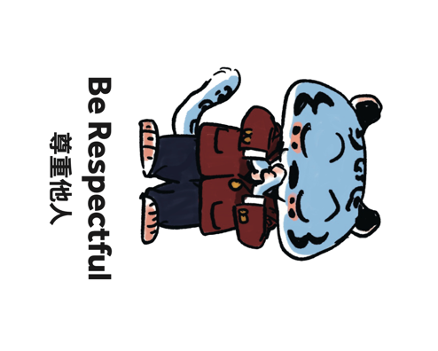 | - Be flexible and respond to the needs of those around you.
Leopard says… | - Complete acts of service by supporting others to maintain the student lockers.

