Leopard’s Expectations for Music and Strings
Leopard says… | - Be gentle when using the music classroom resources such as handling instruments and using computer lab equipment.
Leopard says… | - Persevere when working on challenging tasks and understand that taking risks and making mistakes is part of the learning process.
Leopard says… | - Show enthusiasm for creating, practicing, and performing music.
Leopard says…  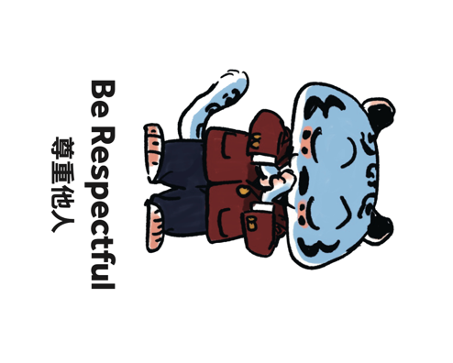 | - Show cooperation by following the teacher’s rules and by treating all your classmates with kindness and patience.
Leopard says… | - Have self-discipline by practicing and improving on music skills and technique.

