Leopard’s expectations for using iPads
Leopard says… | - Be trustworthy by only use the iPad when you are in the Learning Community.  - Be unifying by keeping your iPad settings the same.  - Be assertive and tell an adult immediately if anything inappropriate is on your iPad or your friends.
Leopard says… | - Be purposeful by using the apps we need for our current learning.  - Be diligent by only sharing your learning with your friends.
Leopard says… | - Be appreciative by using technology for your learning.  - Be generous by sharing your iPad with others.
Leopard says…  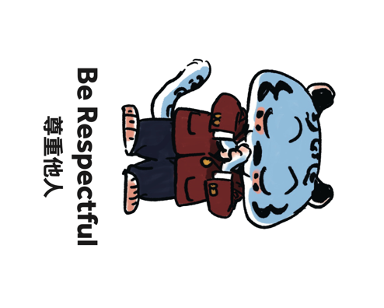 | - Be cooperative by using the iPads when you are allowed to.  - Be thoughtful by paying attention to those around you when using your iPad.
Leopard says… | - Be helpful by taking care of all iPads and where you place them.  - Be accountable by ensuring the iPads are charged.

