Leopard’s expectations for the Library
Leopard says… | - Line-up patiently when waiting to borrow books and leave the library.  - Be mindful to walk sensibly in the library.  - Be trustworthy and only be in the Library when a teacher is present.
Leopard says… | - Raise your hand confidently when you are asking or answering a question during group talk  - Be open-minded about the books that might interest you- try something different!  - Choose your library books purposefully by thinking carefully about what you enjoy and what you want to learn about.
Leopard says… | - Be optimistic about the books that are shared during carpet time.  - If you cannot borrow books you would like, practice detachment and don’t let your feelings control you. There are lots of other ways to enjoy Library time.
Leopard says…  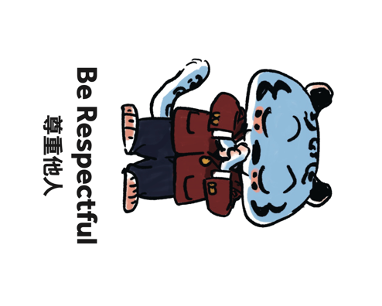 | - Show consideration for others by placing books back correctly and keeping the area tidy.  - Show courtesy to others by not talking over others during carpet time.
Leopard says… | - Be reliable and remember to pack your library books when you have Library.  - If you cannot find a book, speak-up honestly and let the library staff or your teachers know.  - Respond to instructions in an orderly way.

