‘Leopard’s says’ in the Gym
Leopard says… | - use kind hands when playing with or against your friends.  - Show patience and wait your turn  - Be trustworthy and use the equipment how your teacher shows you.
Leopard says… | - Persevere and keep trying the master the skill  - Seek excellence and challenge yourself to improve  - Approach each learning experience with openness and ask the teacher if you don’t understand something.
Leopard says… | - Show appreciation to others that have mastered the knowledge and skills.  - Show friendliness and help others to try their best.  - Show enthusiasm and motivate your team with kind words and praise.
Leopard says…  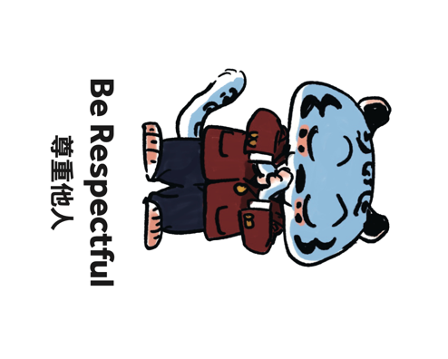 | - When others are speaking we listen with courtesy  - Communicate using care and compassion for others.
Leopard says… | - Be accountable and always follow the rules of the game.  - Take initiative and lead your team when required.  - Be reliable and wear your PE kit to every PE class.

