Leopard’s Expectations for the Art Room
Leopard says… | - Show kindness to others when using equipment and resources.
Leopard says… | - Be open to inspiration and use your imagination to create original pieces of work.
Leopard says… | - Be optimistic and work through the challenges that you find.
Leopard says…  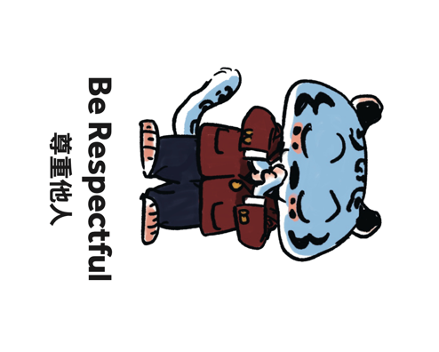 | - Show humility and share your knowledge and skills with others.
Leopard says… | - Commit yourself to the learning objective and complete the task to the best of your ability.

