Leopard’s Expectations for the Playgrounds/Courtyard
Leopard says… | - Interact with others with peacefulness and kindness.
Leopard says… | - Play games with an understanding of the space available and your peers.
Leopard says… | - Be joyful and enjoy the opportunity to run and play  - Be friendly and reach out to others with warmth and care.
Leopard says…  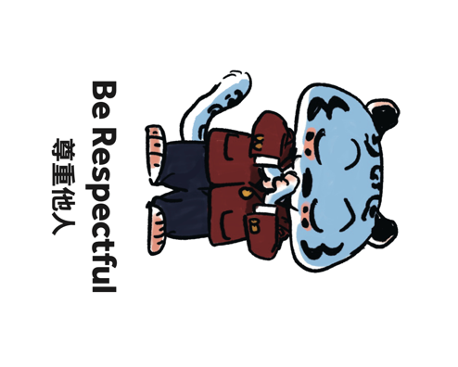 | - Use tact when speaking with your peers. Seek support from the duty teacher if you need it.  - Trust in others and focus on enjoying your opportunity to play.
Leopard says… | - Remain loyal to your peers thorough good and bad times.  - Play with integrity and follow the rules of the game

