Leopard’s Expectations for the Basketball Court
Leopard says… | - Use your wisdom to play safe and inclusive games.
Leopard says… | - Persevere to Improve you skills in drilling, shooting and passing.
Leopard says… | - If you find something challenging, accept it. You will do better next time.  - Show enthusiasm and encourage others to keep trying.
Leopard says…  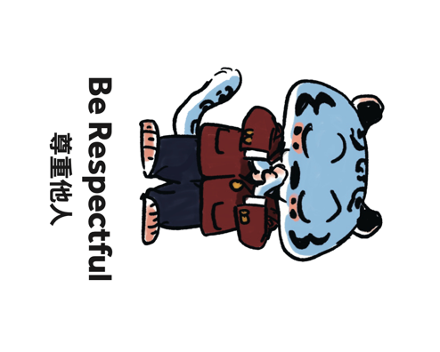 | - Show empathy by including your peers in your games or allowing them to use the equipment.
Leopard says… | - Remain loyal to your peers thorough good and bad times.  - Play with integrity and follow the rules of the game

