Leopard’s expectations for Football on RP Field
Leopard says… | - Show fairness when the ball goes out. Play stops and the ball is thrown in to restart the game.  - Be trustworthy and not use your hands, unless you are the goalkeeper.  - Be mindful of others and don’t slide tackling.
Leopard says… | - Show resilience and have a go at playing in different positions.
Leopard says… | - If you make a mistake, accept it. You will do better next time.  - Show enthusiasm and encourage others to keep trying, even if they make a mistake.
Leopard says…  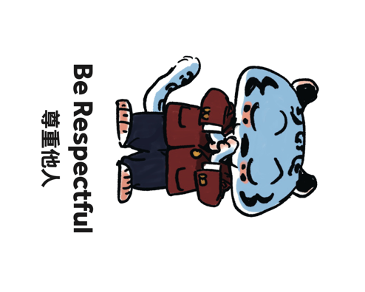 | - Have the courtesy to acknowledge others for good play.  - If you have a disagreement, cooperate with the other person to find a solution or seek the teacher’s support.  - If someone is hurt, show empathy by stopping the game and checking they are ok. The game can restart with a goal kick.
Leopard says… | - Be honest, make the teams fair by matching up against an opponent of a similar ability.  - Have integrity and follow the rules of the game.

