Leopard’s expectations for the Washroom
Leopard says… | - Be assertive and set clear boundaries to protect your personal space.
Leopard says… | - Show understanding by listening with compassion and accuracy to others’ feelings.
Leopard says… | - Show forgiveness, overlooking mistakes, and be willing to move forward in a positive way.
Leopard says…  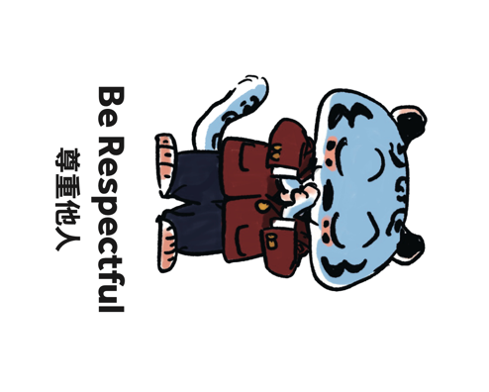 | - Have compassion for others and take action that allows others to use the washroom quickly and easily.
Leopard says… | - Be truthful, open, and genuine by communicating honestly with your peers.

