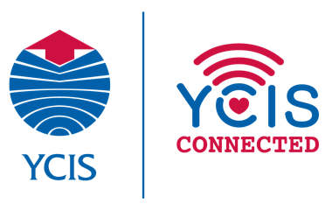
2021-22 Primary e-Learning Contingency Plans and Guidelines
(At the same time zone)
Section 1: Introduction
Having been through e-Learning before, we recognise that it is prudent to prepare ourselves for any emergency situation whereby we would be forced to temporarily close our school doors. We ask all the teachers to note the following points and undertake the listed important actions. As the information provided could change at any time, School Leadership team will keep teachers updated as developments unfold.

- Technology Devices: Teachers are expected to take their laptop, iPad and charger home everyday
- Seesaw and Blog check-up: Ensure all students have access to Seesaw and Blog
- Set-up Classin – Ensure all students have all been entered into relevant classes on Classin
- Parents Contact information: It will be important to ensure that teachers have all the relevant contact information for parents (eg, email addresses, phone numbers). School office will send the most updated class list/emergency contact information.
- Access to the internal School Network: Download the school VPN which will allow teachers to access the school’s internal network, including: server and GMIS. Please see Garfield’s email garfield.yuan@sh.ycef.com (RP) and alan.ge@sh.ycef.com(CP) Contact IT if anyone need the support to download.
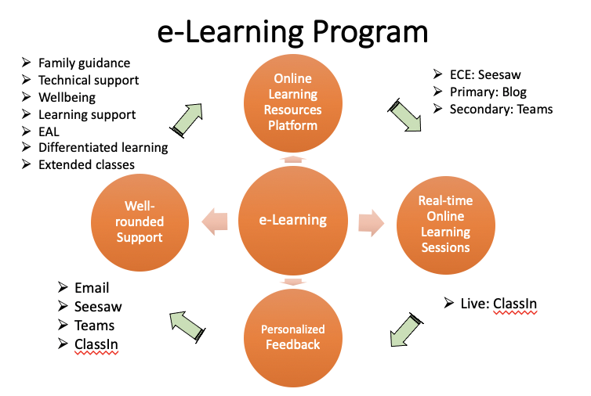
Section 2: Primary Priorities and Considerations
- After receiving initial notice from the Co-Principals about campus closure and timelines, families will receive an email from the Vice Principals with division-specific information. This will be followed up by messages from section Coordinators to teachers as appropriate.
- The main tools for communication between teachers and families will be email and the year level blog. If anything is posted onto the Emergency Wechat Group, the message should be re-sent via email again.
- In order to ensure the integrity of our curriculum and effective delivery of quality teaching and learning, it is important to maintain a sense of routine based around our regular school day as much as possible. In order to do this, students and staff will continue to follow a timetable as they would at school.
- Students will have both off- and on-screen learning activities and tasks designed to engage learners in experiences that connect to current curriculum. Students will be expected to check the daily blog and complete assignments set by their teachers as well as engaging in Live Sessions.
- Daily/Weekly blog posts with assigned work will be posted from 6pm the day before to allow parents to ensure their children are prepared for the tasks.
- Timely feedback will be provided to support students’ learning.
- Students should not work longer than a typical school day. If everything isn’t finished, we recommend you let the teacher know what was not completed.

Section 3: Plan for eLearning
Day 1
- Communication
- Parents will receive an email from the class co-teacher the day before the Day 1 to invite students to join Day 1 Class Assembly via ClassIn and any other relevant information about the day.
- Class co-teachers to arrange a morning Class Assembly to check on students and share e-learning plan and schedule via ClassIn
- Class teachers email schedule to parents and send today’s work link on the blog (Put instructions on the blog, and attach Cowtransfer link for each core subject resources so that parents can easily download and save time for teachers to upload as well. Please name clearly for each files)

- Preparation
- No live lessons required on Day 1 except the class assembly
- Work is expected to be set up on the Blog
- Time given on this day for teachers to set up ClassIn Course and schedule Lessons
- Whole staff meeting in the afternoon – check on staff and Sissy will give ClassIn training via Zomo at 1pm. Amita will support the Specialist team. Melissa will follow up with Overseas staff if needed.
- Amita and Sissy also offer Parents training via Zomo Webinar account (one in the morning, one in the afternoon)
- We will hold ‘test’ lessons in the ICT lessons in each semester to help children/teachers become familiar with platform.

Day 2+
- Online learning resources platform
- Every day students log on to the learning resource platform – year level blog to find the learning activities and tasks.
- Parents will also receive another Morning email at 7:30am from class co-teachers to find the weekly schedule and the blog link (We can send the blog link and schedule for 6:30pm the night before)

- Real-time interactive sessions on ClassIn
- Live Sessions via ClassIn commence according to the schedule
- There are seven sessions a day and two times of class community time at the beginning of day and the end of day

- Personalized feedback
- Teachers give individual feedback on students work in a timely manner as well as give further support as necessary.

- Well-rounded Support
- For those families with individual needs, including, but not limited to: psychological needs, learning support needs, family guidance needs, technical support, etc., all the school departments work closely together to provide services such as extra one-to-one online Classin meetings, counselling and so on, forming a positive home-school collaborative and supportive YCIS community.

Schedule Examples (please do not change specialist, Chinese and English)
Year 1
 | Monday | Tuesday | Wednesday | Thursday | Friday
8:00-8:15 | Class Community Time
8:15-8:55 | English | English | English | English | English
9:00-9:30 | Music | ICT | PE | Violin | Art
9:30-10:00 | Recess and Snack
10:00-10:40 | Chinese | Chinese | Chinese | Chinese | Chinese
10:45-11:15 | Active Kids
11:15-12:15 | Lunch, Recess and Body Rest
12:15-12:55 | Math | Math | Math | Math | Math
1:00-1:30 | PE | Violin | Art | ICT | Music
1:35-2:00 | Topic/Life Skill | Topic/Life Skill | Topic/Life Skill | Topic/Life Skill | Topic/Life Skill
2:05-2:30 | Class Community Time |  |  |  | Year Level Assembly
2:30-3:30 | Independent Time & Finish Daily Tasks and Hand Out Work
* Each core session is 40 minutes, includes 20-mins interactive live lessons and 20-mins class work in total.

Year 2
 | Monday | Tuesday | Wednesday | Thursday | Friday
8:00-8:15 | Class Community Time
8:15-9:00 | Math | Math | Math | Math | Math
9:00-9:30 | Recess and Snack
9:30-10:00 | Art | Music | ICT | PE | Violin
10:00-10:45 | English | English | English | English | English
11:00-11:45 | Chinese | Chinese | Chinese | Chinese | Chinese
11:45-12:45 | Lunch, Recess and Body Rest
12:45-1:15 | Active Kids
1:30-2:00 | Music | PE | Violin | Art | ICT
2:00-2:30 | Topic/Life Skill | Topic/Life Skill | Topic/Life Skill | Topic/Life Skill | Chinese Studies
2:30-3:00 | Class Community Time |  |  |  | Year Level Assembly
3:00-3:30 | Independent Time & Finish Daily Tasks and Hand Out Work
*Each core session is 45 minutes, includes 25-mins interactive live lessons and 20-mins class work

Year 3
 | Monday | Tuesday | Wednesday | Thursday | Friday
8:00-8:15 | Class Community Time
8:15-9:00 | Math | Math | Math | Math | Math
9:00-9:45 | Chinese | Chinese | Chinese | Chinese | Chinese
9:45-10:15 | Recess and Snack
10:30-11:00 | Violin | Art | Music | ICT | Art
11:00-11:30 | Active Kids
11:30-12:15 | English | English | English | English | English
12:15-1:15 | Lunch, Recess and Body Rest
1:30-2:00 | Topic/Life Skill | Topic/Life Skill | Topic/Life Skill | Topic/Life Skill | Chinese Studies
2:00-2:30 | ICT | Music | PE | Violin | PE
2:30-3:00 | Class Community Time |  |  |  | Year Level Assembly
3:00-3:30 | Independent Time & Finish Daily Tasks and Hand Out Work
*Each core session is 45 minutes, includes 25-mins interactive live lessons and 20-mins class work

Year 4
 | Monday | Tuesday | Wednesday | Thursday | Friday
8:00-8:15 | Class Community Time
8:15-8:45 | Active Kids
9:00-9:45 | Chinese | Chinese | Chinese | Chinese | Chinese
10:00-10:30 | PE | Chinese Studies | Art | Music | ICT
10:30-11:00 | Recess and Snack
11:00-11:30 | Topic/Life Skill | Topic/Life Skill | Topic/Life Skill | Topic/Life Skill | Topic/Life Skill
11:30-12:15 | English | English | English | English | English
12:15-1:15 | Lunch, Recess and Body Rest
1:15-2:00 | Math | Math | Math | Math | Math
2:00-2:30 | Class Community Time |  |  |  | Year Level  Assembly
2:30-3:00 | Art | ICT | Music | PE
3:00-3:30 | Independent Time & Finish Daily Tasks and Hand Out Work
*Each core session is 45 minutes, includes 25-mins interactive live lessons and 20-mins class work

6 Day Circle for Y5
Period | Time | Day 1 | Day 2 | Day 3 | Day 4 | Day 5 | Day 6
Homeroom | 8.05-8.20 | Class Community Time
P1 | 8.20-9.10 | Chinese | Chinese | Chinese | Chinese | English/EAL | Mathematics
P2 | 9.10-10.00 | 5A Music  5B Art  5C ICT  5D PE | Mathematics | Mathematics | English/EAL | Independent Work Time | Chinese
Recess/snack | 10.00-10.30 | Recess and Snack
P3 | 10.30-11.20 | 5A Art  5B PE  5C Music  5D ICT | English/EAL | English/EAL | Independent Work Time | Mathematics | English/EAL
P4 | 11.20-12.10 | Mathematics | Independent Work Time | Independent Work Time | 5A Art  5B ICT  5C Music  5D PE | Chinese | Independent Work Time
P5 Lunch | 12.10-13.00 | Lunch, Recess and Body Rest
P6 | 13.00-13.50 | English/EAL | Topic | Topic | Mathematics | Topic | Topic
P7 | 13.50-14.30 | Independent Work Time | Topic | Chinese Studies | 5A Music  5B Art  5C PE  5D ICT | Topic | 5A PE  5B ICT  5C Art  5D Music
Y6 Recess | 14.30-14.40 | Recess and Snack
P8 | 14.40-15.30 | 5A ICT  5B Music  5C PE  5D Art | Life Skills | 5A PE  5B Music  5C ICT  5D Art | 5A ICT  5B PE  5C Art  5D Music | Life Skill/Active Kids | Year Level  Assembly
*Each core session is 50 minutes, includes 30-mins interactive live lessons and 20-mins class work

Period | Time | Day 1 | Day 2 | Day 3 | Day 4 | Day 5 | Day 6
Homeroom | 8.05-8.20 | Class Community Time
P1 | 8.20-9.10 | Chinese | Chinese | Chinese | Chinese | English/EAL | Mathematics
P2 | 9.10-10.00 | Mathematics | 6A Music  6B Art  6C PE | Mathematics | Mathematics | Independent Work Time | Chinese
Recess/snack | 10.00-10.30 | Recess and Snack
P3 | 10.30-11.20 | English/EAL | Mathematics | English/EAL | English/EAL | 6A Music  6B Art  6C PE | English/EAL
P4 | 11.20-12.10 | Independent Work Time | 6A Art  6B PE  6C Music | Independent Work Time | Independent Work Time | Chinese | Independent Work Time
P5 Lunch | 12.10-13.00 | Lunch
P6 | 13.00-13.50 | 6A Life Skills  6B Drama  6C ICT | ICT  (6A, 6B, 6C) | Topic | Topic | Mathematics | 6A Drama  6B ICT  6C Life Skills
P7 | 13.50-14.30 | Topic | English/EAL | 6A PE  6B Music  6C Art | Topic | 6A PE  6B Music  6C Art | Chinese Studies
Y6 Recess | 14.30-14.40 | Recess and Snack
P8 | 14.40-15.30 | Topic | Independent Work Time | 6A ICT  6B Life Skills  6C Drama | Life Skills/Active Kids | 6A Art  6B PE  6C Music | Year Level  Assembly
6 Day Circle for Y6

*Each core session is 50 minutes, includes 30-mins interactive live lessons and 20-mins class work

Section 4: ClassIn Set-up
- Teachers will ensure set up ClassIn for your students, just so that everyone is ready for e-learning should the situation worsen
- Class Co-Teachers are expected to set up the Homeroom (ClassIn Course) first
- EAL and Specialist teachers will set up ClassIn for each year level at Day 1
- After we launch the program, the lessons should be scheduled weekly
- Here is an example of Y3 ClassIn Course set up:
- Y3A Class (Class co-teachers) – the homeroom will be used for Class Assembly, English, Math, Topic and Chinese Studies – set up at the beginning
- Y3 Chinese CFL-2 (Chinese Teachers) - set up at the beginning
- Y3 EAL – Ms.** (EAL teachers) - set up at Day 1
- Y3 PE (Specialist teachers) - set up at Day 1
- Y3 Art (Specialist teachers) - set up at Day 1
- Y3 Violin (Specialist teachers; divided into Two Groups) - set up at Day 1
- Y3 Music (Specialist teachers) - set up at Day 1
- Y3 ICT (Specialist teachers) - set up at Day 1
- Y3 Active Kids (Specialist teachers) - set up at Day 1
- Y3 Year Level Assembly (Year Leaders) – Whole year level can be set up later

Section 5: Individual Meeting
We have also prepared one Zomo account for each year level to use for any special situations, so that Zomo can be used for those individual meeting. (Please note those accounts only can cater for small numbers of people, so only used for emergency individual meeting, all the meeting should be recorded as well)

Y1
- Login in: ycispd2@zomo.cn
- PW: Abcd1234

Y2
- Login in: ycispd3@zomo.cn
- PW: Abcd1234

Y3
- Login in: ycispd4@zomo.cn
- PW: Abcd1234

Y4
- Login in: ycispd5@zomo.cn
- PW: Abcd1234

Y5
- Login in: pd.cp1@sh.ycef.com
- PW: Abcd1234

Y6
- Login in: pd.cp2@sh.ycef.com
- PW: Abcd1234

Please note school will also deliver a Stationary Package to students to use at home if we move on to the full e-learning (at least e-learning last one week).
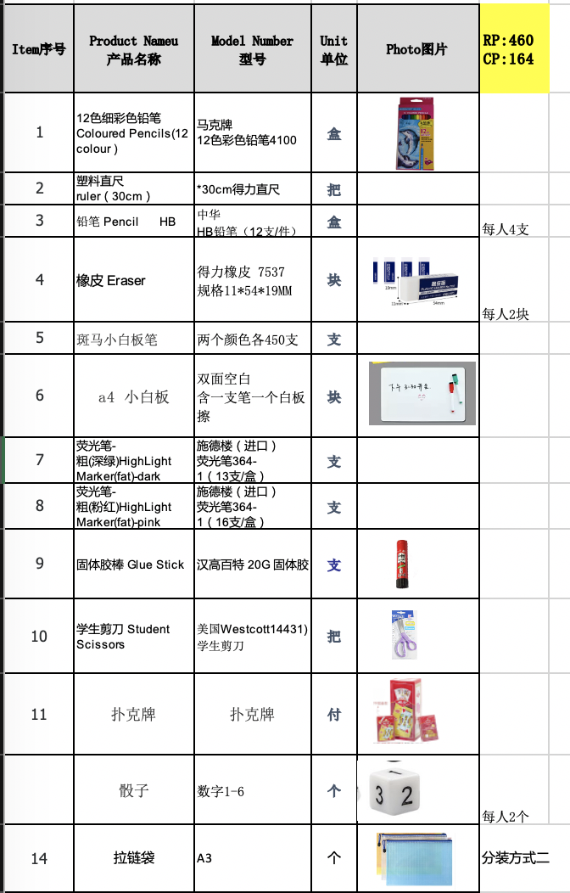

Section 6: Online Learning Expectations
Expectations of Staff
- During online conferences, staff should be sitting in suitable environments and dressed appropriately (i.e. not on their beds, or with highly personal backgrounds).
- Staff should continue the same professional caring attitude and maintain boundaries in their interactions with students, as they would in the face-to-face school environment.
- Staff should adhere to the pre-agreed starting and finishing times.
- Staff must follow normal rules of social media use as outlined in the Child Protection Policy and Procedures, and Adult Code of Conduct for working with Students. There should be absolutely no contact with students outside of school internal and approved platforms, and communication should have an educational purpose. Staff should ensure that their personal social media is private and inaccessible to students.
- If the staff see or hear any unusual or concerning behaviours, they must report it to the Child Protection Officer.
- Staff are expected to record all online sessions as this will provide transparency and a useful record for everyone. Teachers should consult school recording guidelines.
- If staff choose to use any external learning resources, materials and platforms, they should check and get approval from the related Coordinator/Department Head. When possible, staff are required to download resources prior to the lessons.
- Respond to questions from parents within 24 hours
- ClassIn set up:
  - For Homeroom: please set up one co-teacher as Teacher, one as Assistance
  - Shift students in sequence order every 15-30 seconds
  - Mute all course, when the e-learning not starts
  - Mute all students between 3:30pm to 7:30am when the e-learning starts
  - Dismiss the previous year course/class
  - Mute all the course, except Class homeroom
  - Mute any students who are not following the online rules

Expectations of Students (Class co-teachers can go through those rules in the Day 1 Class Assembly)
- Attend all online classes punctually and participate actively in all classes
- Turn on their cameras and microphones unless instructed otherwise by their teachers
- Choose an appropriate place to sit for the conference e.g. ideally at their desk or dining room table. It should be quiet but able to be supervised by adults in the home.
- Dress appropriately, irrespective of the locations
- Set up their devices so that the video captures a plain or suitable background that does not allow other users to see the private contents of their residence
- Maintain appropriate behaviour, respectful interactions and proper language with staff and other students, just as they would in person.
- Chat function is only for asking questions and interactive with class when teachers required
- Communication with other students should only be as instructed by the teachers and not on other social media platforms
- Use a proper name that is either their legal name or their preferred name
- Complete assigned work on time and meet deadlines
- Inform their teacher, counsellor or Child Protection Officer if they feel unsafe in a virtual class, session or forum.
- Report any inappropriate, harmful or illegal material to their teacher, counsellor or Child Protection Officer.

