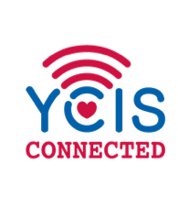
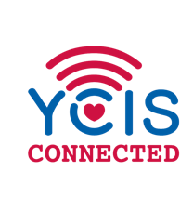
2021-22 ECE e-Learning Counterplan
Contingency Plans for Teaching & e-Learning

Having been through e-Learning before, we recognise it is prudent to prepare ourselves for any emergency situation whereby we would be forced to temporarily close our campus. We ask you to note the following points and undertake the following important actions. As the information provided could change at any time, we will keep you updated as developments unfold.

- Technology Devices: Please take your laptop, iPad and charger home everyday
- Seesaw check-up: Please ensure all students have access to Seesaw
- Set-up Classin – Please ensure your students have all been entered into your relevant classes on Classin
- Parents Contact information: Please ensure you have all the relevant contact information for parents (eg, email addresses, phone numbers). Please contact the office if you require your class list/emergency contact info.
- Access to the internal School Network: Download the school VPN which will allow you to access the school’s internal network, including: server and GMIS. Contact IT if you need support garfield.yuan@sh.ycef.com.

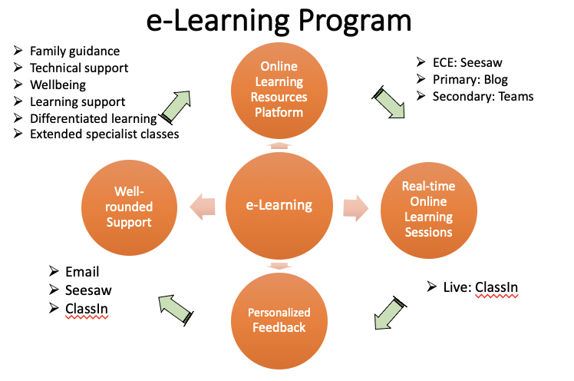

Plan for e-Learning - Day 1

- Communication
- Arrange a class parents meeting on the first morning with both co-teachers via ClassIn, for information sharing and questions and answers
- Email e-learning schedule to parents along with any other relevant documentation

- Preparation
- No student live sessions required on Day 1
- Seesaw activities are expected to be uploaded on class Seesaw the day before going live: t
- ime is allocated today in such a way as to provide space for teachers to prepare all ClassIn activities for the week ahead
- Meet with leaders if required
- Whole staff meeting in the afternoon – check on staff and Sissy will give ClassIn training via Zomo at 1pm?? Amita will support the Specialist team.
- Amita and Sissy also offer Parents training via Zomo Webinar account

Plan for e-Learning – Day 2+

- Online learning resources platform
Parents log on to the learning resource platform – Seesaw to find the learning activities.
Parents will also receive the daily email from the teacher to find the Classin live activity and any other relevant information about the day.

- Real-time interactive sessions on ClassIn
- Live Sessions via ClassIn commence according to the Schedule
- There are five sessions a day including co-teaching, language (English & Chinese), music, PE and other activities

- Personalized feedback
- Teachers give individual feedback on students work in a timely manner as well as give further support, as necessary

- Well-rounded Support
- Families with individual needs (psychological, learning support, family guidance, technical support, etc) will be supported by appropriate school departments, who will work closely together to provide suitable services, such as extra one-to-one online classin meetings, counselling and so forth, forming a positive home-school collaborative and supportive YCIS community.

Schedule for Each Year Level
Each K2 session is 15-30 minutes:
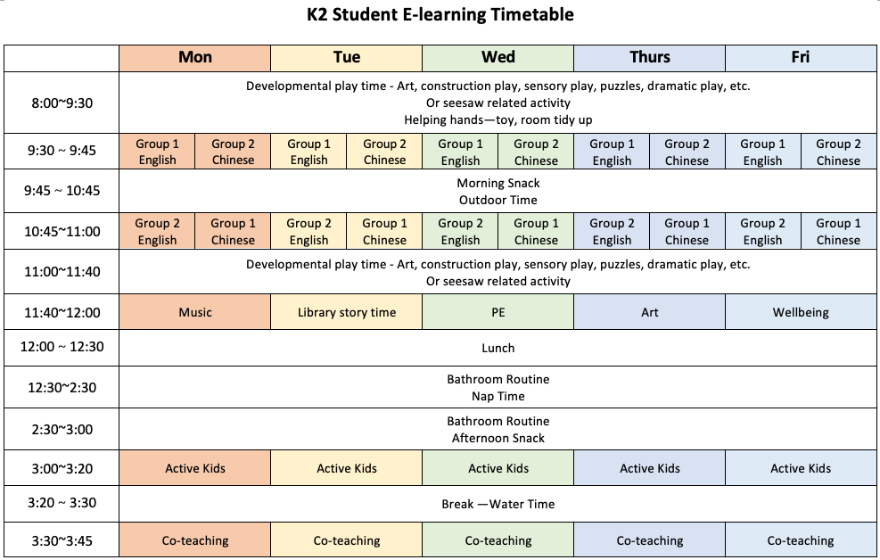
Each K3 session is 20-30 minutes:
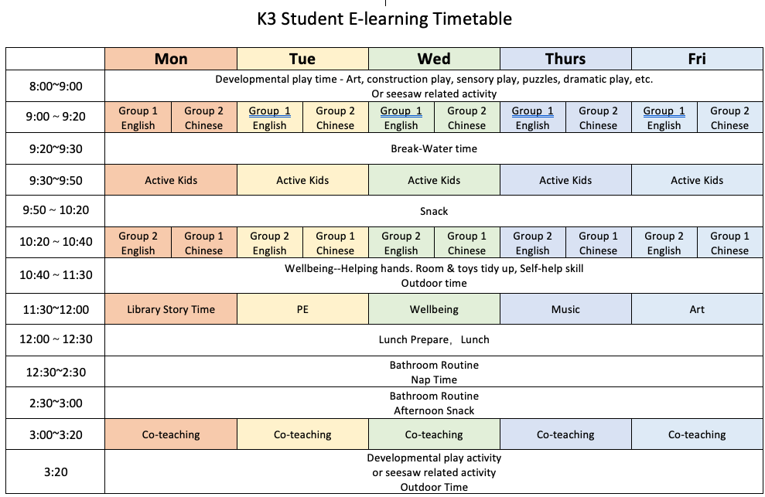

Each K4 session is 20-30 minutes:
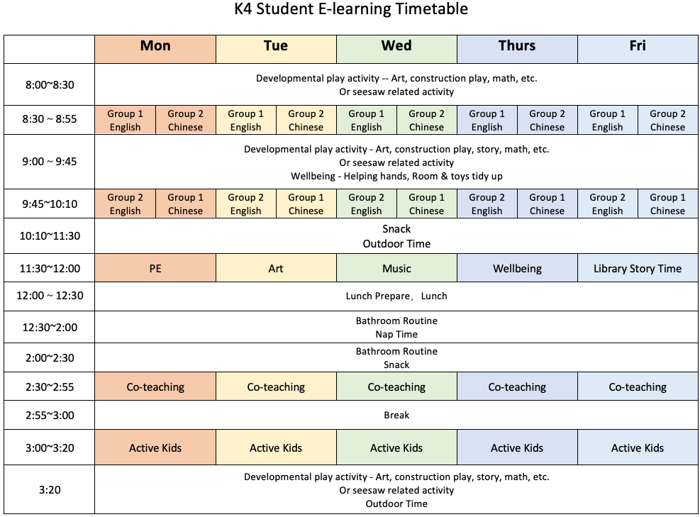

- ClassIn Set-up:
- Class teachers, please ensure that you have ClassIn set up for your students, just so that everyone is ready for e-learning should the situation worsen
- Specialist teachers will set up ClassIn for each year level
- Teachers are expected to set up the Subject (ClassIn Course) first
- After we launch the program, the lessons should be scheduled weekly
- Here is an example of K4 ClassIn Course set up:
- K4A Class Co-teaching (Class co-teachers)
- K4A English Group 1 (International teachers)
- K4A English Group 2 (International teachers)
- K4A Chinese Group 1 (Chinese Teachers)
- K4A Chinese Group 2 (Chinese Teachers)
- K4A PE (Specialist teachers)
- K4A Art (Specialist teachers)
- K4A Music (Specialist teachers)
- K4A Active Kids (Specialist teachers)
- K4A Wellbeing (ECE Curriculum Coordinator)
- K4A Library (ECE Head of ECE Chinese )

We have also prepared one Zomo account for each year level to use for any special situations, so that Zomo can be used for those individual meetings if required. (Please note those accounts only can cater for small numbers of people, so only used for emergency individual meeting and all the meetings should be recorded)
K2
- Login in: ycispd1@zomo.cn
- PW: Abcd1234

K3
- Login in: pd.rp1@sh.ycef.com
- PW: Abcd1234

K4
- Login in: pd.rp2@sh.ycef.com
- PW: Abcd1234

