Student Led Conferences
‘My Learning Journey’

Guidelines 2020-21

Century Park Campus – Student Presentations published on Seesaw
on Monday, March 29, 20201

Regency Park Campus –Week 27 & 28 (see calendar)

Rationale for Student Led Conferences
Student-led conferences involves a two-way conversation, between a student and their parents. Students lead the conference, and discuss their learning in different curriculum areas, using relevant assessment information, demonstrations of skills, explanations of process and progress, work samples and projects as evidence of learning.
Student-led conferences allow students to engage their parents in a range of interactive activities, designed to demonstrate current skills, knowledge, and understanding of their learning.
Dr. Cherie Taylor-Patel, 2011

The benefits of SLCs
- SLCs allow children to take ownership over their learning and their work and lead the conversation with their parents.
- It allows students to share authentic learning with their parents in the form of showing their work as well as demonstrating skills and concepts they have learned. It is highly motivational for children.
- It is an opportunity for them to be self-reflective and evaluate what they have achieved and what they need to continue to work towards. Encouraging all stakeholders to engage in open and honest dialogue.
- SLCs facilitate the development of students' oral communication skills and to increase their self-confidence.
- It increases parent understanding of how they can further support their child at home.

Year 1-4 SLC Activities Guidelines:
- SLCs will be organised as interactive centres.
- Activities will be stationed at tables organised around the auditorium and outside corridor if needed.
- Activities should be linked to what the students are currently or have recently studied.
- Activities can take the form of games, demonstrations, work samples, videos etc that demonstrate students’ application of skills, as well as knowledge and understanding.
- All activities must include:
- An Explanation of the task/student prompt – child friendly language and explicit
- LOs and SCs must be visible – child friendly language
- An example to support students if needed
- Vocabulary needed
- Evidence of differentiation ( see below)
- Teachers are to share the preparation of activities between the team
- Option: Guiding questions or prompts for the parents can be sent home ahead of time.

Year 5 & 6 SLC Digital Portfolio Guidelines:

Years 5 and 6 students will develop individual digital portfolios.

- All subject areas will be represented in the digit portfolio on Seesaw.
- All subjects will involve a short presentation sharing their work either through video footage, work samples or photos and collated on imovie.
- All presentations will be uploaded onto Seesaw as an ‘Activity’. Each Seesaw activity must include:
  - Title
  - Explanation of what has been studied over the period
  - Linked to a subject
  - Learning Objectives and Success Criteria in child and parent friendly language
- All work chosen needs to be marked with the rubric included if used.
- Student and teacher reflections included in each activity through the comment feature.
- Final imovies should be compressed using Quicktime/Handbrake so that they do not take a long time to download.
- Option: Guiding questions or prompts for the parents can be sent home ahead of time.
Specialist Seesaw SLC Post
- Please ensure that the caption/title of your post includes Student Led Conferences.
- Each post must include a blurb explaining the task uploaded. I have attached the Seesaw guidelines that you should follow when uploading a post. This is very important as parents need to know what the post is about.
- Feedback must also be given on your post. If you have added work that has been marked already you don’t need to add feedback again. There are some feedback prompts in the guidelines attached.
- As per guidelines these posts can include video footage, pictures, work samples etc
- As you know, the SLCs won’t take place at the same time for the year levels as it has in the past. Please see the dates below as this may help you to prepare. These dates are also on the logistics document sent out.
- All posts to be published the morning of the class SLC only. We don’t want these posts published any time before.

Differentiation:
- When teams are developing learning centre activities, differentiation of activities must be incorporated. This is an excellent opportunity to show parents how we are able to meet the needs of all our students in our class. For example: If the Mathematics centre is highlighting word problems, children should have available different strategies that they can call upon to solve the problem, such as use of manipulatives, numbers lines, TIPS framework etc etc The types of word problems should also be differentiated so that children select one that is appropriate to their level.
Technology:
- Opportunities to show how technology is integrated into any subject are welcome. This can be discussed with Amita, Alex and Vish. Technology can be incorporated into one of the centres as appropriate. ICT specialists will be responsible for setting up any activity centres that are specific to technology related software or tools, for example Bee-Bots, Sphero, Scratch etc

Student Information:

- Students who commence school after Chinese New Year or even closer to the date of SLCs can do the following:
- If appropriate they are also to engage their parents in the learning centres.
- Complete a partial digital portfolio (1 or 2 pieces if possible). For example, recent assignments.
- Show their parents their notebooks/journals or perhaps talk about a book/novel they have been reading. Co-teachers will need to notify parents ahead of time.

Student Reflection and Parent Feedback
- All students will be provided with a self-refection and feedback form to take home. This can be part of a continued discussion with their parents about the learning centres that were presented.
- Reflection activities and parent feedback can be designed by each year level with the following options:
  - Interactive Seesaw Activity for students to do with parents at home
  - Reflection and feedback sheet designed by the team could include 2 stars and a wish for both student and parent to complete at home.
  - Once completed please send to coordinators to ensure some consistency.
- Year 5-6 will complete their reflections with parent feedback on Seesaw.

Expectations for subject areas:
English or EAL | Writing: Children can share a piece of writing at their desk with their parents. What have been some of their goals that they have been working on in writing? What progress have they made?  Word Work/Phonics: Students can engage their parents in phonics game such as full circle, a word sort or any other activity.  Reading (optional): Students can share their reading progress with parents or a particular area of focus that has been studied during Guided Reading.  EAL work will be shared during SLCs, and prepared by the EAL teacher.
Mathematics | Focus on reasoning or problem solving activities rather than fluency activities.  Make use of whiteboards, games, manipulatives, ipads etc While games can be engaging and fun, the primary focus is that students can apply and show an understanding of strategies they have learned.
Chinese & Chinese Studies | Children can share a piece of work, reading or an activity with their parents. This must be prepared by the Chinese language teacher.  Chinese Studies: This activity is to be prepared by the class teacher.
Topic (Science or Social Science) | Consider the most recent unit of work the children have studied or are currently studying. What hands on activities have been completed in class that can be replicated in this centre? For example, a simple experiment to demonstrate knowledge of the scientific method or activities that compare and contrast. Children can also present the culminating work from the lastest PBL unit.
Specialist Subjects | Year 1-4: Specialists are required to make a post of a recent unit of work per student. This can be approved just before SLCs. Students can discuss these posts with their parents.  Year 5-6: In specialist classes students to collect video footage, work sample or photos of work and collate into imovie. Specialists will be responsible for putting the imovie together with students.  Subject Integration: If specialist subjects have been integrated into a recent unit, please have this represented within the station or imovie. This can be discussed between the specialist and class teachers. Specialists to support class teachers with collating this material.

Resources

Laptops
- Class ipads can be utilized for activities or project presentations.
- If teams need additional laptops, please see Amita.

Materials
- Teams to order materials needed during the unit of work and ahead of SLCs
- SLC boards – please check the ERC and contact Coordinator to order if needed.

Timeline:

Week 24 | Thursday, March 4: | - Initial letter sent home to parents about SLCs
Week 25: | All Week | - Year levels to have an SLC Year Level Assembly to introduce the students to the upcoming event.
 | Monday, March 8 | - Class Teachers send out Volunteer Sign-up email to parents by end of day.  - OAs to text an SMS reminder to Years 1-4 pri. parents about SLC registration (Reminder to add in the student diaries)
 | Friday, March 12 | - Online sign-up closes  - Teachers to send out a reminder email that today is the last day to register for SLCs.  - Learning Centre activities prepared and finalized (including EAL/specialists) & student to practice from Wk 26
Week 26: | All Week | - Classes to schedule in practice times and take their class through the boards.
 | Monday- Wednesday,  March 15-17: | - Teachers to contact parents that have not signed-up.  - Contact Coordinators to confirm any students that will not have  parents attending.
 | Monday, March 15: | - Draft Progress Reports for new students who commenced between Weeks 17-24 given to Melissa/Jon. (Y1-6)
 | Thursday, March 18: | - Edited progress reports returned teachers. Teacher to make edits.
 | Thursday-Friday, March 18-19 | - Teachers to complete all Zomo set up for SLC.
Week 27 | Year 3 & 2 | - SLC Week for Year 2 & Year 3
 | Monday, March 22: | - OAs to print progress reports and pass to teachers with envelope. Teachers to sign.
 | Tuesday, March 23: | - Send home Progress Reports
Week 28 | Year 4 /1 | - SLC Week for Year 4 and Year 1
 | Year 5/6 | - SLC Blog Posts Published on Seesaw

Some examples of Interactive Centres
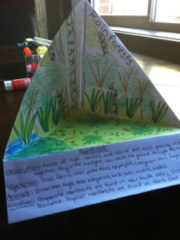
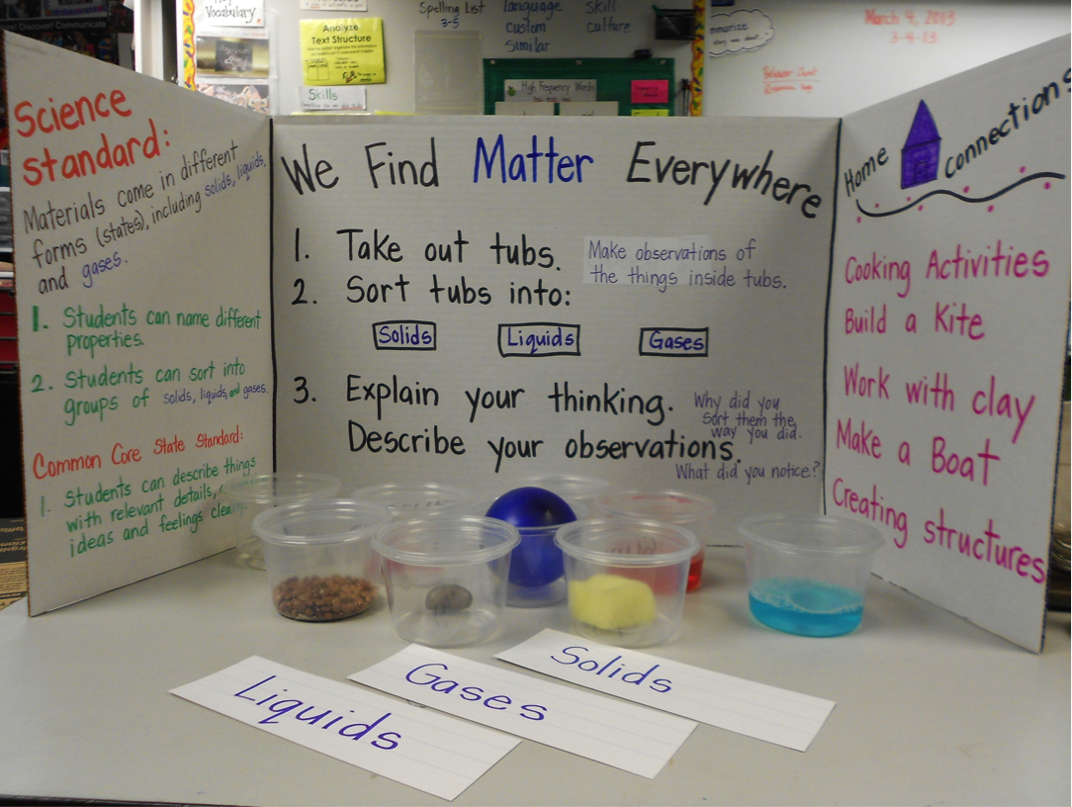
Science

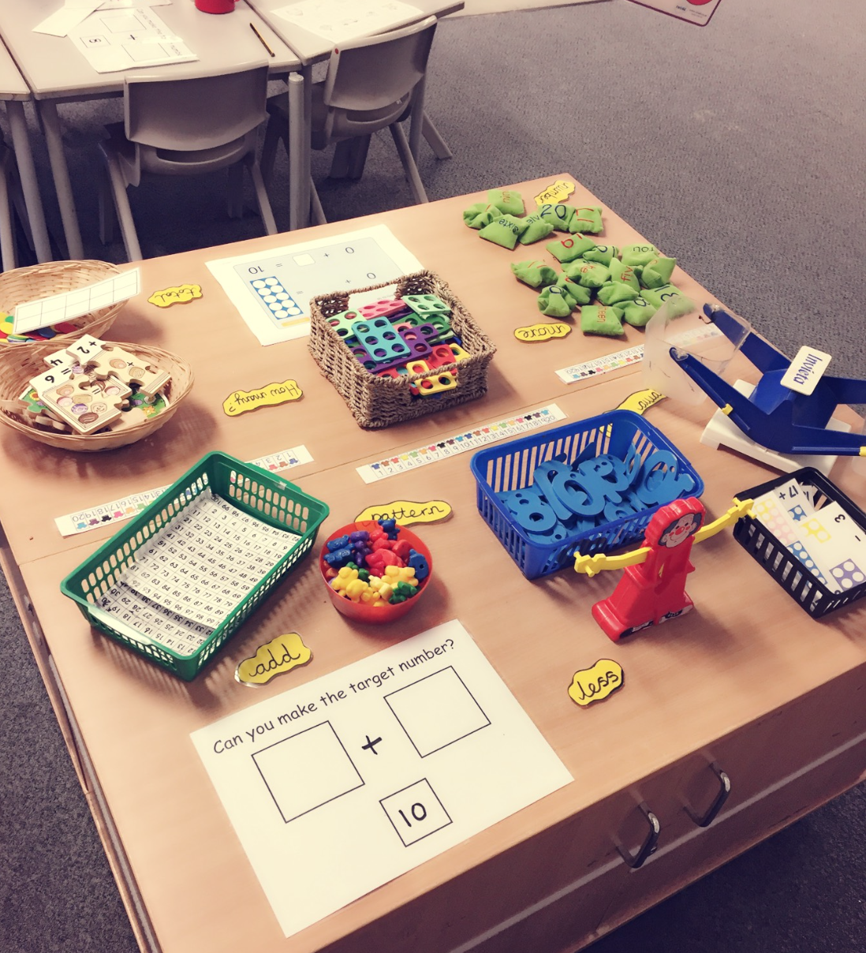
Mathematics
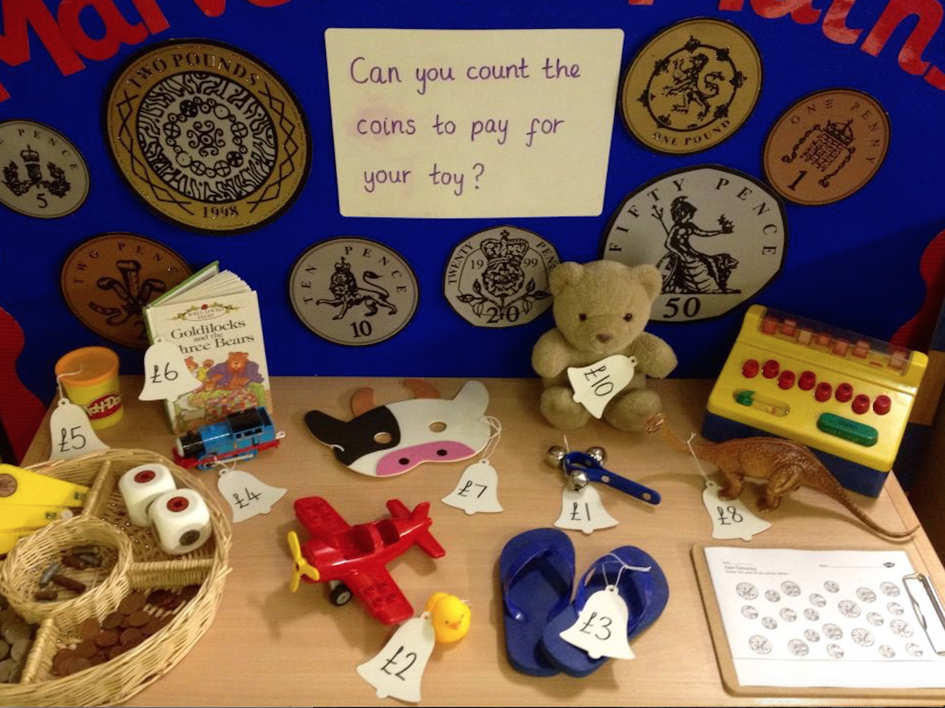

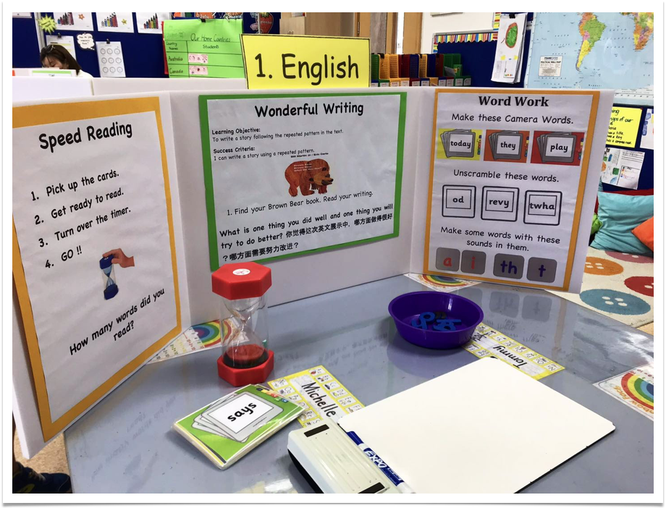
Reading Writing
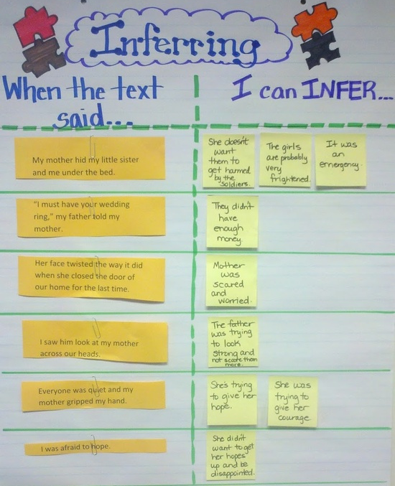

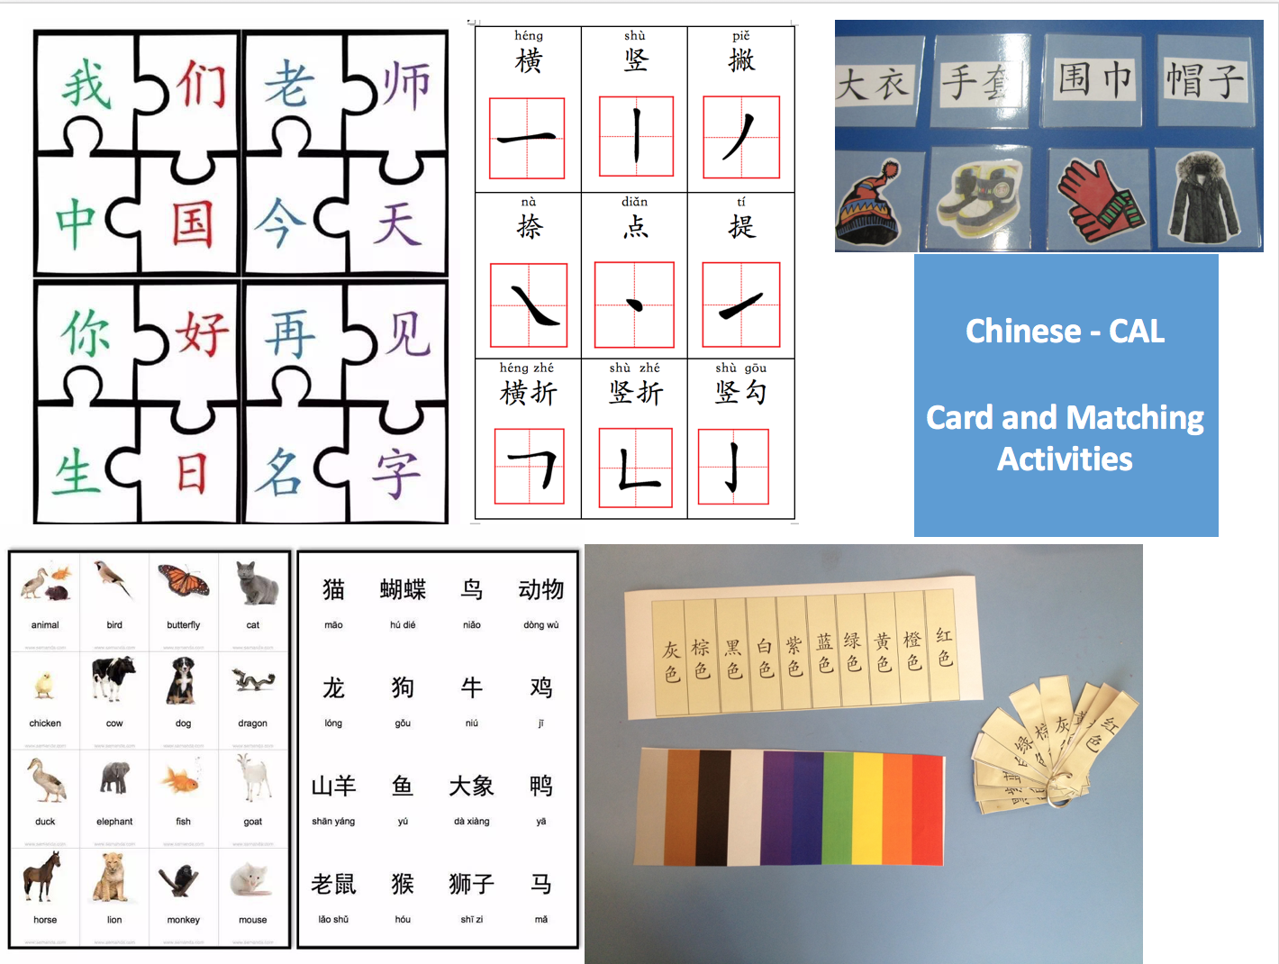
Chinese & Chinese Studies
