YCIS Shanghai - Pudong

Digital Portfolio (Seesaw) Guidelines

Rationale for using Digital Portfolios

Digital portfolios and journals have become an integral part of making learning visible in schools today (Rhodes, 2011).

Digital portfolios form an important link between making learning visible in a school environment for students’ self and peer reflection, building their desire to produce high quality artefacts and engaging family in their learning journey. They facilitate student engagement in the learning process and development of 21st Century skills.

Digital Portfolio Usage at YCIS Shanghai- Pudong

- Seesaw is the digital portfolio we use at YCIS Shanghai-Pudong.
- Seesaw will be used in all classes from Y1-Y6.
- Seesaw will be used to publish items of the following nature to parents:
  - Work samples
  - Collaborative group activities
  - Audio, video and photos showing learning taking place inside and outside of the classroom.
  - Audio, video and photos of student work.
  - Student, parent and teacher feedback and reflection.

Post Limits
The below table shows minimum posts per unit of work, per student unless stated otherwise.
There is no stated maximum number of posts per unit. Year leaders are responsible for working with their teams, in team meetings, to ensure that all classes are posting consistently in terms of quantity of posts.

 | English | Maths | Chinese | Topic | Specialists | EAL | Chinese Studies | Wellbeing
Y1 | 1 | 1 | 1 | 1 | 1 every 2 units | 1 | 1 per semester | 1 per unit
Y2 | 2 | 2 | 1 | 1 | 1 every 2 units | 2 | 1 every 2 units | 1 per unit
Y3 | 2 | 2 | 1 | 1 | 1 every 2 units | 2 | 1 every 2 units | 1 per unit
Y4 | 3 | 3 | 2 | 2 | 1 every 2 units | Beginner 2  Inter 2  Adv 3 | 1 every 2 units | 1 per unit
Y5 | 3 | 3 | 2 | 2 | 1 every 2 units | Beginner 2  Inter 2  Adv 3 | 1 every 2 units | 1 per unit
Y6 | 3 | 3 | 2 | 2 | 1 every 2 units | 2 | 1 every 2 units | 1 per unit

Organisation
- Groups will exist for homeroom classes, Chinese classes and EAL classes. Where students are grouped by homeroom, they will post in their homeroom group (Music, Art, PE, ICT, Violin, Library, Chinese Studies).
- Teachers should have the QR codes for each of their classes in their usual teaching room. This will enable students to easily log in to their class if the iPads are logged out.
- Teachers are responsible for the quick approval of posts in their subjects. Teachers should not approve posts made in other subjects.

Posting
- An explanation should be added to each post in the form of a caption. This can be recorded or written.
- There needs to be a balance of work, including written and oral work, and group and individual work.
- Work should be organised into folders of different colours as per the below:

Chinese
Chinese Studies
Mathematics
English
Topic
Art
PE
Violin
Music
ICT
Library
Events/Trips
Wellbeing

- Each post should have some form of feedback. This can be:
  - Teacher feedback
    - A minimum of one post per unit in each subject area should have teacher feedback.
    - If book work is clearly marked, and this can be seen in the photo, this does not need to be replicated in Seesaw.
  - Student self-assessment.
    - Useful stems for self-assessment (verbal or written) include:
        - I am learning about…
        - I know/can…
        - I would like to improve…
        - I wonder…
  - Peer assessment.
    - Useful prompts for peer assessment (verbal or written) include:
        - What have they learned?
        - What can they improve?
        - What question do you have about their learning?
  - A combination of the above.
- A simple format for all feedback is WWW (what went well) and EBI (even better if), related to learning objectives and success criteria.
- The provision of a prompt question may be useful to allow students to reflect meaningfully on their work.
- Teaching appropriate student commenting is essential. Language should be formal and academic, as per age expectations. Emojis are not appropriate. See useful guidelines: https://help.Seesaw.me/hc/en-us/articles/208222033-Digital-Citizenship-Posters-Blogs-and-Comments-Guidelines-
- Classroom expectations for Seesaw should be clear, and consistent across the year group. They should be communicated to all teachers who teach students in a year level. See useful guidelines at: https://help.Seesaw.me/hc/en-us/articles/208054203-Classroom-Expectations-Poster

Photos
- Photos of class events should be posted to Seesaw regularly by the class teacher, with each child tagged as appropriate, and they should be appropriately captioned. They can be put into either an appropriate subject folder, or the events folder. These do not contribute to the above post limits.
- Photos should be clear and good quality.
- PicCollage or similar can be used to post multiple photos as one post (max 10).
- Only tag the children who are actually in the photos/collages you post. This avoids parents seeing multiple photos not featuring their child.

Parents
- Teachers should ensure that parents are aware that they should not scan the classroom QR code.
- Enable “new comments require approval” for parents. This enables you to pre-screen comments. If you feel a comment is not suitable, please contact the parent and explain why.
- The school will provide information to parents informing them that Seesaw will be launched from Parent Information Evening.
- A brief introduction will be shared at Parent Information Evening where family login details passed to parents.

Settings
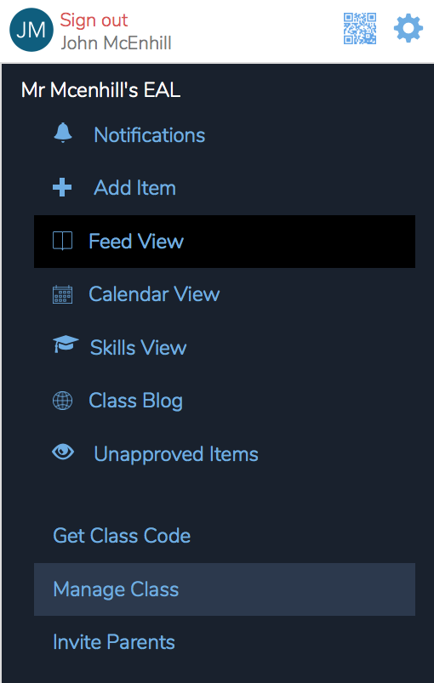
These settings can be found under manage class:

The settings for students should be as below:
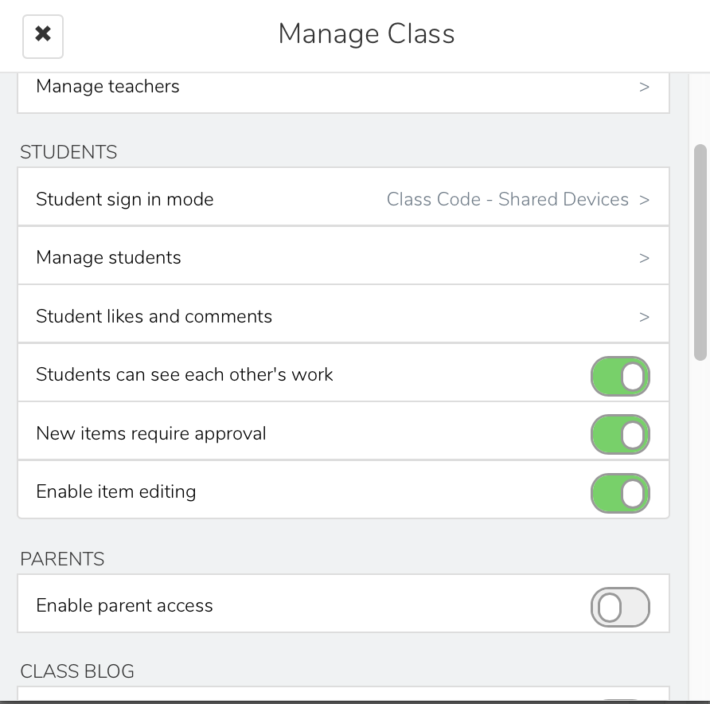

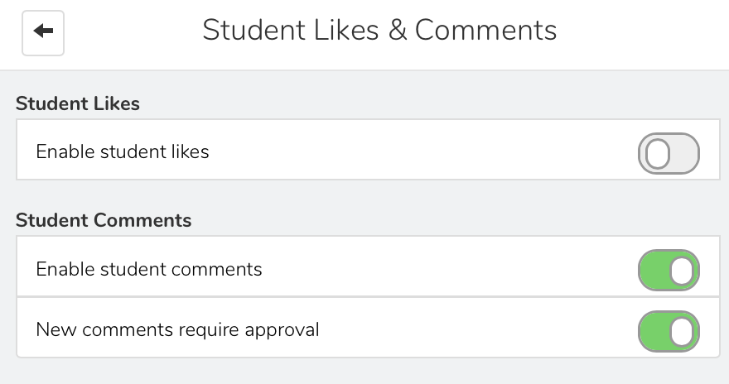
The setting for student likes and comments should be as below:

Examples of High Quality Posts and Feedback

Activities
