Wet Play/Red Air Day Buddies

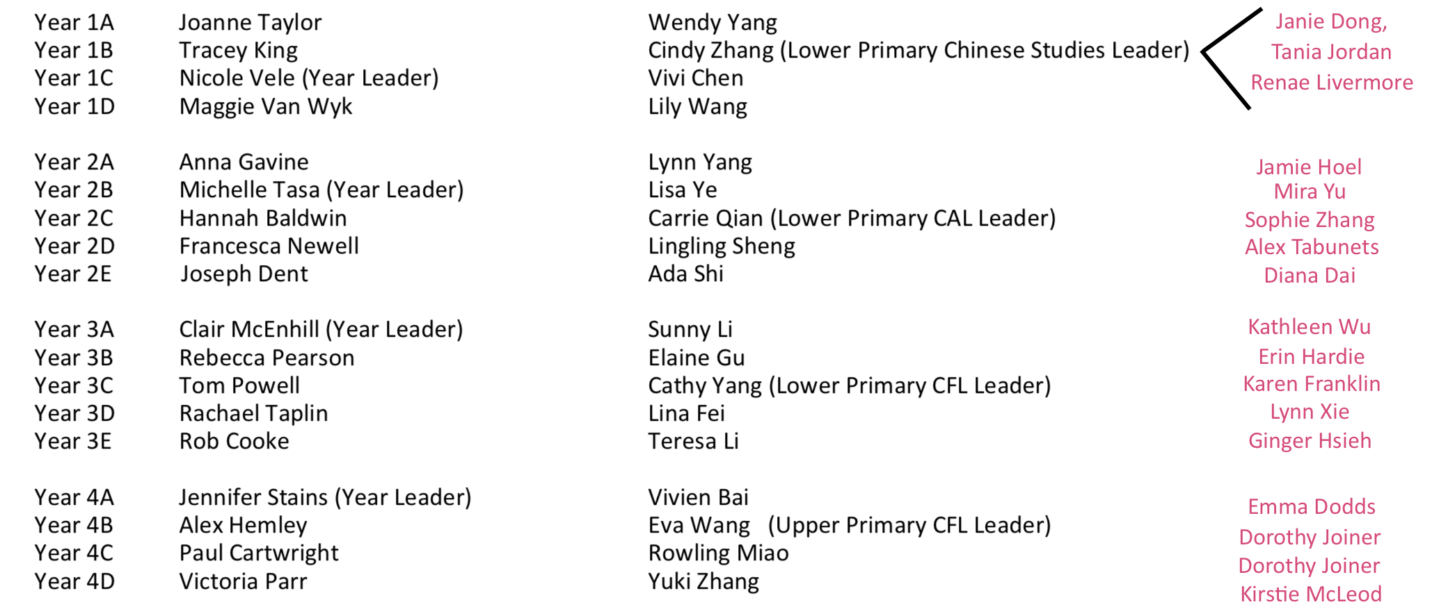

5 JUNE 2019
AMENDMENTS TO THE ABOVE
1A and 1B: Janie Dong
1C and 1D: Tania Jordan
3B AND 3E: Momina
4A AND 4B: Nathan
4C AND 4D: Anita (am)/Amy (pm)

- Co-teachers can contact the cover teacher via email to ask for help on wet play/red air days.
- It would be appreciated if the cover teacher were to be proactive in offering the co-teachers help.
- Year 1 have 3 buddies between 4 classes – this is because the Y1 co-teachers all work only with the Y1 class to whom they are attached and so 2 teachers are always available to each class
- Not all cover teachers are available on all days for all duties.
- Dorothy is covering for two classes – this should be borne in mind to ensure demands are not excessive.
- Any problems: please contact John

