Report Writing Instructions
Primary School

Mid Year Reports
January 2019

Important Report Information

- When printing/collating draft reports (for proofreading purposes); please ensure the student’s full report is together (in other words, do not give the EAL/Chinese/Specialist reports in separate piles).
- If parents request the report early – please politely say this is impossible – as there are so many steps involved in the process, it can’t be done. However, parents may request a letter of reference from the class teachers if they need it for applications to other schools.
- The student’s passport name will be automatically generated on the front cover. However, please make sure that the name on the comments is consistent with the name in Power Teacher Pro. Where there are two passport names listed (e.g. a Western and Asian name), it is the responsibility of the EAL and Chinese teachers to check with the rest of the report to ensure consistency of name throughout the report comments.

Effort Marks
All subjects have effort marks. There are multiple effort marks required for English, EAL and Chinese.

Instructions for comments
Mid-Year Reports require comments for all core subject areas and a general comment in the ‘Personal Development & Approaches to Learning’ section. See the sample report provided with the guidelines.

The comment box is limited to a set number of characters and cannot be altered. Minimum and Maximum characters expected for each comment are outlined below:

English, Maths & Topic will have a short curriculum statement – instructions on how to add this are at the end of this document. Coordinators will provide the curriculum statement. The character count below does not include the curriculum statement

Subject | Maximum Characters | Minimum Characters Expected
English | 750 | 550
Mathematics | 750 | 550
Topic/Science | 600 | 450
Personal development | 1000 | 700
EAL | 750 | 550
Chinese | 750 | 550

How to add the Curriculum Statements in PowerTeacher Pro
By doing it this way, the teacher only needs to copy and paste the statement once.

- Choose the appropriate course at the top of PTP (English, Maths, Social Science (for Topic) or your EAL group).

- Go to Settings
- Choose Class Description and paste the curriculum statement in there which will be applied to the entire class.

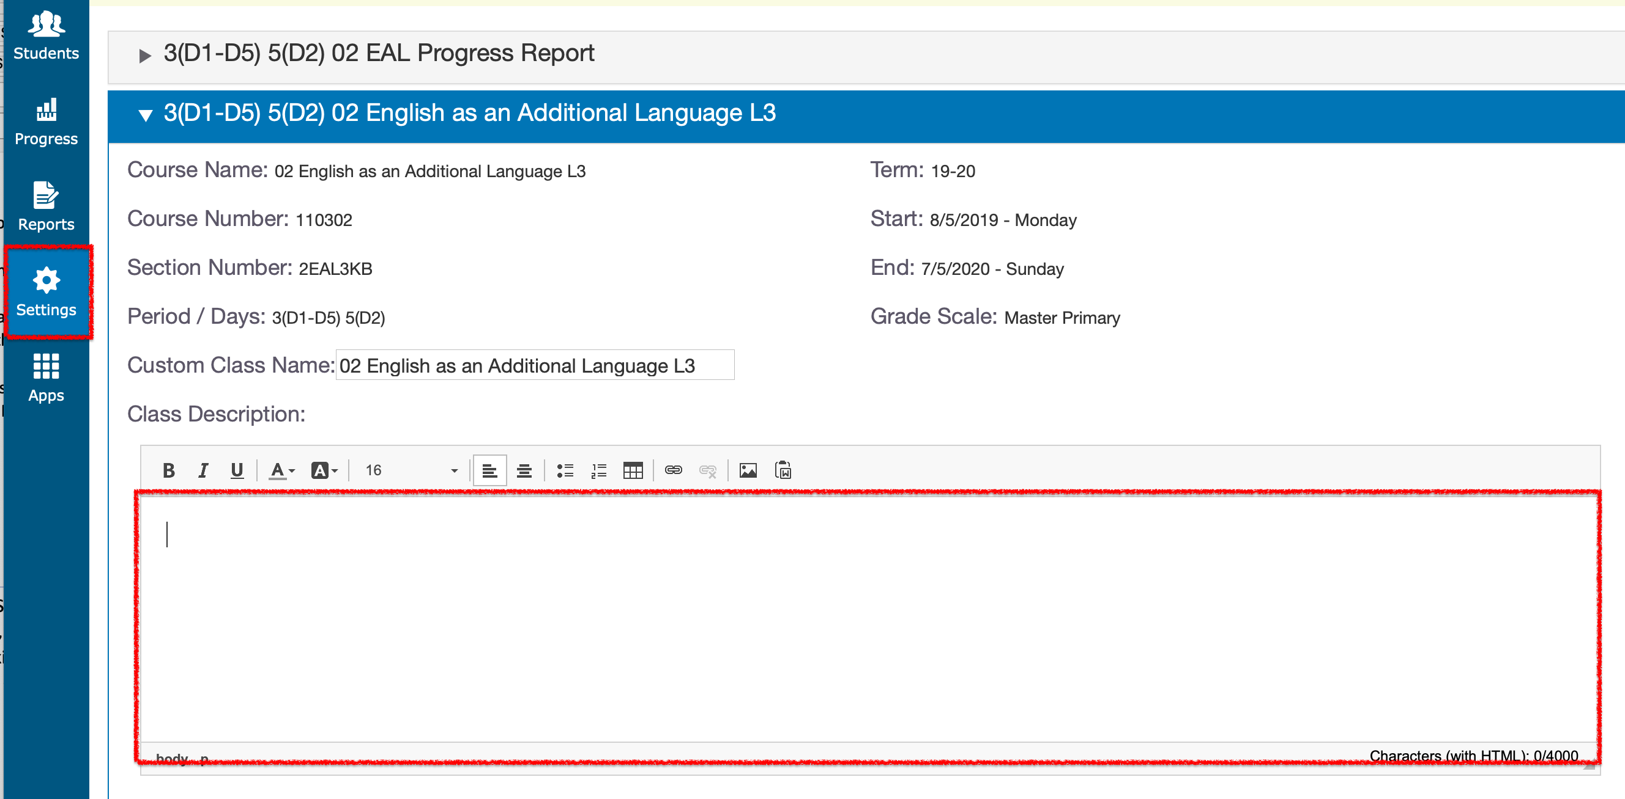

Specialist Comments
- Specialists are asked to review student grades and amend if necessary.
- If a student has been given a mark of NYA (Not Yet Apparent) or BD (Beginning to Develop), or EE (Exceeding Expectations) please ensure that there is a comment that reflects this mark in the document referenced below.
- A document will be sent to all specialists to review the class lists. A comment should be added next to a student if necessary. Only 1 sentence is expected, that is specific and personal (e.g. ‘In Art, Johnny is to be commended for designing an intricate and detailed series of patterns on his Egyptian sarcophagus’ or ‘In Art, Johnny continues to struggle with fine motor skills and is encouraged to work on cutting and drawing’. These are better than ‘In Art, Johnny loves to paint’.) We would expect there to be some students in each class who merit a comment.
- Specialists are to complete comments by November 21. These will then be passed to class teachers.
- Class teachers will incorporate comments given into the general comment of the student’s report.

Checking, Printing and Collating Reports

Once reports are completed, the office administrators will print hard copies for you.

Proofreading: Teachers are responsible for checking their own reports. Please use your best professional effort to ensure your draft reports are free from errors before they are passed to the Coordinators. When proofreading your reports please make note of the following:

- Spelling, punctuation and grammatical errors (please use British spelling).
- Write Mathematics in full: not Maths or Math.
- English must be spelt with a capital 'E' (as should all subjects).
- Typing errors (e.g. spaces used correctly).
- If a student has been given a mark of BD (Beginning To Develop) or NYA (Not Yet Apparent) for core subjects only, please ensure that there is a comment that reflects this mark, explaining what the student can do to improve.
- A suggested format is to start with a positive and ensure comments are balanced. Comments should include a next step/goal/target.
- N/A (Not Assessed) can be used when a child has arrived late and there has been no opportunity for assessment of any of the standards within a strand. If it is used for any other reason, it needs a Coordinators approval.
- Comments should not be directed to the child (e.g. ‘Well done, Kelly’).
- Please ensure you include something personal about each child. Comments for two different students should never be exactly the same.
- General comments can include awards they have received during the semester and/or ways they demonstrate the Helping Hands values.
- Avoid run-on, lengthy sentences and check that the language you have used can be understood by the parents (especially if their first language is not English).
- Avoid being impersonal (e.g. ‘Kelly displays a responsible attitude towards completing homework’ is better than ‘A responsible attitude is shown towards completing homework’.)
- Do not mention the name of other children in reports (e.g. Johnny enjoys playing with Freddie.)
- Students should not be labeled or grouped (e.g. ‘He helps the EAL students’ or ‘She plays well with the other Korean girls’.)
- Teachers should not directly reference results from individual assessments. (e.g. According to Thomas’ last summative assessment, he scored highly….)
- Please ensure that EAL/Chinese teachers use the pronoun ‘I’ to refer to themselves. International teachers to use the pronoun ‘I’ when commenting on English. Co-teachers use the pronoun ‘we’ when commenting on Mathematics, Topic and General comments.

If Coordinators feel that the reports are not properly proofread, they will be passed back to the teacher.

Chinese teachers should give their reports to their co-teacher to check the comments.

It is the class teachers’ responsibility to read the EAL report and know what is written. If there is a major difference, then a meeting between the class teacher/EAL teacher should be called.

Timeline for Reports

Week 11  Monday, Nov. 4 | - Guidelines sent out. Year Level leaders to add Mid-Year Report Instructions to  meeting agenda. Teachers to begin reviewing grades and making notes for student  comments.
Mon. Nov. 21 | - Any specialist comments placed on teams document by the end of the day.
Wed. Nov. 27 | - Draft Chinese Reports completed and passed to Chinese leader
Thur. Nov. 28 | - EAL Reports completed by the end of day.
Fri. Nov. 29 | - Office to print draft EAL Reports to be proofread by the EAL teacher.
Mon. Dec. 2 | - Specialist marks to be completed by the end of day.
Tues. Dec. 3 | - Hard copy of draft Chinese Reports given to international teachers to be edited.
Week 15 (w/c Dec 2) | -LR teachers meet with class teachers to review reports of students on support plans and in extension groups for consistency. LR teachers to arrange this.
Fri. Dec. 6 | - Draft Chinese Reports handed back to Chinese teachers to make amendments.
Mon. Dec. 9 | - All reports completed by staff by 7:30am  - Office to print draft reports and pass to class teachers.
Mon. Dec. 9 – Wed. Dec. 11 | - Teachers to collate and proofread their own class reports.
Wed. Dec. 11 | - Class Teachers hand full draft report (collated), including Chinese, EAL & Specialists  to relevant Coordinator by the end of the day.
Thursday, Jan. 9 | - All reports returned to teachers to make final amendments.
Thurs Jan. 9- Mon Jan. 13 | - Teachers to make any changes needed to reports. Changes to be made by the end  of day on Monday, Jan 13.
Tuesday, Jan. 14 | - Office to print final reports. EAL and Chinese teachers to check that final reports  are complete and accurate and return to the office. Office to pass all sections of  the reports to the class teacher with report covers.
Wednesday, Jan. 15 | - Co-teachers to sign the reports and place into cover. Use the same envelopes as Progress Reports. Double check that all pages belong to the student.
Friday, Jan 17 | - Hand out to students at the end of the day.

Please Note:
- Reports should be completed for any student who started before November 1. Any student who started on or after this date should receive a Progress Report, including an EAL Progress Report if applicable. These can be completed after the Christmas holidays to allow more time to assess these students. New students who start after January 7 will not receive a Progress Report.

- For EAL students who have transferred to mainstream, the report needs to be co-written by both the EAL and the Mainstream class teachers to reflect the child’s time in both classes. EAL and class teachers must work together to decide the child’s final marks for the semester. Likewise, if students have moved between EAL classes the report should be written by the teachers of both levels.

- Any student that has left the school before October 21 will not receive an End of Year Report.

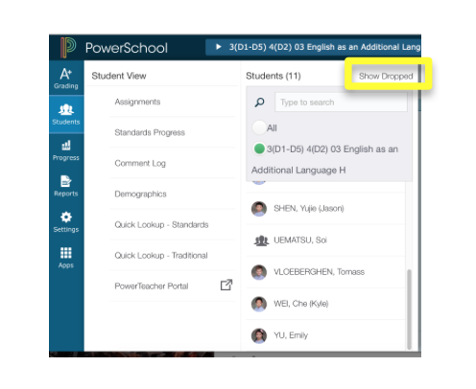

Hand reports to the following coordinator:
Melissa - Years 2 & 5
John - Years 3 & 6
Andrea - Year 1 & 4

Sample Report Comments and Structure

The curriculum statements, which are generic for every student in the year level, are highlighted yellow below – they should not be highlighted in your reports.

Topic

Comments should include:
- An introduction comment summarising overall achievement
- Attitude to Topic
- Strengths and weaknesses in the context of their skills – one sentence related to Science and one for Social Science.
- Next steps

Character count: 450-600. This does not include the curriculum statement.

This semester in Topic, Year 4 have studied: Science units on the Body and Electrical Circuits, and Social Science units on Explorers.

Steven has achieved strongly in all of our Topic units this year. He enjoys working independently to develop his skills in previously unknown concepts. Steven can apply the scientific method independently to plan a simple experiment. He can explain why a source of historical evidence is valid or invalid. The next steps for Steven include recording his work in a more methodical fashion, so the reader can follow his thought processes.

Mathematics

Comments should include:
- An introduction comment summarizing overall achievement
- Attitude to Mathematics
- Mental Mathematics
- Strengths and weaknesses in the context of fluency, reasoning and problem solving: teachers must ensure that these terms are written in parent friendly language.
- Next steps

Character count: 550-750. This does not include the curriculum statement.

This semester in Mathematics, Year 3 have studied: number and place value, addition and subtraction, and multiplication and division.

Shu Yung has a very good foundation of mathematical skills. She has a positive attitude towards Mathematics and enjoys being challenged. Her mental calculation is quick and accurate, and she knows the 2, 3, 4, 5, and 10 times tables. She is able to choose and apply appropriate methods to solve problems within the four operations, although she finds division challenging. Shu Yung can confidently explain why she has chosen a particular method. She can solve one step mathematical word problems. The next step for Shu Yung is to work towards consolidating her knowledge of methods in division, by solving a range of division calculations and explaining her choice of method.

English/EAL

Comments should include:

- An introduction comment summarizing overall achievement
- Attitude to English
- Strengths and weaknesses in the context of speaking and listening, reading, writing, spelling and presentation - teachers must ensure that these terms are written in parent friendly language.
- Next steps

Character count: 550min-750max This does not include the curriculum statement.

This semester in English, Year 3 have studied: personal writing, instructions, playscripts and story writing.

Gabriella has made consistent progress in English, but continues to require individual support. She shows a positive attitude to reading and now we would like to see this attitude reflected more in her writing. She speaks clearly in class discussions, and listens carefully to the ideas of others. Gabriella reads aloud well and shows an understanding of what she has read. Her goal for reading is to develop her ability to make inferences. Gabriella tends to write in short sentences, so is being encouraged to be more descriptive in her writing. The next steps for Gabriella are to edit her work thoroughly and to start writing more complex sentences using a range of verbs and conjunctions.

Chinese

Comments should include:
- An introduction comment summarizing overall achievement
- Attitude to Chinese
- Strengths and weaknesses in the context of speaking and listening, reading, writing, and handwriting - teachers must ensure that these terms are written in parent friendly language.
- Next steps

Character count: 550-750. There is no curriculum statement.

Isabel has made steady progress in Chinese this semester, especially in her oral Chinese. She listens attentively and plays an active part in Chinese lessons. She has an interest in creating dialogues and actively participates in oral activities. Isabel is now able to speak and express her opinion using the correct pronunciation. She has also shown an improvement in her reading skills, although she needs to work on being louder. More reading practise will help Isabel to widen her vocabulary and enrich her imagination, so that she can use more descriptive vocabulary and language in her speaking and writing. With her continued hard work, she will continue to make further improvements.

Personal Development and Approaches to Learning

Comments can include:
- An introduction comment summarizing overall achievement and effort over the semester.
- Attitude to school overall.
- Social & emotional development/ friendships
- Have they taken on roles or responsibilities in the school.
- Behaviour: role modeling, demonstration of Helping Hands values or good character
- Curriculum or Character Awards received
- Commendations from specialist teachers
- Specific strengths and weaknesses that need to be mentioned – significant improvement or decline
- Next steps

Character count: 700-1000 . There is no curriculum statement.

Dana has made good progress and achieved a great deal this last semester. She is our class representative for the Student Council, a role she really enjoys. Her performances at our recent Curriculum Assembly and Christmas Concert were impressive. Dana works hard in class and is a kind and friendly student who has a good sense of humour. She needs to work on her presentation as well as consistently completing her work in the given time. In class she confidently shares her work with her peers and works well collaboratively. Dana can be relied on to try her best and should be encouraged to raise her hand more to participate in all class activities. We are confident of continued progress in the coming months.

