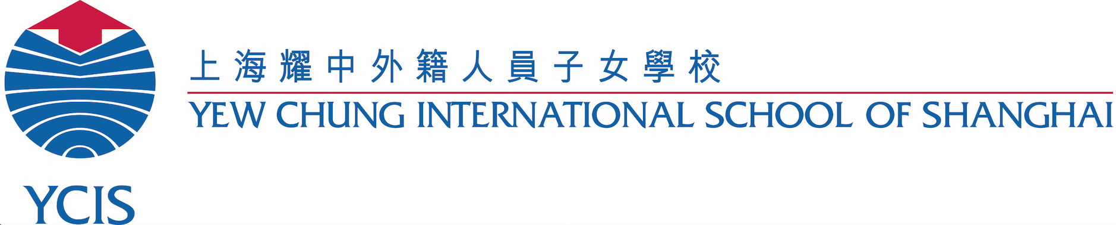

School Photographs for ECE and Y1-4 Students

Dear Parents,

The annual school photographs for the YCIS Pudong students at the Regency Park Campus will take place from October 14-16. Please see the individual class schedule below. See more details below.

Photo Schedule:

Monday, October 14 | Year 2 Students  Year 4 Students
Tuesday, October 15 | K2 Students  K3 Students  Year 3 Students
Wednesday, October 16 | K4 Students  Year 1 Students
On the assigned photo taking day, all students should come to school looking smart and wearing the formal school uniform. As the class photograph will also be taken, we would like consistency in what the students are wearing.

K2 Students - Please send them to school that day wearing smart/neat clothing.

K3 & K4 Students - YCIS sports shirt and blue shorts. Ensure running shoes are clean and paired with white socks. No dresses or school button up shirts.

Primary Students –Students should wear their cotton shirts and red blazers. Boys should wear their blue winter trousers. Girls can wear either their summer dress, winter skorts or their winter trousers. All students should wear their black dress shoes. If your child has PE on that day, it will be necessary for them to change to their sports uniform before/after their photograph has been taken.

Please note that the School Photographs will be arranged later this month, and parents will be informed of these nearer to the time.

Photograph Package Details

One photo package will be offered free of charge to every student at the school. There will be no need for online orders; we will simply send home a photo package for each student and it is yours to keep. There will be no additional photos available for purchase, but we will provide you with digital copies of the individual portraits so that you can arrange your own additional copies if required.

Please see below the package that each student will receive:

- ONE (1) class photo with frame - 5” x 7”
- TWO (2) individual portraits, including digital copy - 5” x 7”
- TWELVE (12) pocket-sized photos including digital copy - 1.5” x 2”

We will provide more information with regards to accessing the digital copies of individual photos at a later date.

Please contact our Office Administrators, Ms. Helen Huang helenh@sh.ycef.com (RP) or Ms. Elia Li elial@sh.ycef.com (CP) for any questions you may have.

Yours sincerely,
Damien Hehir Mary Yu Ray Zhang Co-Principal Co-Principal School Business Manager (Pudong)

亲爱的家长：
耀中御翠园校区 （幼教部和小学1至5年级）将于10月15日至17日、世纪公园校区 （6年级至13年级）学生将于10月26日和10月29日拍摄年度校刊照片。请参照以下各年级拍摄安排表。今年，我们很高兴将免费提供给每个孩子一整套校刊照片。更多具体信息请见下文。
拍摄日程安排：
10月15日，星期一 | 2年级，4年级A班和B班，以及5年级学生
10月16日，星期二 | 所有幼教部学生 – K2,K3和K4
10月17日，星期三 | 1年级，3年级，以及4年级C班和D班
10月26日，星期五 | 所有中学部学生 Y7 - Y13
10月29日，星期一 | 6年级学生，中学部因参加ACAMIS比赛而错过了周五拍照的学生

拍摄当天，请所有学生务必穿着整齐统一的校服来校，因为学生将拍摄班级集体照，我们希望学生们可以穿着统一。
幼教两岁班学生 – 拍照当天请穿着整洁。

幼教三岁班和四岁班的学生 – 请穿着耀中运动衫和蓝色短裤。确保运动鞋干净，搭配白色袜子。请不要穿裙子或校服衬衫。

小学部学生－需穿着校服衬衫和红色正装外套。男生需要穿着蓝色冬季长裤。女生可以穿着校服棉裙，或冬季裙裤，或冬季长裤。所有学生必须穿黑色鞋子。可能您的孩子尚未需穿外套，那么请您在孩子服装上写好班级姓名后，当天带到学校。 如果您的孩子在当天有体育课，他们需根据时间在拍照前后更换运动服。

中学部学生 － 学生需穿着校服衬衫，男生着蓝色长裤，女生着蓝色裙裤。所有学生必须穿正装外套，黑色皮鞋和白色袜子。 另外，参加10月24日至27日在北京举行的ACAMIS排球锦标赛的学生将在10月29日星期一拍照。

照片套餐细节
每个学生都将会收到一整套免费的校刊照片。无需上网订购，我们会将照片送到每个学生手里，让他们带回家给您保存。您也无需另外订购额外的照片，因为我们会提供电子版照片给每个学生，可以根据个人需要自行印制。
给每个学生提供的照片套餐中包括了：
- 一张班级照片附照片框 – 5” x 7”
- 两张个人照片（包括电子版） – 5” x 7”
- 12张钱包照（包括电子版） – 1.5” x 2”

我们将于稍后提供更多关于如何获取个人照片电子版的相关信息。
如果您有任何问题，请联系我们的学校办公室主任黄海云老师 Helen.huang@sh.ycef.com（御翠园校区）或李颖老师 Elia.li@sh.ycef.com（世纪公园校区）。

致礼！

何大明 俞珉 张锐
校长 校长 学校业务经理（浦东校区）

