Guidelines for Taking and Uploading Photographs
ECE & Primary

Objective:
To ensure good quality photographs of major school events are taken and made available to our whole school community. These photographs will also be used for our internal and external marketing of the school (such as YCIS School Newsletters, WeChat articles, Smugmug site, Yearbook, etc…)

Smugmug – School Photo Galleries:
Smugmug is the place where we showcase our school events and provide good-quality photos for marketing use. The ECE & Primary Coordinators are responsible for uploading photos to this website. However, we need the help of teachers to ensure that quality photographs have been taken and saved into the relevant network folders.
Website Link: Click here (Password for accessing: pudong21)
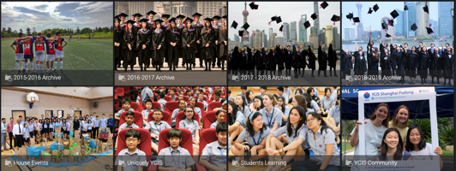

Guidelines for Taking and Storing School Photographs
- Staff members who have been assigned photographic responsibilities for events will be notified by a CLT member.
- Please post a maximum of 30 photos per event (some of the smaller events will consist of fewer photographs).
- Once the event has taken place, the staff member is responsible for saving the photographs onto the Year book server
- The folders are expected to be named clearly with the event name, and labelled as yellow for waiting for uploading.
- Though formal and informal photos are acceptable, please be selective that the photos you choose positively represent the students and school. Ensure facial shots if possible so students can be recognized. Please see the sample photographs below for further guidance.
- Once the photographs have been saved onto the yearbook server, then please inform the ECE & Primary Coordinators.
- The ECE & Primary Coordinators will then upload the photographs onto SmugMug
- Rob/Helen will then ensure the link is included in the weekly parent email.

Student Privacy & School Safety
- All parents/guardians have been asked to sign a consent form allowing their child to be photographed or videoed while taking part in school activities. This year, all the parents have given the school permission to use their child’s photos for school marketing or publication purposes.
- When selecting photos, avoid choosing photos which may be seen as infringing on student privacy or safety. Please do not take or upload photos of students in swimsuits. Photos of students swimming in the pool or photos of students covered up before or after a swimming race are acceptable.
- As explained in our Child Protection Policy and Procedures, photos of YCIS students should not be put on personal social media sites or apps by members of staff.

Sample photos:
- Excursions:  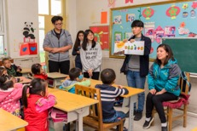 | - Performing Arts:
- School Events:  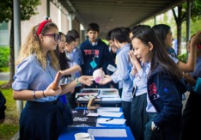 | - Clubs:  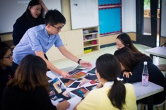
- Lessons: | - Sports:
- Assembly： | - Photos regarding privacy:

