Olivia’s Place
http://www.oliviasplace.org

Pudong Clinic (浦东):
1868 Pudong Avenue, 3rd Floor, Pudong New District, Shanghai
上海市浦东新区浦东大道1868号东方城市大厦3楼
- Phone: (8621) 5404-0058; 5404-0059
Email: intakesh@lih-oliviasplace.com

Hours of Operation:
Monday – Friday, 9:00 am – 6:00 pm /
Saturday, 9:00 am – 5:00 pm
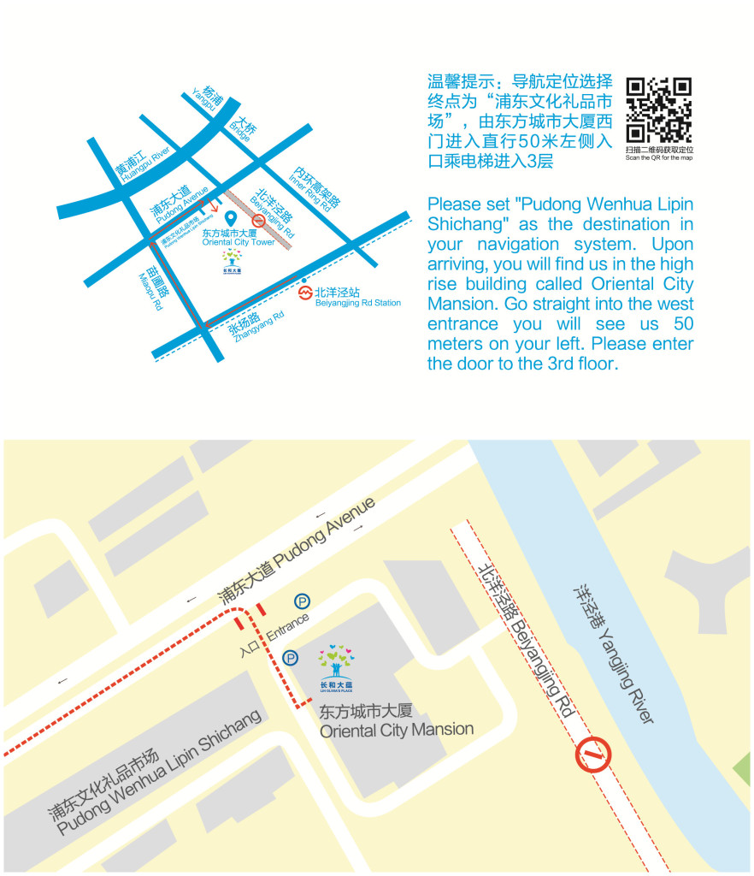
Essential Learning Group (ELG)
http://www.chinaelg.com

Client Hotline: +86 4006 129 423
Main Office: +86 21 5206 6273
Email: services@chinaelg.com

