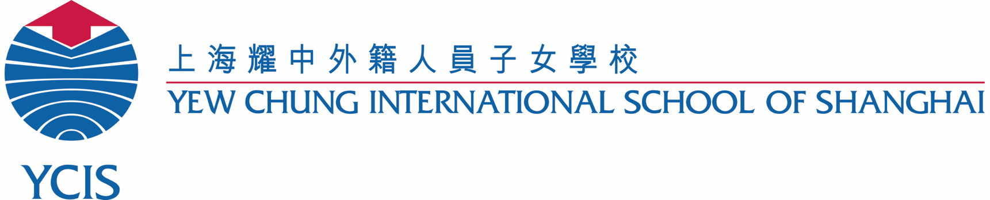

Learning Support Assistant Policy

Procedures & Agreement

Learning Support Assistant Screening Process/ Procedure

- YCIS can provide a list of approved LSAs that have worked with the school in the past. It is the parents’ decision to choose from this list or find an external LSA candidate. The LSA candidate will then meet with a member of the Student Support Team to determine suitability for the child's needs. The school resreves the right to decline any LSA candidate if deemed not suitable for the role or child’s needs.
- Once a Learning Support Assistant has been chosen, they will receive a short training on the school’s Adult Code of Conduct and Child Protection Policy. This is required, and especially important for external candidates who have previously not worked within the school.
- The Learning Resource teacher/ECE Student Support teacher will communicate the needs of the student and strategies that will assist in the student’s progress.

Please refer to the Learning Support Assistant Agreement below for further guidance. The Learning Support Team, School Counsellor and the Student Support Coordinator can all be of assistance should there be any concerns or questions regarding Learning Support Policy.

Learning Support Assistant’s Role
- Provide individualized or small group support to a student, as directed by the class/specialist teacher.
- Supervise the student during teaching time, and assist with the completion of group or individual tasks.
- Assist the student to understand the material and the learning task for the lesson.
- Under the direction of the teacher, implement any behaviour management procedures, or social-emotional learning strategies.
- Provide social/emotional support in the classroom and/or playground, if required.

Responsibilities
- Report to the assigned Learning Resource/ECE Student Support teacher and/or the Student Support Coordinator for your campus.
- Attend designated class and specialist lessons with the student, and lunchtime or play time if needed – alternate breaks will be scheduled for the Assistant, if required.
- Translate, interpret or clarify the teacher’s instructions in the classroom.
- Accompany the student to all designated lessons, as instructed by the class teacher.
- Support the student according to the specific directions of the supervising teacher.
- Communicate directly with the class teacher, who will maintain responsibility for all communication with the parent/s regarding the student’s progress and any areas of concern.
- Communicate directly with the parents regarding issues such as absences, payment and any short or long-term changes made by the school to the support schedule.
- Communicate absences with the school.
- Abide by the YCIS employee Code of Conduct
- As part of the YCIS Child Protection policy, the Learning Support Assistant is not permitted to take photos of any child with his/her personal device.
- Take part in any training that is deemed relevant by the school.
- Once the LSA has agreed to a support schedule, the LSA must stay committed to those support hours and not accept supply work during this time.

Teacher Responsibilites
- Communicate emotional, behavior and academic needs/progress to the parents.
- Communicate daily with the Learning Support Assistant
- Direct the Learning Support Assistant with appropriate behavior/emotional strategies and academic activities

Parent’s Responsibilities
- Negotiate fair remuneration for services provided by the Learning Support Assistant. The recommended reimbursement is 200RMB per hour for non-certified teachers and 250 RMB per hour for certified teachers.
- Discuss all academic and behavioural progress and concerns with the class teacher(s) directly.
- Inform the Learning Support Assistant in advance of any current or impending absences from school.
- Should the parent wish to replace the Learning Support Assistant, it should be arranged without gaps in service.

Requirements and Additional Information
- The Learning Support Assistant must be available for flexible and changing scheduling, depending upon the student's needs.
- There will be an initial trial period, followed by a review meeting to determine the success of this arrangement. If deemed successful, then Learning Support Assistant will continue in the role after the review.
- All information/observation regarding all other class children, teachers and YCIS intellectual property is strictly confidential and should not to be discussed with any other persons.
- The school, the parents and the Learning Support Assistant have the right to terminate an arrangement at any time, with reasonable advance notice (2 weeks).
- The actual daily schedule (including break times) will be determined by the Learning Resource/ECE Student Support Teacher in consultation with the class teachers.

We have read and understood these guidelines and agree to follow these procedures.

__________________ _____________________ __________________
Parent LR / ECE SS Teacher LS Assistant

___________________ __________________
Class Teacher Class Teacher

Date: _____________________

