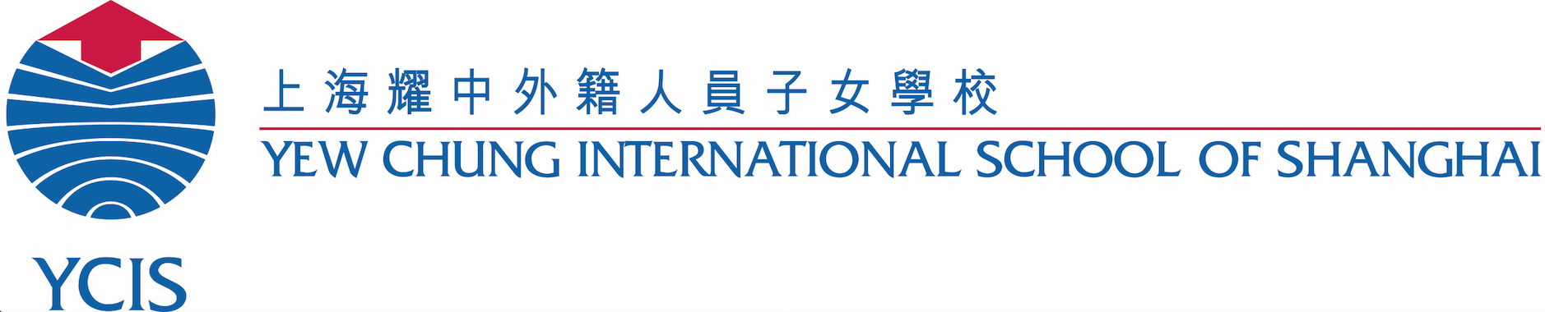
Confidentiality Agreement for Classroom Observation
YCIS Shanghai Pudong

Name of Observer: | Agency:
Student to be Observed: | Class:
Date of Observation: | Time of Observation:
Reasons for Observation:

- I shall protect the rights to privacy of all students, and, therefore, shall not share information about any other students in the classroom orally or in writing.

- I shall restrict my observation and comments to the behaviours of the student being observed. I understand that the purpose of the observation is not to critique the performance of the teacher or observe other students.

- I shall obtain all additional information (i.e., completion of forms, questions specific to the student, etc.) outside of classroom observation via email, follow-up conference or phone with the appropriate staff member, to minimize disruptions to the learning environment.

- I shall follow the School’s Child Protection policies and procedures and sign the ‘Code of Conduct for Working With Students (Community Partners)’ document.

- I understand that I am not to take videos/photos at YCIS unless prior permission from the Campus Leadership Team has been granted.

- I understand that access to student records shall require a signed written consent from the parent/guardian in accordance with the School’s policies and procedures.

- I understand that all classroom observations must be scheduled at least two weeks in advance with the Learning Resource Leader (Primary) or the Student Support Teacher (ECE), in accordance with the School’s policies and procedures.

- If I have any questions concerning the procedures for classroom observations or compliance with this Agreement, I shall direct them to the Learning Resource Leader (Primary) or the Student Support Teacher (ECE).

- When producing the final written report for the assessment, I agree to refer to ‘teachers’ in a general sense and not quote individual teachers by name.

I have read and understood these guidelines and agree to follow these procedures.

- Observer Signature                   Date

Please hand a signed version of this form to the Learning Resource Leader (Primary) or the Student Support Teacher (ECE) before carrying out any testing at YCIS Shanghai Pudong. Updated 08/18

