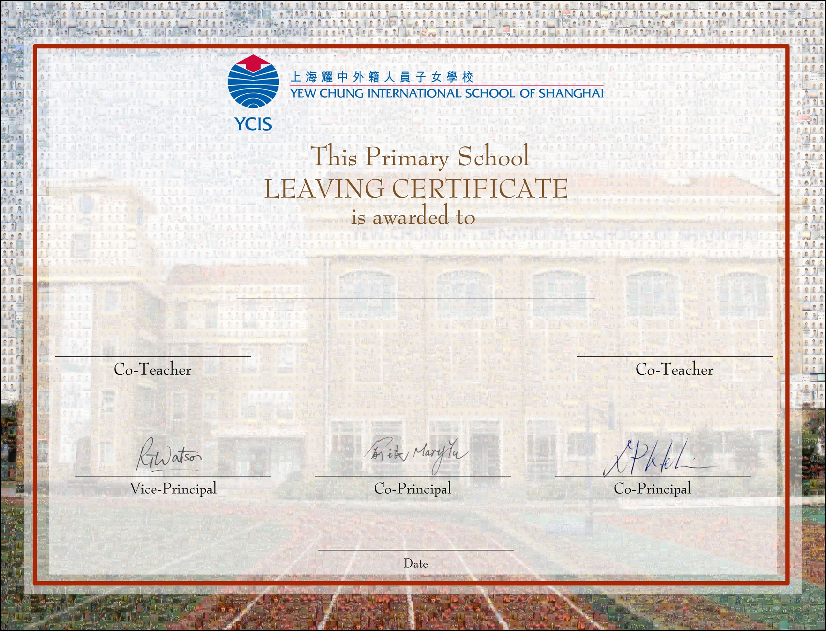

XXXXXXXX

XXXXXX