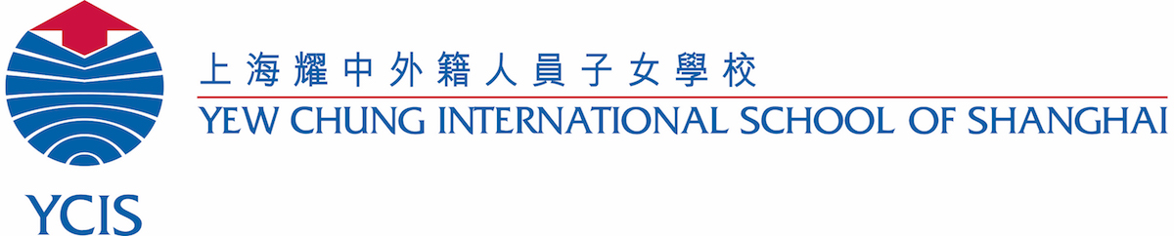

Schedule for Staff In-Service Day – Monday 7th January 2019

Morning sessions for Everyone (RP):

Time | Activity | Location | People
8:00 – 8:30 | Arrival / tea & coffee | RP Cafeteria | All
8:30 – 9:00 | Professional Learning  at YCIS Pudong | RP Gym | SS, MS, AY & AC  to lead
9:00 – 10:00 | Developing YCIS Pudong  Definition of Learning | RP Gym | LC / LP Committee  to lead
10:00 – 10:30 | Tea & coffee | RP Cafeteria | All
10:30 – 12:00 | Developing YCIS Pudong  Learning Principles | RP Gym | LC / LP Committee  to lead
12:00 – 13:00 | Lunch  Buses depart RP for CP at 12:45 | RP Cafeteria | All

Afternoon sessions for ECE (@RP):

Time | Activity | Location | People
13:00 – 14:30 | Gender Equality: Reducing Unconscious Bias | ECE Library | All ECE
14:30 – 15:00 | Afternoon Break | Courtyard | All
15:00 – 16:15 | Team Meetings | Classrooms | All ECE
16:30 | Staff Bus Depart | RP | As needed

Afternoon sessions for Primary (@RP):

Time | Activity | Location | People
13:00 – 14:30 | Gender Equality: Reducing Unconscious Bias | Auditorium & Classrooms | All Primary
14:30 – 15:00 | Afternoon Break | Courtyard | All
15:00 – 16:15 | PBL – Unit Planning | Auditorium | All Primary
16:30 | Staff Bus Depart | RP | As needed

Afternoon sessions for Secondary (@CP):

Time | Activity | Location | People
13:00 – 14:00 | Developing YCIS Pudong Guiding Principles for Home Learning | CP Staffroom | All
14:00 – 15:00 | Department Meeting 1  Chinese 302; English 201; Math 225;  Art 103; PE Gym | CP Various | Depts
15:00 – 15:15 | Afternoon Break | CP Staffroom | All
15:15 – 16:15 | Department Meeting 2  Social Sciences 416; D&T 127; Computing 425; Science 325; Music & Drama 525 | CP Various | Depts
16:30 | Staff buses depart | CP | As needed

