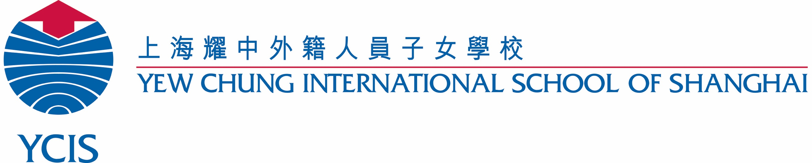
Character Education 2015.16
Regency & Century Park
Character Education: Sept-Oct– Availability

Class: ________

Philosophy & Objectives:
- Provide a holistic education that nurtures the whole person;
- Promote multiple-intelligence development to allow students to develop their own individual talents;
- Uphold moral and spiritual values based on Christian faith, affirming the worth and dignity of each individual while instilling in each student a caring attitude towards people and the environment;
- Nurture in each student an open outlook in life, respect for cultural diversity and the beliefs and values of all people, and a sense of commitment and social responsibility;
- Integrate high technology, sciences and the arts to allow students to adjust well in a competitive global society;

Key Concept:
Understanding the importance of showing good character within your family, circle of friends and school.

Availability: (Giraffe)  Availability is being ready to help.  随时待命就是随时准备提供帮助 | Thinking Tools:  Balloon facts  Brainstorming web  KWL-chart | Week 6 – Week 9  24 September 2018 – 19 October 2018
Key Understandings:  Students will understand that…  - Availability requires working together for the common good  - Availability requires you to find ways to help others.  - Availability requires good communication  - Availability requires a positive attitude | Essential Questions:  - How can you show availability at home or at school?  - Why is it important to show availability?  - How can you give some of your time to others?  - What can you do to make new friends feel welcome?  - How can you show availability when making friends? | I will statements:  - I will find a way to make a difference.  - I will be ready to help.  - I will accept new people as my friends.  - I will give of my time to others.
Activities:

- Read and discuss the story of the ‘Giraffe’ page 4&5 of the Character First Manual file: “Giraffe.pdff”
- Read and discuss the story of availability in History, ‘Remember the Alamo’ page 6&7 “Remember the Alamo.pdf”
- Copy the I will statements
- “I will be ready to help” (write/draw)
- Availability word trace Y1-Y2
- Availability word chart/ word card/ vocabulary box
- Opposites: Availability vs self-centeredness
- Write a poem about a giraffe
- Various Giraffe writing templates to write about Availability or Giraffe facts
- Availability song/poem

Chinese Culture:  The Seven Chinese Brothers by Margaret Mahy, Mou-Sien Tseng  Once upon a time in China there lived seven brothers who walked, talked, and looked alike. Each one possessed an amazing power all his own. But it is only when the brothers combine their special powers that they fool Ch'in Shih Huang, the cruel first emperor of all China, and save each others lives.  Script to act out in class. | ICT:  - Design a poster on ways that you can make a difference.  - Research fun facts about giraffes |  | Science Activity: Great Potential (CF, p.9)  Relating potential and kinetic energy to availability.  Potential energy is stored energy that is available to do work. Kinetic energy is the energy of movement which results from work being done. The two forms can be converted back and forth from potential to kinetic and back to potential energy again.  Supplies:  Rubber bands  (A stretched rubber band is full of potential energy. Once released, that potential energy becomes kinetic energy as the rubber band shoots across the room.)  Balloons  (A balloon stores energy when it is blown up. Once released, the pressure of the stored air propels the balloon around the room.)  Large rock (represent boulder)  A rock perched on the edge of a table contains potential energy. When pushed over the edge, gravity converts the potential energy into kinetic energy as the rock falls. The bigger the rock and the longer the drop, the greater the potential energy that can be converted to kinetic energy.)  Applications:  - Availability is like energy in its potential state. It is a person with skills and a willingness to serve waiting for the right opportunity. When the chance comes, availability turns stored energy into kinetic energy that gets things done.  - Find out how big of a rock or how long of a drop is required to crush a foam cup. Remember that the availability of potential energy can be dangerous as well as beneficial. E.g. helping a friend cheat or steal doesn’t help – it hurts.
Arts and Crafts:  - Giraffe colouring sheet  - Origami Giraffe  - Giraffe mask  - Cut out and make standing giraffe  - Cut and stick the giraffes from shortest to tallest  - Blank giraffe template to use as needed | Extra PE (Teambuilding):.  An activity for students to get to know each other better, understand their differences, and make new people their friends.  Ask each child to draw around one of their hands and cut out the resultant outline. Using the ink pads, each child makes prints of their fingers and thumb in the relevant places on their paper cut-out. Let the students compare the different patterns of their prints with those of a couple of other students. Ask each child to write their name and 3 things they use their hands for on the palm of their cut-out; e.g. writing, catching balls, holding books, etc. Bring the students together in a circle and put all the cut-out hands in the centre. Ask a volunteer to choose one at random. Ask them to read out the comments, excluding the name, and see if students can guess whose hand it is. Repeat with others.  Talk to students about similarities and differences in their hands.

