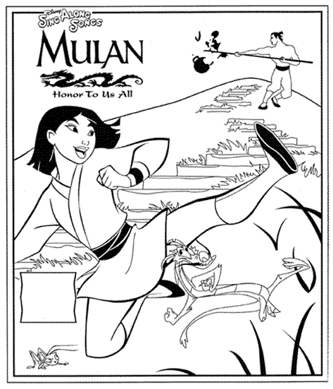

Write a sentence below to explain how Mulan showed loyalty to her family.

______________________________________________________________________
______________________________________________________________________
______________________________________________________________________

Explain how you can show loyalty to your own family.

______________________________________________________________________
______________________________________________________________________
______________________________________________________________________

