Sports (Non) Experts 2017
April 13 – June 3

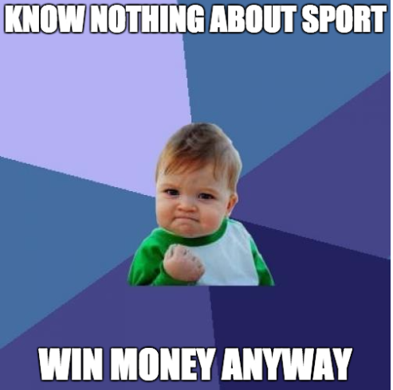

That grey area between Qing Ming and the end of the year is coming up. Need something to look forward to every week? Well this is it!

For those of you who are new to the wacky world of sports punting the rules are simple:

- Each week you will be sent an email with 8 sporting events. Your job will be to guess the outcome of these events

- At the end of the competition the top 5 competitors will win a share of the prize money (Last years winner walked away with 1000RMB)

- Every week the player(s) with the top score will win a share of 200RMB

- There is a party at the end of the competition for us all to celebrate (or drown our sorrows)

If it sounds like you might be interested:

1. Email cathal.grimes@sh.ycef.com with your intentions of taking part.

2. Pay your 200RMB fee to Cathal Grimes at CP. (I accept WeChat payment also)

3. Wait for the first week of tipping to begin and let the money roll in.

If you would like any more information please contact me and I’ll be sure to give you more details.

Best of luck!
How to play

Answer the given questions. For example:
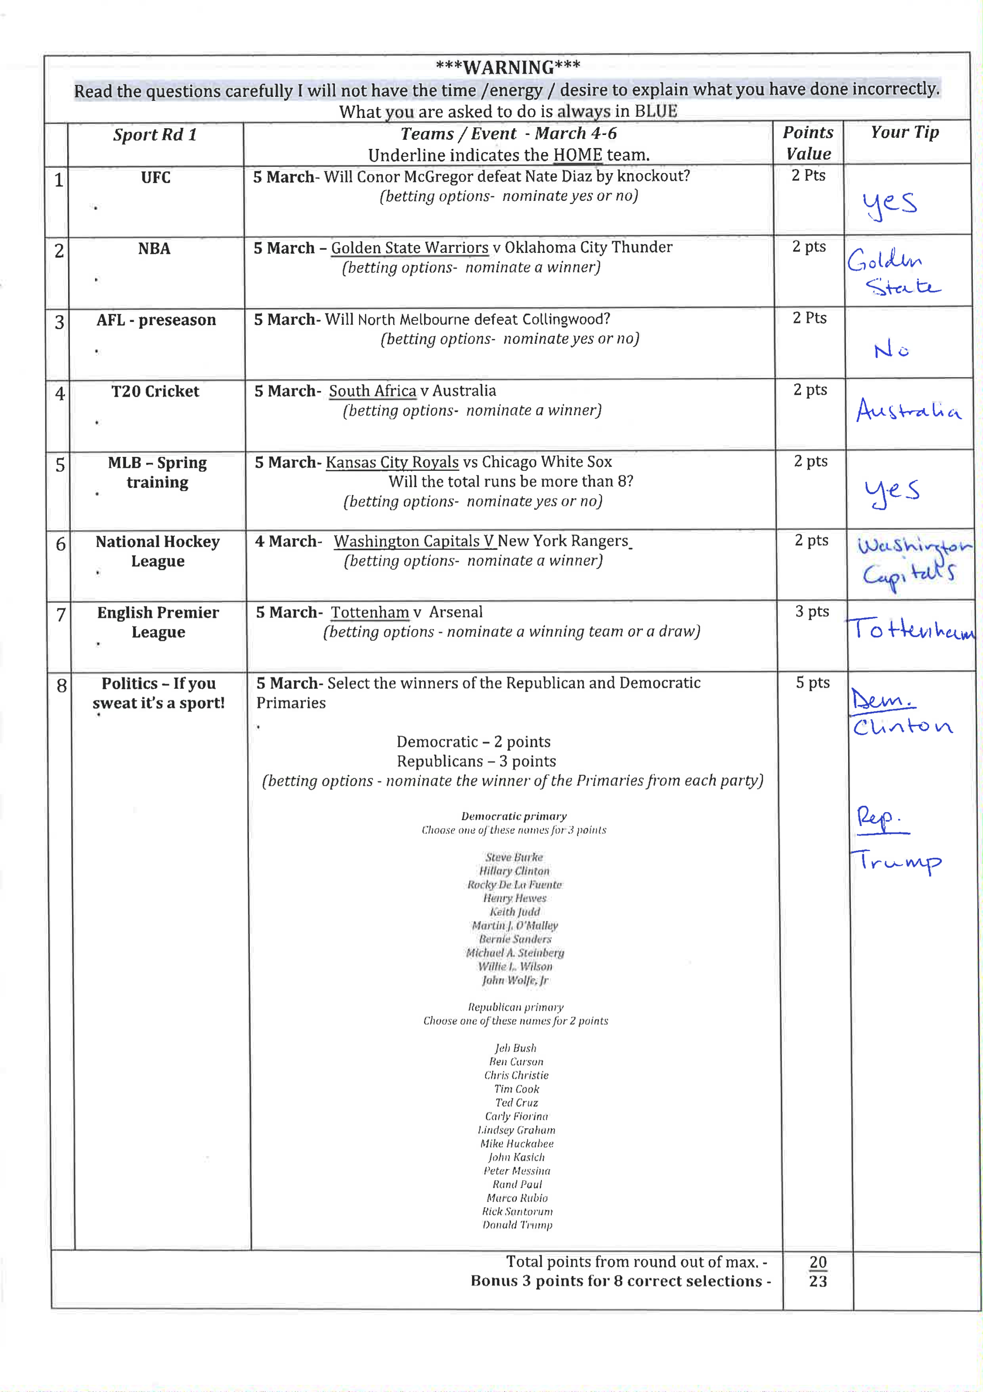
Then hope that your answers are better than everyone else’s! Every week the player(s) with the top score will win a share of 200RMB.

It’s easy. It’s fun. What are you waiting for?

