Student Led Conferences
‘My Learning Journey’

Guidelines 2017-18

Regency Park Campus –Thursday March 29, 2018

Century Park Campus – Thursday April 26, 2018

Rationale for Student Led Conferences
Student led conferences involves a two-way conversation, between a student and their parents. Students lead the conference, and discuss their learning in different curriculum areas, using relevant assessment information, demonstrations of skills, explanations of process and progress, work samples and projects as evidence of learning.
Student-led conference allow students engage their parents in a range of interactive activities, designed to demonstrate current skills, knowledge, and understanding of their learning.
Dr. Cherie Taylor-Patel, 2011

The benefits of SLCs
- SLCs allow children to take ownership over their learning and their work and lead the conversation with their parents.
- It allows students to share authentic learning with their parents in the form of showing their work as well as demonstrating skills and concepts they have learned. It is highly motivational for children.
- It is an opportunity for them to be self-reflective and evaluate what they have achieved and what they need to continue to work towards. Encouraging all stakeholders to engage in open and honest dialogue.
- SLCs facilitate the development of students' oral communication skills and to increase their self-confidence.
- It increases parent understanding of how they can further support their child at home.

Organisation
- SLCs will be organised as interactive centres with students engaging parents in various activities covering different areas of the curriculum. Some activities can be stationed at the student desk and/or others can be organised around the room.
- Activities can take the form of games, demonstrations, work samples, videos etc that demonstrate students’ application of skills, as well as knowledge and understanding.
- Activities should be linked to what the students are currently or have recently studied.
- Teachers are encouraged to share the preparation of activities between the team.
- All activities must have an explanation/student prompt with the learning outcomes.

Expectations for subject areas:
English or EAL | Writing: Children can share a piece of writing at their desk with their parents. What have been some of their goals that they have been working on in writing? What progress have they made?  Reading (optional): Students can share their reading progress with parents or a particular area of focus that has been studied during Guided Reading.  EAL work will be shared in the classroom, but prepared by the EAL teacher.
Mathematics | What skills would you like to highlight in this centre? Make use of whiteboards, games, manipulatives, ipads etc While games can be engaging and fun, the primary focus is that students can apply and show an understanding of strategies they have learned.
Chinese & Chinese Studies | Children can share a piece of work, reading or an activity with their parents. This must be prepared by the Chinese language teacher.
Topic (Science or Social Science) | Consider the most recent unit of work the children have studied or are currently studying. What hands on activities have been completed in class that can be replicated in this centre? For example, a simple experiment to demonstrate knowledge of the scientific method or activities that compare and contrast. Children can also present a project that they have completed in class.
Seesaw | This centre highlights activities from specialist classes. Specialists are required to make a post of a recent unit of work. This can be approved just before SLCs. Students can discuss these posts with their parents.
Art Show | Together with parents, students can go to the Art Show. They can highlight a project they enjoyed and explain what they have learned through the project.

Differentiation
- When teams are developing learning centre activities, differentiation of activities must be incorporated. This is an excellent opportunity to show parents how we are able to meet the needs of all our students in our class. For example: If the Mathematics centre is highlighting word problems, children should have available different strategies that they can call upon to solve the problem, such as use of manipulatives, numbers lines, TIPS framework etc etc The types of word problems should also be differentiated so that children select one that is appropriate to their level.

Technology
- Opportunities to show how technology is integrated into any subject are welcome. This can be discussed with Amita and Alex and can be incorporated into one of the centres as appropriate. ICT specialists will be responsible for setting up any activity centres that are specific to technology related software or tools, for example Bee-Bots, Sphero or Scratch.

Student Information
- Students who commence school after Chinese New Year or even closer to the date of SLCs can show their parents their notebooks/journals or perhaps talk about a book/novel they have been reading. They can show their parents around the classroom and even work together on some of the learning centre activities. Co-teachers will need to notify parents ahead of time.

Some examples of Interactive Centres
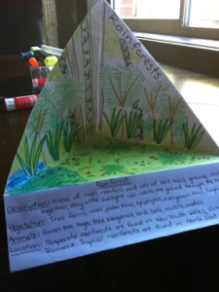
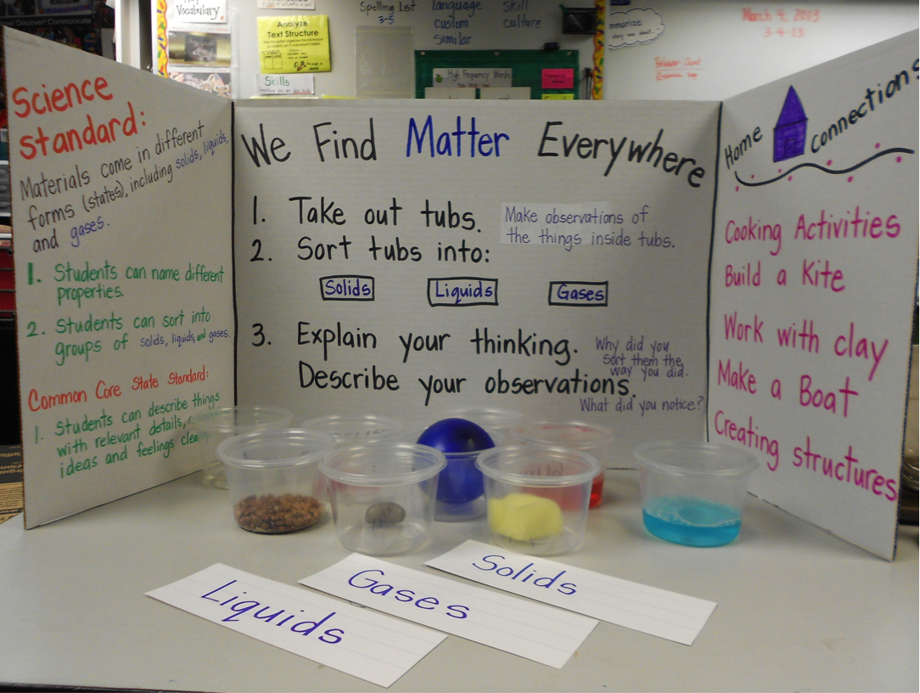
Science

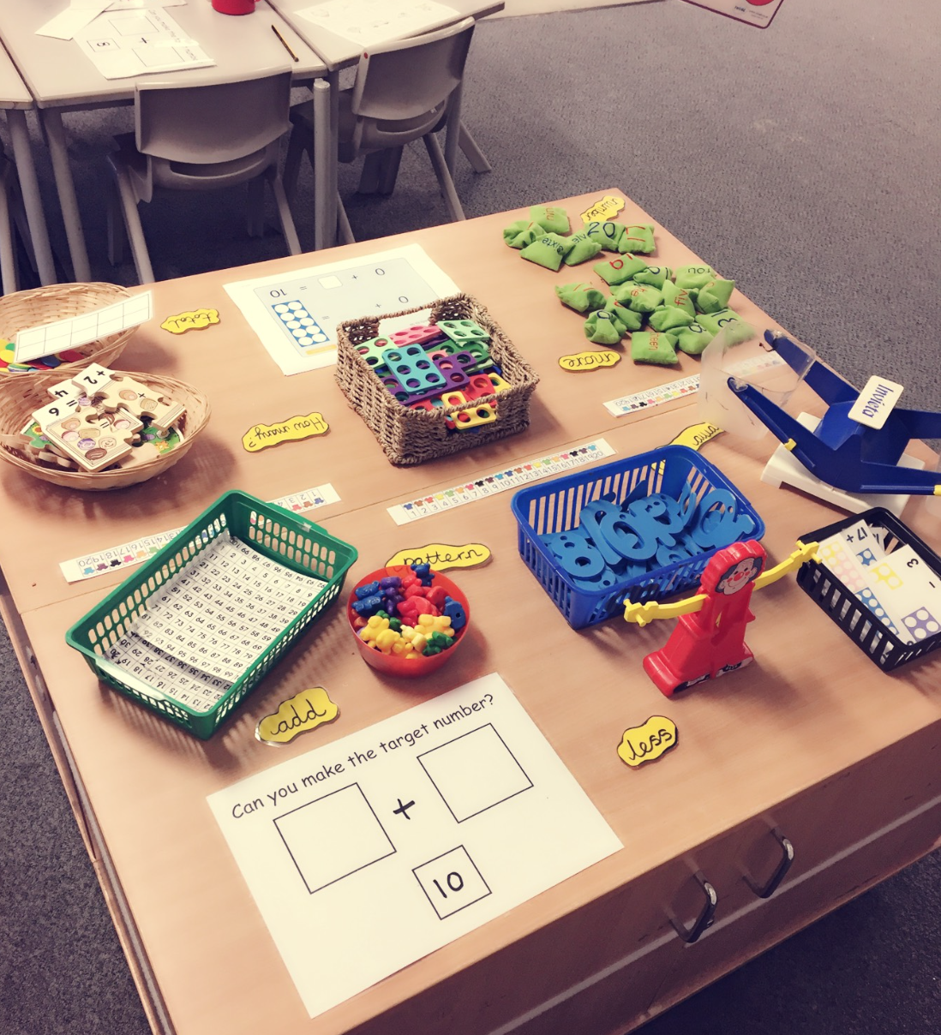
Mathematics
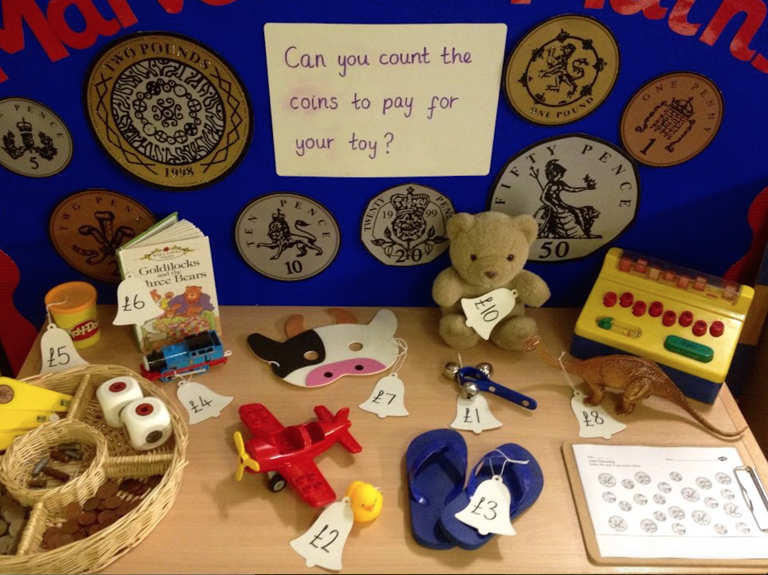

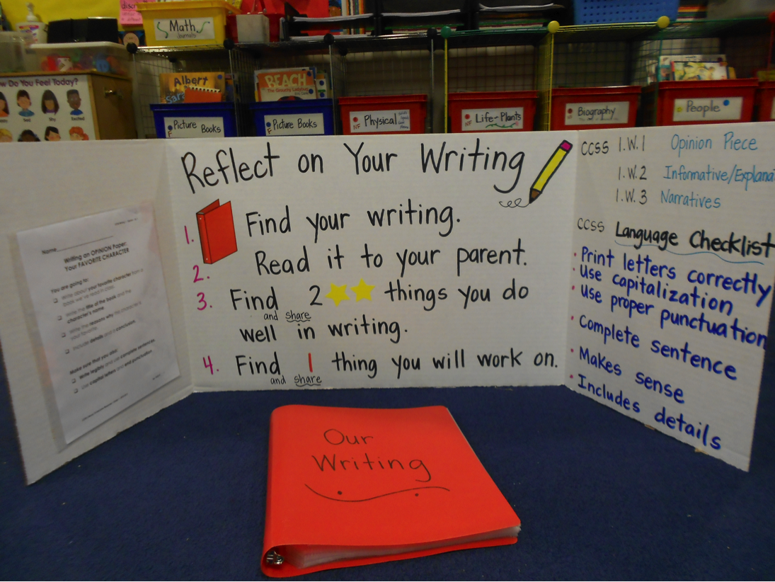
Reading Writing
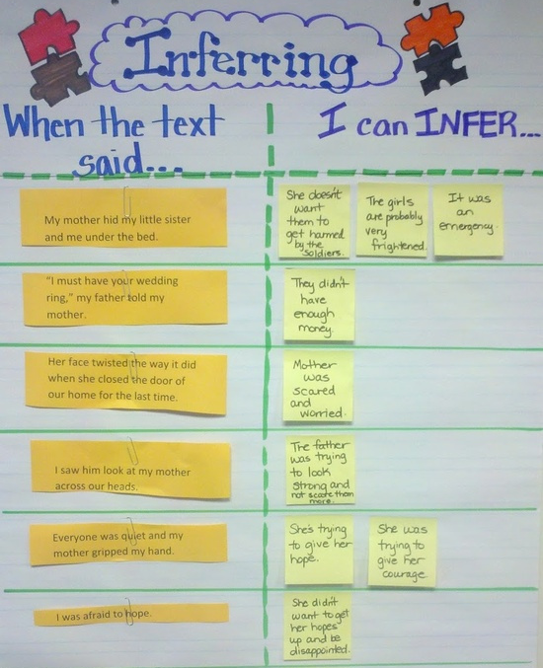

Chinese & Chinese Studies
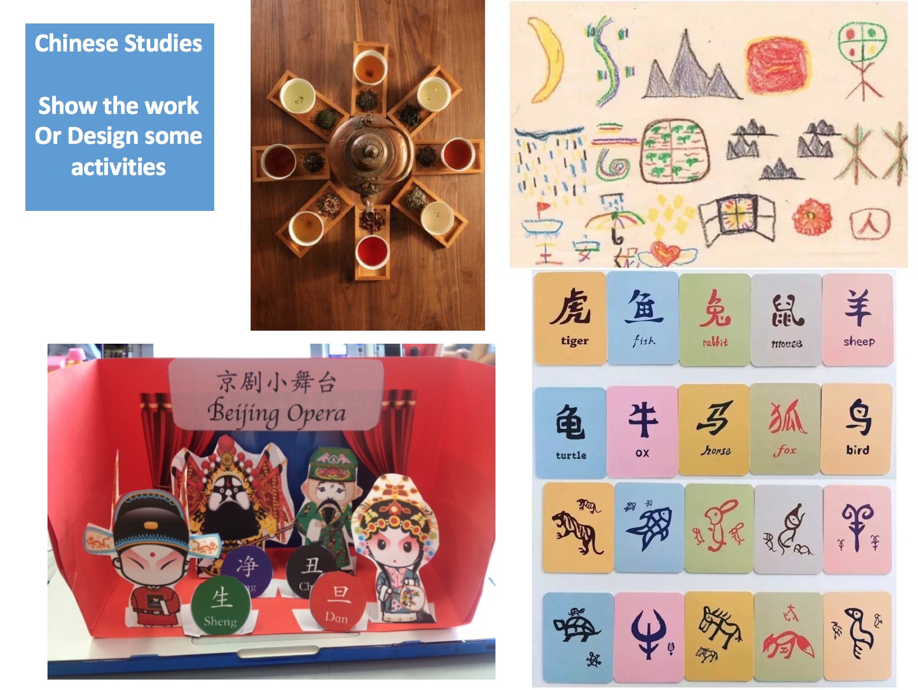
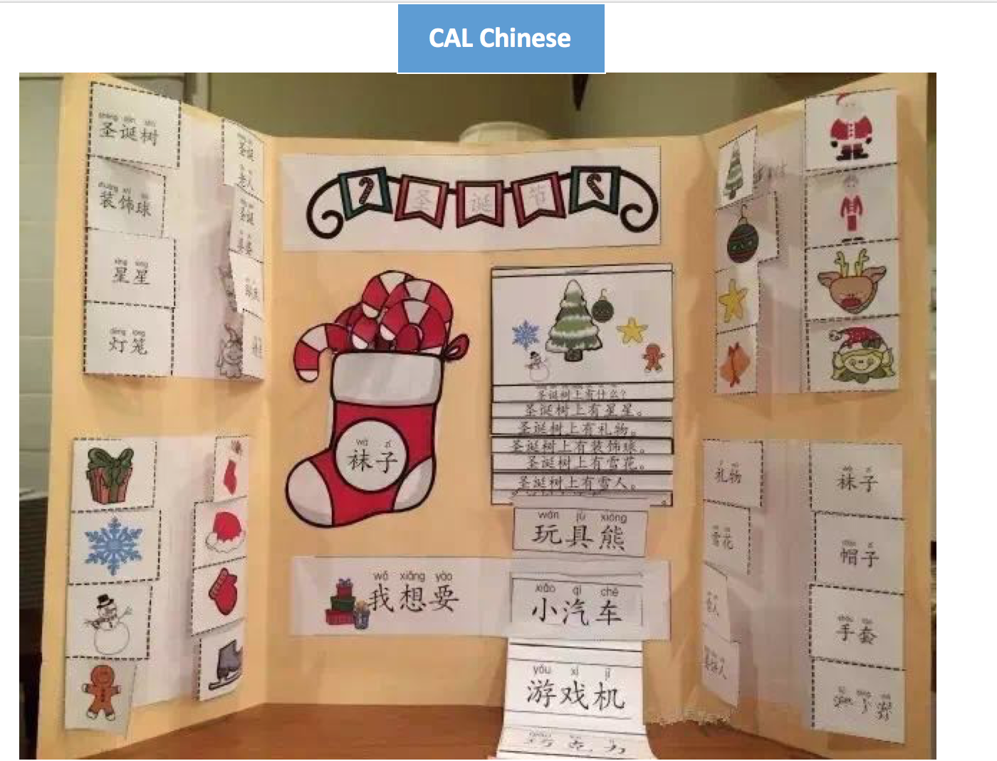
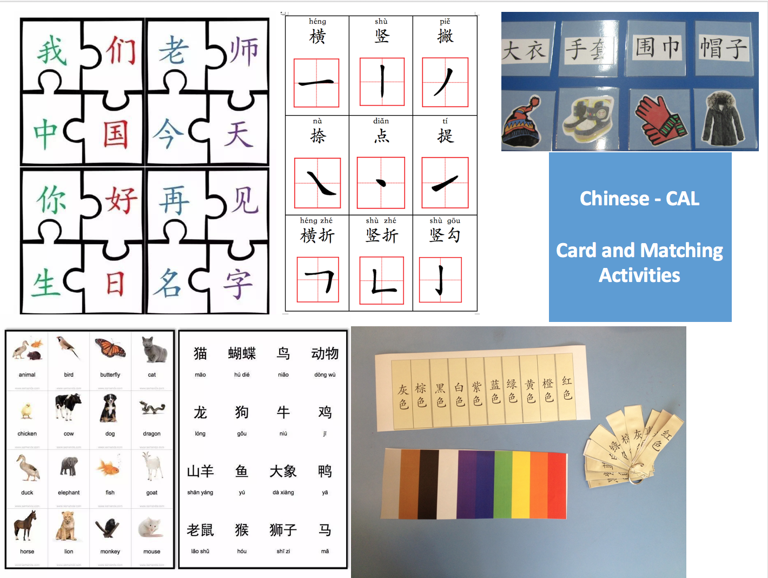
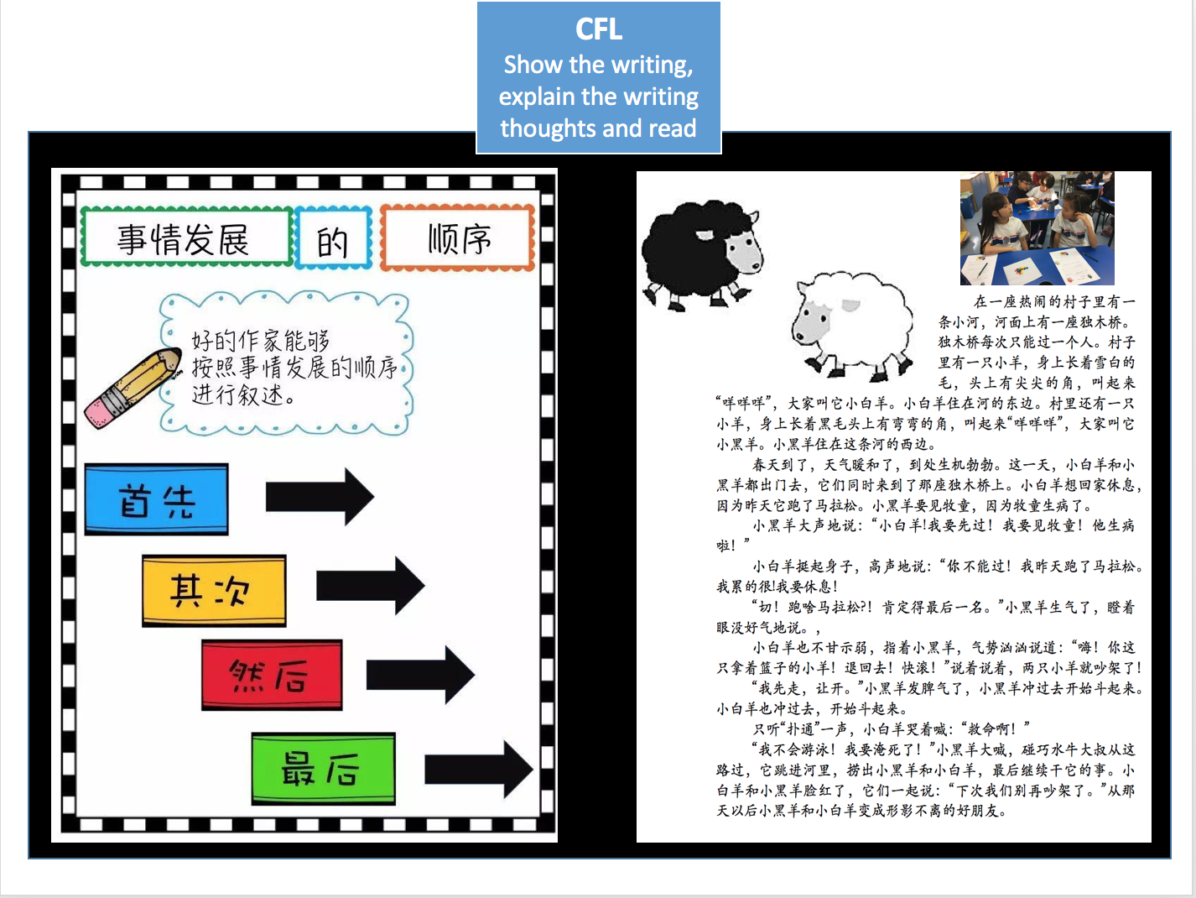

Logistics

Laptops
- Class ipads can be utilized for Seesaw activities or project presentations.
- Teacher laptops will be utilized during the afternoon. If teams need additional laptops, please see Amita.

Timeline
Dates | Action Points
Monday, March 12 (Wk 26): | During this week, teachers explain process of SLC during Pastoral Care Assemblies.
Monday, March 19,  (Wk 27/28): | Learning Centre activities prepared and finalized (including EAL/specialists)  Students to practice as needed.
Wednesday, March 21: | Draft Progress Reports for new students who commenced between Weeks 17-24. Melissa (Y1-5)
Thursday, March 22: | Melissa to pass back draft progress reports to teachers
Monday, March 26: | Office to print progress reports and pass to teachers with envelope
Tuesday, March 27: | Send home Progress Reports  Office to send final schedule out to teachers
Wednesday, March 28: | Class teachers to send pick-up note to parents to indicate pick-up location at the end of day.
Thursday, March 29: | SLC Day!

*The schedule for the day, amended duty rosters and where children will be placed while they wait for their SLC will be shared closer to the date. Teachers supervising year levels will also be notified ahead of time.

