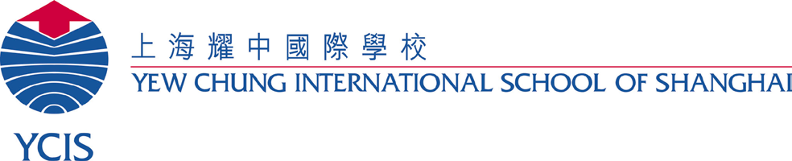

Tuesday, September 19, 2017
2017年9月19日星期二
Dear Parents,
亲爱的家长：

International Schools’ Assessments (ISAs)
国际学校学生评估测试(ISAs)

On the mornings of Tuesday 26th September and Wednesday 27th September, all Year 4-10 students will be taking an International School Assessment (ISA). These ISA tests form part of an annual assessment programme that has been specifically developed to measure skills in Mathematics, Reading and Writing of students attending international schools.
9月26日星期二上午和9月27日星期三上午，所有四到十年级学生需要参加国际学校学生评估测试 (简称ISA)。这些ISA 测试是年度课程评估的一部分，用于测试国际学校学生的数学、英语阅读和写作水平。

We will pass on the information about your child’s results to you in the form of an individual report in Semester 2. These reports provide descriptive information about what students know and can do in Mathematics, Reading and Writing. As a school, we will also analyse all data about the general patterns of performance and use these as a way in which to monitor and modify our educational programme.
我们将会于第二学期就学生们的测试结果给到家长相关的报告单。这份报告将向您提供您的孩子在数学、英语阅读和写作领域中处于何种水平的信息。作为学校，我们也会根据这些数据作为参考来检测和修改我们的教育课程。

Please note that these tests are designed to give a snapshot of your child’s capabilities in each of the areas mentioned above. It is not necessary or indeed possible, for your child to ‘revise’ for these tests. We ask that you please do not place unnecessary pressure on your child in relation to these tests.
请注意这些测试旨在评估学生在相关学科领域的各种能力，因此无需进行专门的复习，我们希望您不要因为此次测试给予孩子不必要的压力。

Attached to this letter is a privacy statement from the International Schools Assessment directors.
另外附上国际学校学生评估测试（ISA）委员会发布的声明。

If you would like more information regarding the ISAs, please feel free to visit ACER (https://www.acer.edu.au/isa) and/or the PISA website (www.pisa.oecd.org)
如果您想获取更多关于ISA的信息，请访问ACER网站 (https://www.acer.edu.au/isa) 或者PISA 网站 (www.pisa.oecd.org)

Regards,
此致，

Robert Watson Dusten Kent
罗博特 戴士霆
ECE & Primary Vice Principal Secondary Vice Principal
小学部副校长 中学部副校长

