Sports Day Itinerary

Year 2
Blue | Yellow | Red | Green
Ann Gavine (B) | Geoff Quirk | Elisabeth Liau (G) | Lina Fei
Rebecca Pearson (G) | Ada Shi (G) | Carrie Qian | Yuki Zhang(G)
Sophie Zhang | Kathleen Wu (B) | Jamie Hoel (B) | Lynn Xie
 |  | Diana Dai | Alex Tabunets (B)
(B)= Boys group during rotational activities. (Teacher for each house colour)
(G)= Girls Group during rotational activities. (Teacher for each house colour)
Year 3
Blue | Yellow | Red | Green
Joseph Dent (B) | Linda Zheng | Elena Granato (B) | Ann McCor (G)
Cathy Yang (G) | Teresa Li (G) | Vivian Bai | Jeannie Jackson
Tania Jordan | Anne Peters(B) | Mira Yu (G) | Anita Dai
 | Amy Chu |  | Ed Kitts (B)
2

Students Assistants
4A | 4B | 4C | 4D
Sungwoo Cho | Jun Kai Loh | Eli Chu | Alicia Bolstein
Adison Chow | Caden Tan | Claire Coquerel | William Kai
Elizabeth Shih | Wendi Wu | Brenda Kim | Alana Gartz
Sophia Tsives | Sharlene Yap | Ivy Wang | Antonio Teh

*Year 2 & 3 to snack prior to 10.15am sports day commencement. This will mean the year 2 students will have additional class time. Year 4 & 5 only will have a 10-10.15am recess.

Agenda
10.10am Water/hats/toilets/sunscreen …fingers crossed for good weather. Classes make their way to the field.
Students assemble in their designated colored areas under the shade structures.
10.15 Rehearse team chants – teachers to lead (noted below)

Can you feel it, it’s the hour, and the time for Panda Power – Rebecca Pearson
Turn up the music, what do you hear, Tribal Tigers give a cheer – Ed Kitts
One, Two, Three, Four, Dazzling Dragons hear us roar – Elena Granato
Shout it to the East, and the West, that Magic Monkeys are the best – Geoff Quirk

10.20am Opening Ceremony

Event 1 – Team Chants (Lennart/ Lynn Xie /Rob)

Event 2 – Running Races

When students are called for sprints can the following staff escort them to the starting line to coordinate their assembly and supervise them until they race. The other teacher will continue to supervise the remaining students.

Y2 | Anna Gavine | Geoff Quirk | Elisabeth Liau | Lina Fei
Y3 | Cathy Yang | Linda Zheng | Vivian Bai | Ann McCormick

10.25am Yr 2 60m Sprint - Wave 1 Girls Starter: Lennart
- Wave 2 Boys Judges: Tania

– Running Races (playground side of running track)
10.25am Yr 3 70m Sprint - Wave 1 Girls Starter: David Watson
- Wave 2 Boys Judges: Anita Dai/Amy Chu

10.45am Teachers Novelty Event

Y2 | Anna Gavine | Geoff Q | Carrie Q | Ann McC
Y3 | Cathy Yang | Kathleen | El | Ed Kitts
 | Rebecca P | Amy Chu | Jamie | Anita
Sophie Z

Event 3 Rotational Events
10.55am Rotation 8 activities X 10 minutes rotations.

Please note at the top of the page that you have been allocated a group to supervise, follow and to keep the score of. There are 8 rotations with a teacher and a year 4 boy and girl stationed at each. All female groups go to the girl with all male groups going to the boy. The year 4’s role is to explain the activity. The teacher stationed at each activity will be supervising the whole station.

Your role is to supervise behavior and to keep the score of your group. Every time a task is successfully completed by an individual the group scores 1 point. When the whistle is blown, groups rotate to the next activity, receive the briefing and then commence.

Groups will start in the following areas:

Y2 Green= Basketball Dribble & Shoot (1)
Y2 Blue= Soccer Dribble (2)
Y2 Red= Hurdles (3)
Y2 Yellow= Vortex Throw (4)

Y3 Green= Long Jump (5)
Y3 Blue= Frisbee Throw (6)
Y3 Red= Bin Stacking (7)
Y3 Yellow= Scooter boarding (8)
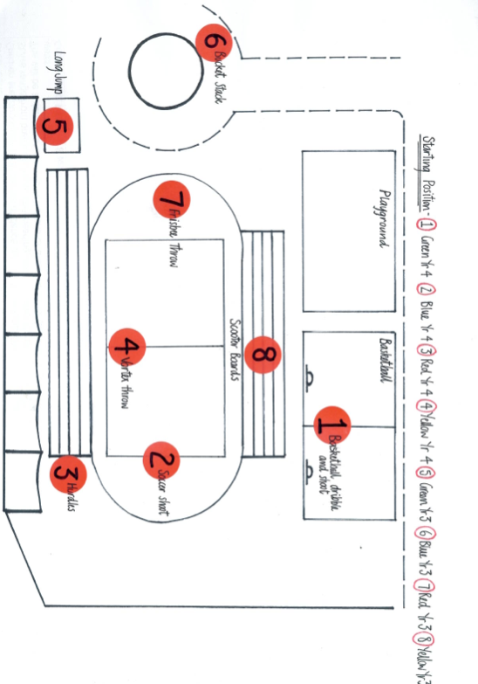
Folders and score sheets will be issued to you at your first rotation. Keep them with you. When you depart rotation 8, progress to rotation 1. The year 4’s will know where you are to go so don’t be afraid to ask. After completing 8 stations you can calculate your team’s total score before handing in your score sheet to David Watson.
6
7
Rotation 1 – Green Y2’s Rotation 2 – Blue Y2’s Rotation 3 – Red Y2’s Rotation 4 – Yellow Y2’s
Rotation 5 – Green Y3’s Rotation 6 – Blue Y3’s Rotation 7 – Red Y3’s Rotation 8 – Yellow Y3’s

Event 4
12.15pm Tug-O-War Color Clash

Lunchtime Variations

- 11.30pm Year 1 Cafeteria then 11:55-12:20 Recess ECE play area and Courtyard
- 12:30-12:50 Year 2&3 Cafeteria and Year 4 & 5 Recess.
- 12:50-1:15 Year 4 & 5 Cafeteria and Year 2 & 3 Recess.
- 1.15pm lunch finished, all Y1-Y3 students back to sports day

Event 5

1:25pm Entire Year Level Relay Races.
Race A Year 1 Race B Year 2 Race C Year 3

Tug of War- Those students not participating in Relay and Championship run will do tug of war in middle of field

Each year level will have 4 boy relay teams and 4 girl relay teams (Blue-Green-Red-Yellow). Each House-team has 5 runners, except Y1 (one runner from each class). Each class will have 8 runners (4 girls and 4 boys). The runners are attached on the last page.
The girls in Year 1A run first and hand the baton to girls in Year 1B, then Girls in 1C, and 1D.
The girl in 1D will pass the finish line. When the girls are finished, the boys will start.
Western Co-teachers will put the 4 boys and 4 girls from their class into position (Lennart/Dave will explain where) and the Chinese Co-Teachers will stay with the students who do not participate in the Relay Race (which is between ½ and 2/3 of the class).
Year 1A, 2A, and 3A are all waiting at the same position. Same for 1B, 2B, 3B, etc.

Coaches for the Year 1-3 Relay Team (Job description: Cheer very loud ;)

Y1-3 | Sophie | Kathleen | Mira | Alex

Judges for all relays: Judges: Tania/David Watson

1:45 Parent Relay: Lead by Lennart/David.

Judges: Anne/ Lynn Xie/Tania/ Diana. One per House Team

All Championship Runners will go with David

1:55 Championship Final runs!!
Year 1: 100 Meter Run
Year 2: 200 Meter Run
Year 3: 400 Meter Run

Judges for all championship runs: Judges: Lennart/ Tania

2:10 Awards ceremony for Year 1-3 Primary presentation of the Trophy.
School day continues as usual at 2:15

Sports Day Score Sheet

Completed by ____________ Color Team- ___________
Year Level- ___________________ Boys / Girls (circle)

Rotation 1 | Supervisors | Events | Tally | Total
 | Lynn Xie  John  (S)Sungwoo Cho  (S) Elizabeth Shih | Basketball  Shooting | Ring= 1 Point, basket= 2 Points
Rotation 2 | Sophie Z  (S)Alicia Bolstein  (S)Caden Tan | Soccer  Dribble | 1 lap = 1 point
Rotation 3 | Vivian Bai  (S)Adison Chow  (S)Jun Kai Loh | Hurdles  Course | 1 lap = 1 point
Rotation 4 | Anita Dai  Amy Chu  (S)Wendi Wu  (S)Eli Chu | Vortex  Distance  Throw | Line 1=1 point, Line 2= 2 Points, Line 3, 3 points
Rotation 5 | Geoff Quirk  Carrie Qian  (S) Sophia Tsives  (S) Claire Coquerel | Long  Jump | Line 1=1 point, Line 2= 2 Points, Line 3, 3 points
Rotation 6 | Diana Dai  Lina Fei  (S)Sharlene Yap  (S)Ivy Wang | Frisbee Throw | Large goal= 1 point, small goal= 2 points, Target= 5 points
Rotation 7 | Jeannie Jackson  Sharon Sun  (S)William Kai  (S) Alana Gartz | Bucket Stack | 1 lap= 1 point
Rotation 8 | Tania Jordan  Andrea/Mel  (S)Antonio Teh  (S)Brenda Kim | Scooter Boards | 1 lap = 1 point
Grand Total

Relay Runners
 | Blue | Green | Red | Yellow
1A | Devas  Sinco | Ryan K  Victoria | Ryan C  Renata | Brian Y  Camila
1B | Xinze  Isabel G | Wei Tai  Amelie | Miles  Carla | James  Julia
1C | Sher Ru  Freyja | Joey  Tisha | Liam  Ashley | Vivaan  Sophia Xu
1D | Zander  Hanna | Rico  Olivia C | Alex  Isabella Z | Louis  Rachael
2A | Ethan  Fiona | Will  Zoe | Zibang  Chandana | Aiden  Ana
2B | Junseong  Alison | Mike  Carrie | Samuel  Emily | Adam  Katie
2C | Alex Smith  LiLi | Akshay  Cherry | Oliver  Xin Wei | Daniel  Carina
2D | Bruno  Lisa | Charles  Laisha | Marx  Anya | Amogh  Sophie
3A | Sher En  Kandy | Ethan  Laura | Justin  Winnie | Andrew  Kaitlyn
3B | Eric Du  Maggie | Willson  Mimi | Dalton  Rosanna | Paul  Allison
3C | Ayaan  Lucia | Danny  Isabella | Matias  Julie | Jason  Katherine
3D | Dan Ji  Jada Lee | William  Luiza | Lin Feng  Caroline 3A | Eric Wen  Emily

Championship Runners
 | Blue | Green | Red | Yellow
Year 1 | 1. Griff (1C)  2.Oliver (1B) | 1. Liam Cui (1C)  2.Shun (1C) | 1.Austin (1D)  2. Alejandro (1C) | 1.Tahn (1D)  2.Thomas (1D)
 | 1.Olivia Bell (1D)  2.Sui In | 1.Sunyoung (1B)  2.Joyce (1A) | 1. Irene (1D)  2. Jordan (1C) | 1.Lily(1B)  2.Isabella T (1D)
Year 2 | 1.Derek(2C)  2. Aaron Y (2A) | 1. Brayden Chow  2. Lukas (2D) | 1. Elijah (2A)  2.Zimao (2B) | 1.Samuel (2C)  2.Aaron C (2A)
 | 1.Isabel G (2C)  2. Chloe Zh (2D) | 1. Jessica (2B)  2.Yeonwoo (2C) | 1.Xin Wei (2C)  2.Tayte (2C) | 1.Emma (2A)  2. Chloe Ald (2D)
Year 3 | 1.Benjamin (3B)  2.Tomass (3B | 1.Yiching (3D)  2. Ethan Z (3C) | 1. Daniel (3C)  2. Justice(3C) | 1.Theo (3B)  2.Jason (3C)
 | 1.Tina Wu (3A)  2. Ningjing (3A) | 1.Jada Kelly (3C)  2.Marguex (3B) | 1. Tim Tim (3B)  2.Riley (3D) | 1.Abbie (3D)  2.Grace (3A)

