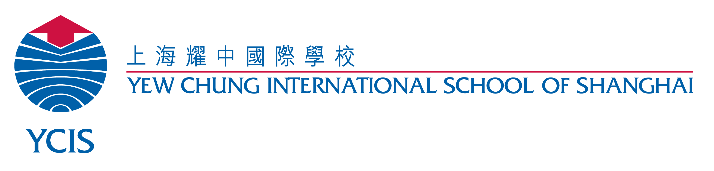

TIME 时间 | Monday 周一 | Tuesday 周二 |  | Wednesday 周三 |  | Thursday 周四 |  | Friday 周五
8:00 | Developmental Learning Activities发展性学习活动 | Developmental Learning  Activities发展性学习活动 |  | Developmental Learning  Activities发展性学习活动 |  | Developmental Learning  Activities发展性学习活动 |  | Developmental Learning  Activities发展性学习活动
9:00
 |  |  |  |  |  | Music 音乐
9.30 | Bathroom Routine / Snack  盥洗 / 点心时间 |  | PE  体育课 |  | Bathroom Routine / Snack  盥洗 / 点心时间 |  | Bathroom Routine / Snack  盥洗 / 点心时间 |  | Bathroom Routine / Snack  盥洗 / 点心时间
10.00 | Circle Time (Chinese / English)  语言体验 (中/英文活动) |  |  |  | Circle Time (Chinese / English)  语言体验 (中/英文活动) |  | Circle Time (Chinese / English)  语言体验 (中/英文活动) |  | Circle Time (Chinese / English)  语言体验 (中/英文活动)
10:30 | Outdoor Play户外活动 | Outdoor Play户外活动 |  | Outdoor Play户外活动 |  | Outdoor Play户外活动 |  | Outdoor Play户外活动
11:00 |  | Circle Time (Chinese / English)  语言体验 (中/英文活动)
11:20 | Half-day Children Dismissal  半天的小朋友放学  Full-day Children Lunch  全天的小朋友吃午饭 | Half-day Children Dismissal  半天的小朋友放学  Full-day Children Lunch  全天的小朋友吃午饭 |  | Half-day Children Dismissal  半天的小朋友放学  Full-day Children Lunch  全天的小朋友吃午饭 |  | Half-day Children Dismissal  半天的小朋友放学  Full-day Children Lunch  全天的小朋友吃午饭 |  | Half-day Children Dismissal  半天的小朋友放学  Full-day Children Lunch  全天的小朋友吃午饭
12:00 | Bathroom Routine / Body Rest / Afternoon Snack  盥洗 / 午休准备 / 午休时间 / 点心时间
2:30 | Developmental Learning Activities / Outdoor Play / Stories / Songs  发展性学习活动 / 户外活动 / 故事 / 歌曲
3:15 | Dismissal  小朋友放学
K2C Timetable 作息时间表

