External Providers

Currently, there are two providers used for external educational assessments in Shanghai. Below are the contact details.

1. Olivia’s Place
http://www.oliviasplace.org

- 35 YongJia Rd, 19th Floor (at Maoming Rd)
- HuangPu District, Shanghai, 200020
- (8621) 5404-0058; 5404-0059
- For General Inquires: contact@lih-oliviasplace.com
To Inquire about Scheduling an Appointment:intakesh@lih-oliviasplace.com

Hours of Operation: Monday – Friday, 9:00 am – 6:00 pm / Saturday, 9:00 am – 5:00 pm
LIH Olivia’s Place is located only a short walk away from three metro stations:
-8 min walk from line 9 (DaPuQiao station)
-8 min walk from line 10 (Shaanxi Rd station)
-10 min walk from line 1 (Shaanxi Rd station)
For full directions, please contact us or consult map below.
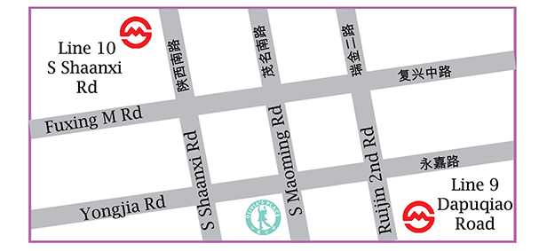

2. Essential Learning Group (ELG)
http://www.chinaelg.com

Client Hotline: +86 4006 129 423
Main Office: +86 21 5206 6273
Email: services@chinaelg.com

