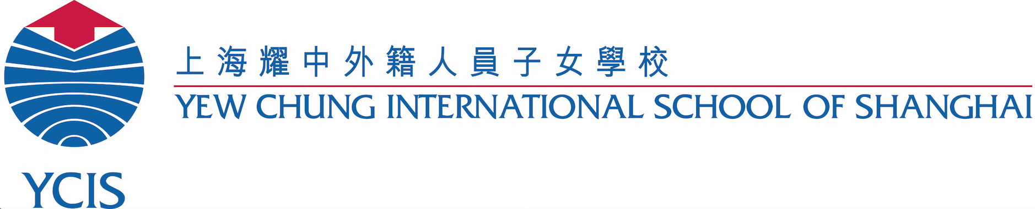

Confidentiality Agreement for Classroom Observation

Name of Observer: | Agency:
Student to be Observed: | Class:
Date of Observation: | Time of Observation:
Reasons for Observation:

- I shall protect the rights to privacy of all students, and, therefore, shall not share information about any other students in the classroom orally or in writing.

- I shall restrict my observation and comments to the behaviours of the student being observed. The purpose of the observation is not to critique the performance of the teacher or observe other students.

- I understand that I cannot make educational program or placement decisions.

- I shall obtain all additional information (i.e., completion of forms, questions specific to the student, etc.) outside of classroom observation via email, follow-up conference or phone with the appropriate staff member, to minimize disruptions to the learning environment.

- I shall follow the School’s Child Protection policies and procedures and sign the ‘Code of Conduct for Working With Students (Community Partners)’ document.

- I understand that I am not to take videos/photos at YCIS unless prior permission from the Campus Leadership Team has been granted.

- I understand that access to student records shall require a signed written consent from the parent/guardian in accordance with the School’s policies and procedures.

- I understand that all classroom observations must be scheduled at least two weeks in advance with the Learning Resource Leader (Primary) or the Student Support Teacher (ECE), in accordance with the School’s policies and procedures

- All materials (e.g., data collection forms, visual supports, etc.) are accessible only with obtained permission from the Learning Resource Leader (Primary) or the Student Support Teacher (ECE),

- If I have any questions concerning the procedures for classroom observations or compliance with this Agreement, I shall direct them to the Learning Resource Leader (Primary) or the Student Support Teacher (ECE),

- I understand that the school reserves the right to monitor classroom observations and to rescind authority to participate in classroom observations to any individual who misuses such access or otherwise violates this Agreement.

- I understand that any questionnaires and/or surveys that accompany the observation are completed by the group of professionals that work with an individual child. Therefore, a single name cannot be referred to in the report.

I have read and understood these guidelines and agree to follow these procedures.

- Observer Signature Date

􏰀

