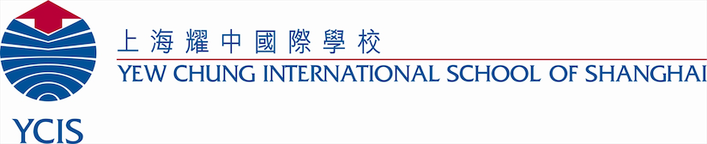

The Primary Library- RP and CP campuses

Library sessions with the teacher librarian are scheduled regularly throughout the year and are in addition to students’ weekly borrowing time.

Ms Irene Xie (irene.xie@sh.ycef.com) is the librarian in the ECE library. She is responsible for the collection and borrowing of books.

Ms Ruth Sun (ruth.sun@sh.ycef.com) is the librarian at RP. She is responsible for the circulation of books and library materials.

Ms Laura Yao (laura.yao@sh.ycef.com) is the library supervisor who manages all three Pudong libraries- at ECE, RP and CP. She also oversees borrowing at the CP campus.

Ms Tania McPhillamy (tania.mcphillamy@sh.ycef.com) is the primary teacher librarian who works with classes and teachers at regular intervals through the year. She will keep you updated during the year via the school newsletter and can be contacted by email or in person by dropping into one of the libraries.

The Y1-6 library program is based on a checklist of skills required by students at each year level.

For Year 1-2 students these skills include:
- Following library rules and routines
- Differentiating between fiction and non-fiction
- Making a good choice of book

For Year 3 to 4 students skills include:
- Understanding how libraries are organised
- Using reference materials for research
- Recognising and selecting from a variety of fiction genres

For Year 5-6 students skills include:
- Internet research
- Note-taking
- Introduction to bibliographies

