Use the following directions as a guide to logging in and getting started with Raz-Kids.

Login Instructions card

Your teacher will provide your child with a Login Instructions card. It will have the teacher’s ID, your child’s name and symbol, along with a password. All the information you need to access Raz-Kids will be found on the Login Instructions card like the one below.

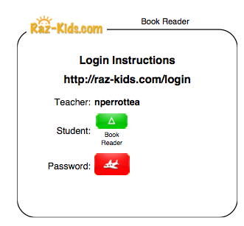
Name

Website address
Teacher’s ID

Logging In

Go to Raz-Kids (www.raz-kids.com). Once there, click on “Hey Kids! Start Here”.
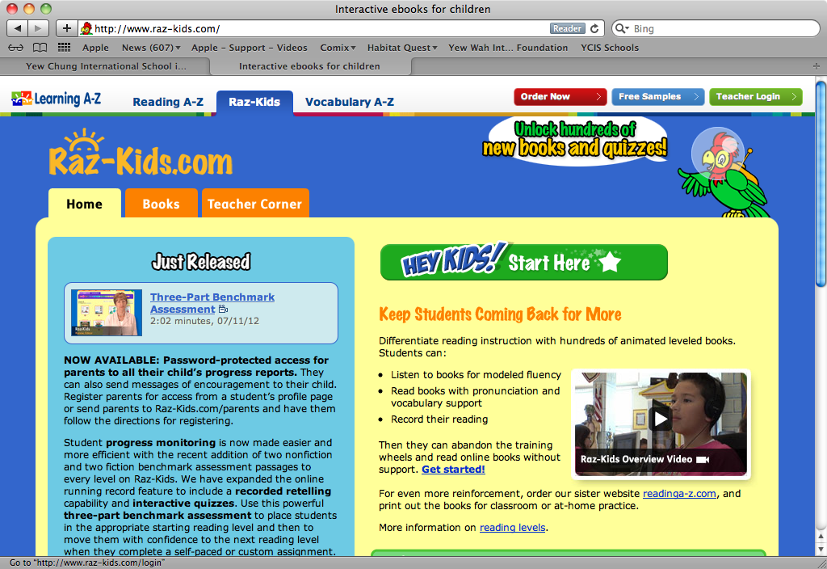

Click here

Enter the teacher’s user name from the Login Instructions card then click go.

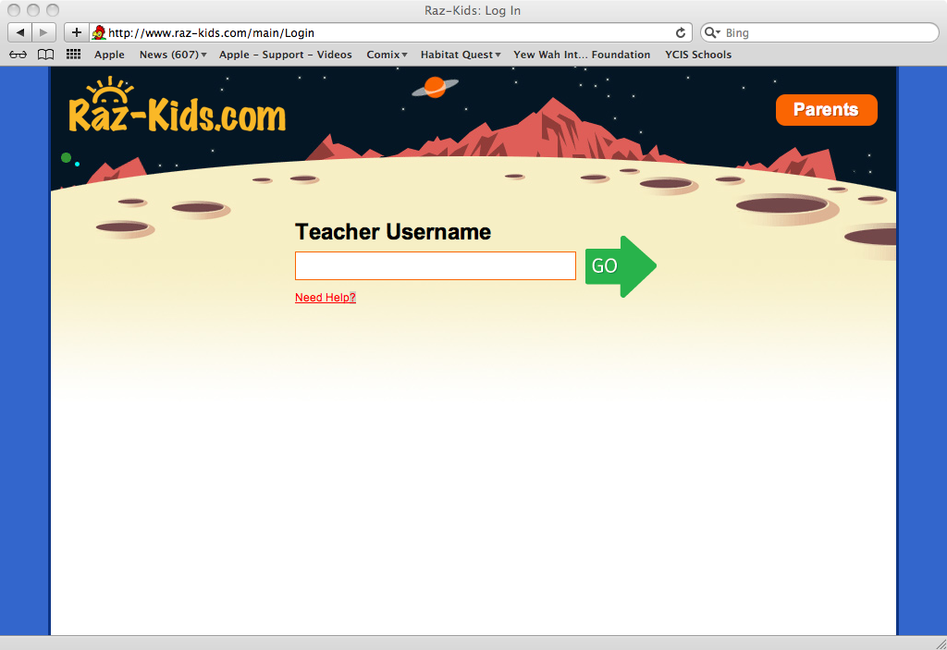

This will take you to the teacher’s classroom as seen below.

Find the sign and coloured rectangle from the Login Instructions card. Your child’s name will be below it. Click on it. You will be taken to the student password screen.

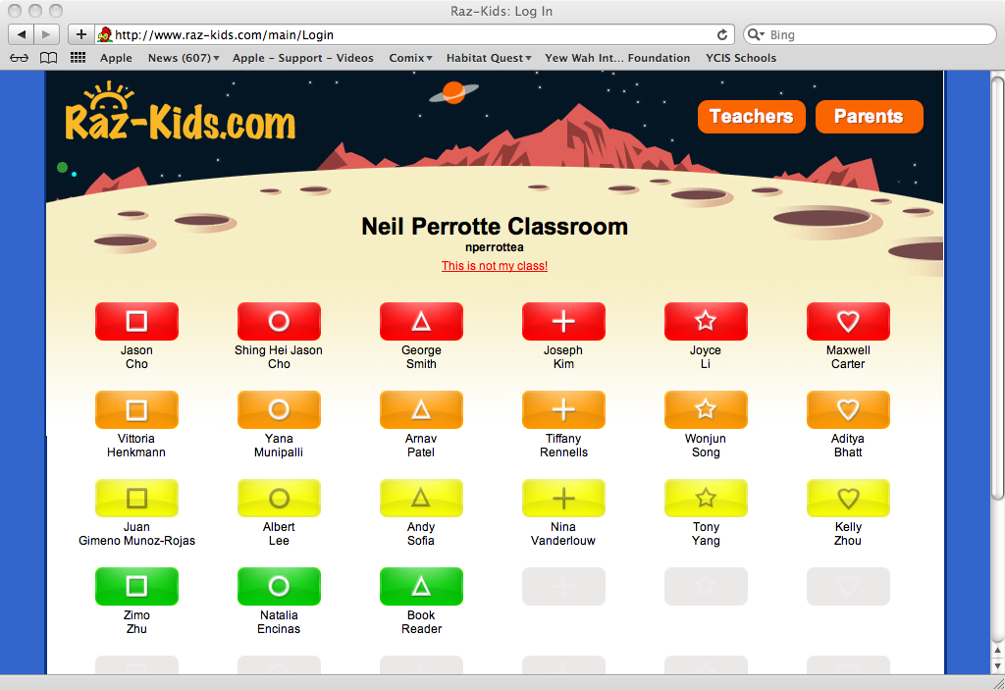

Your child’s password could be symbols or words. Enter the password then click on the go arrow.

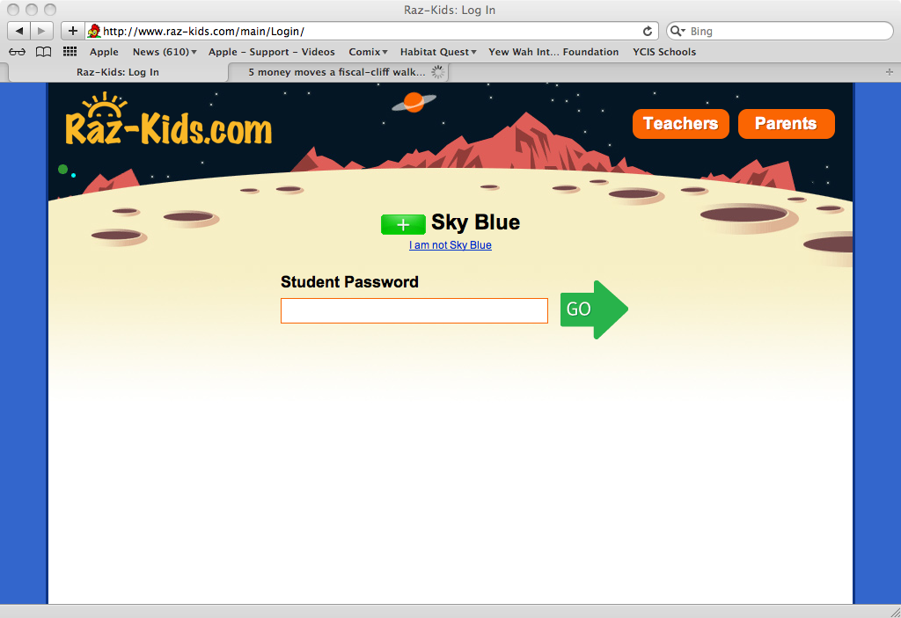
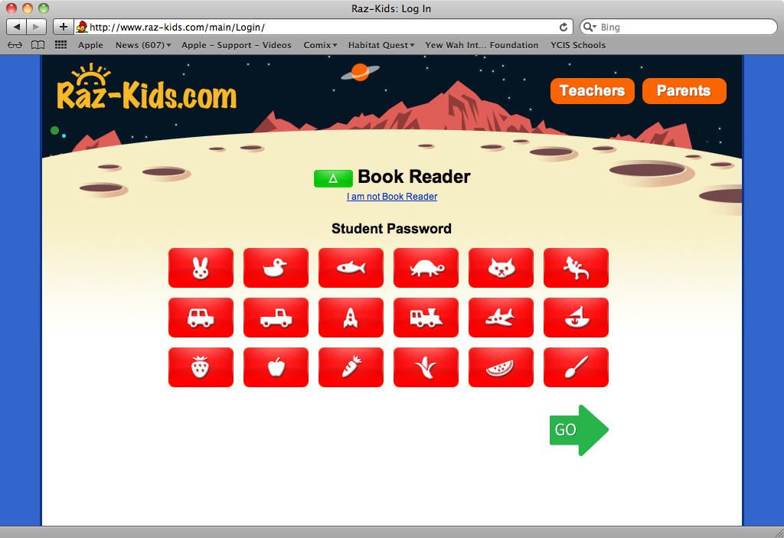
Password as symbol(s)
Password as text

Congratulations! You have now successfully logged into Raz-Kids.

Completing Assignments

If your child has an assignment, then the screen will look like the one below.

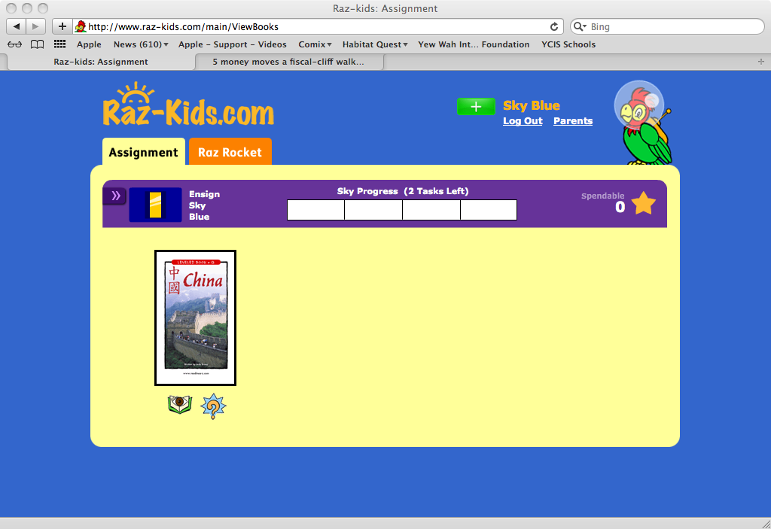

If your child has been assigned self-paced reading, then the screen will look like this one.

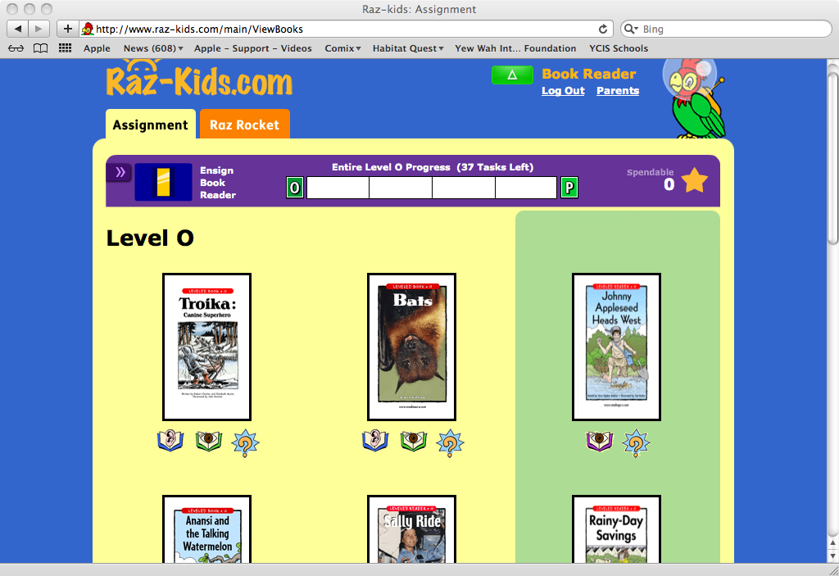

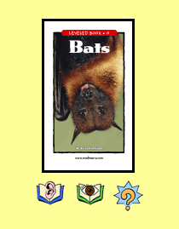

The teacher may assign your child the option to listen or read a book and then take the quiz. Below a book you will see three icons.

Please remind your child to listen to or read the book before taking the quiz.

Click to listen to the book.

Click to read to the book.
Click to take the quiz.
As your child becomes a better reader, he or she will progress through the levels of Raz-Kids.

Happy reading!

