YCIS Pudong Attendance Guidelines

- Teachers will need to take attendance once each day before 8:15am. If a child arrives after 8:15am, the teacher must send them to the office to ‘sign in’. The office staff will amend the attendance code and send the student to class with a pass.
- If a class has a specialist in the first period, the co-teachers are still responsible for taking the attendance at 8am. Then, students leave for their specialist. If a student arrives late to a specialist and that student does not have a pass, they need to be sent to the office to get one.

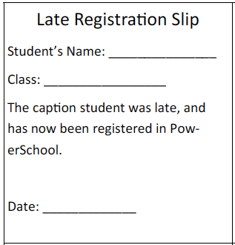

- When logging in to PowerTeacher, take attendance in course, ‘Class Assembly’.
- When entering the attendance codes, only use the following:
  - Present (is the default setting)
  - WABSEX – Whole day ABSent Excused- Use this if the parent has notified you of the reason for absence. Record this reason for the office in the comment box. See the screen shot below.
  - WABSUX- Whole day Absent Unexcused. Use this if the parent has not notified you of the reason for absence. The office will then call the parent and change the attendance code after they confirm the reason for absence.
- If a child leaves early, the parent will need to fill in the ‘early leave’ form and get one of the class teachers to sign first. A member of the Office staff will also sign the ‘early leave form’ and then amend the attendance code accordingly. It is a great idea to keep some of these in your desk as sometimes the parent comes straight to the classroom then has to make the trip to the office and back again for proper signatures.
- For extended absences, the teacher notifies the office. They will mark the attendance accordingly for that period of time.
- When attendance is completed, DO NOT FORGET TO HIT ‘SUBMIT’.

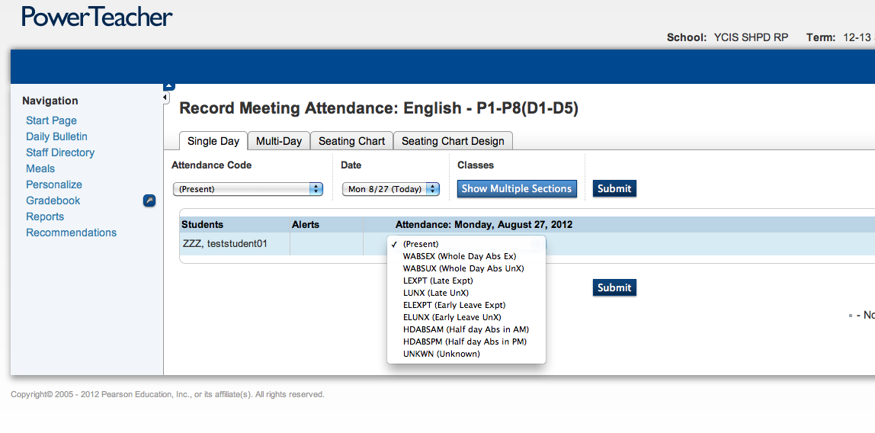

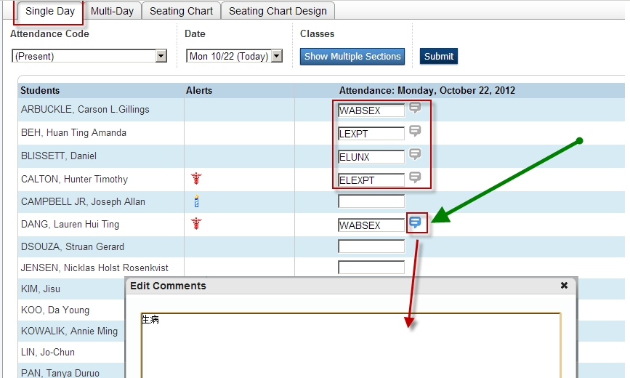

Date (日期) _________________
EARLY CHECK OUT FORM
离校申请表

Student’s Name 学生姓名____________________________ Class 班级 __________ _______
Bus No校车号 ASA课外活动

Early check out reason: □Parent request through □Phone call □Pick-up □Diary/note
提前离校原因 家长已通知学校 电话 家长来接 联系本/短信
□ Medical Reason 医疗原因
□ Others 其它_____________________________________________

Class Teacher’s Name 教师姓名_____________________________
Teacher’s Signature 教师签名_____________________________
Office’s Signature 办公室人员签名_______________________
Guard’s Signature 警卫签名______________________________
The student will be allowed to leave school ONLY when Early Check Out Form is signed.
无此完整填写证明，学生不允许离校
This form should be submitted to the Security Office.
此出门证由门卫保管。

______________________________________________________________________________

Date (日期) _________________
EARLY CHECK OUT FORM
离校申请表

Student’s Name 学生姓名____________________________ Class 班级 __________ _______
Bus No校车号 ASA课外活动

Early check out reason: □Parent request through □Phone call □Pick-up □Diary/note
提前离校原因 家长已通知学校 电话 家长来接 联系本/短信
□ Medical Reason 医疗原因
□ Others 其它_____________________________________________

Class Teacher’s Name 教师姓名_____________________________
Teacher’s Signature 教师签名_____________________________
Office’s Signature 办公室人员签名_______________________
Guard’s Signature 警卫签名______________________________
The student will be allowed to leave school ONLY when Early Check Out Form is signed.
无此完整填写证明，学生不允许离校
This form should be submitted to the Security Office.
此出门证由门卫保管。
Attendance Guidelines
for Chinese Co-teachers/ Supply Teachers

Log in to the index page: http://index.ycis-schools.com/sh/default.htm

Click on Substitute Teacher Attendance as shown below.
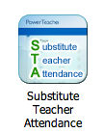

Select the school, the Western teacher and enter the password as shown below:

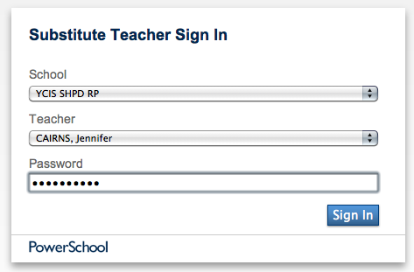

For RP supply: The password is the day of the month followed by ‘goldstar’. For example, tomorrow is October 11 so the password is ‘11goldstar’.
For CP Supply: The password is the day of the month followed by ‘cover’. For example, tomorrow is October 11 so the password is ‘11cover’.

At the home page below, click the chair icon for ‘Class Assembly’.

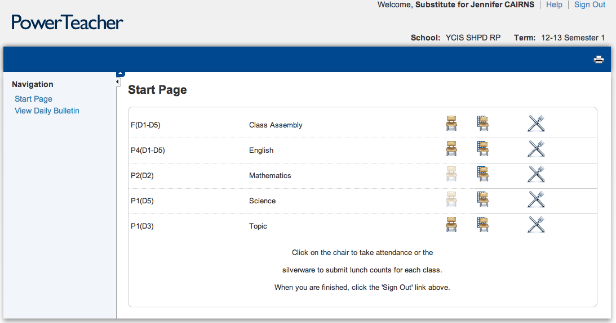

The default setting on the class list is present. If all students are in attendance, just press ‘submit’.

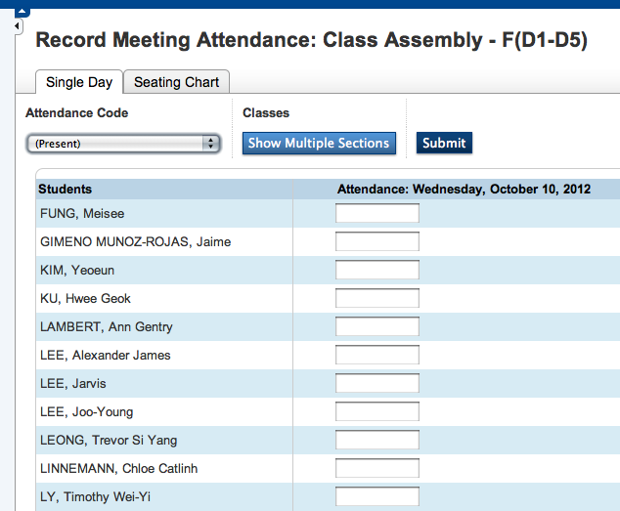

- When entering the attendance codes, only use the following:
  - Present (is the default setting)
  - WABSEX – Whole day ABSent Excused- Use this if the parent has notified you of the reason for absence. Record this reason for the office in the comment box. See the screen shot below.
  - WABSUX- Whole day Absent Unexcused. Use this if the parent has not notified you of the reason for absence. The office will then call the parent.
  - LEXPT – Late If a child arrives between 8:00-8:15am, the teacher should enter in the Late code (LEXPT)
- If a child arrives after 8:15am, the teacher should send them to the office to ‘sign in’. The office staff will amend the attendance code.
- If a child leaves early, the parent will need to fill in the ‘early leave’ form and get one of the class teachers to sign first. A member of the Office staff will also sign the ‘early leave form’ and then amend the attendance code accordingly.
- If a child leaves early, then the parent will need to fill in the ‘early leave’ form and get one of the class teachers to sign first. A member of the Office staff will also sign the ‘early leave form’ and then amend the attendance code accordingly.
- When attendance is completed, DO NOT FORGET TO HIT ‘SUBMIT’.

