Report Writing Guidelines
Primary School

End of Year Reports
June 2016

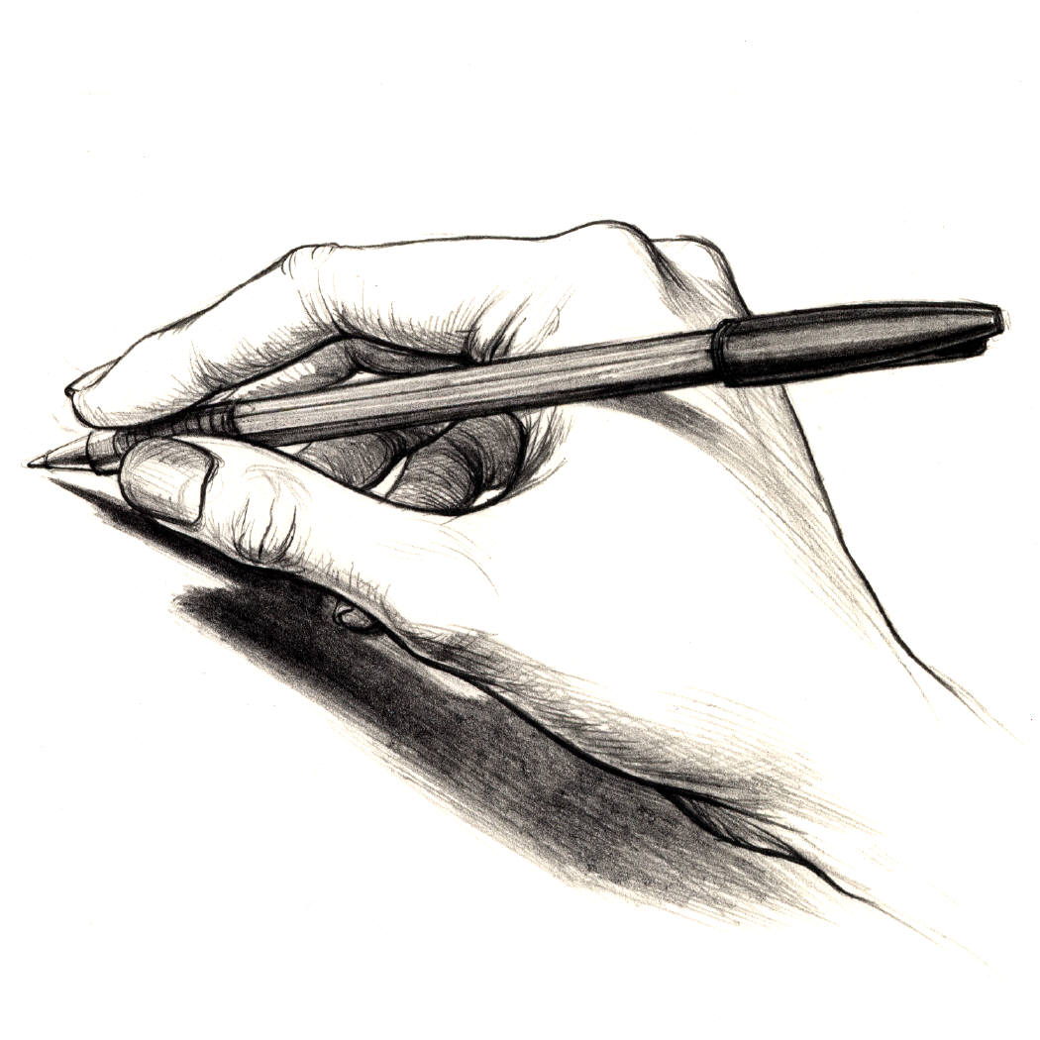

Important Report Information

- For step-by-step guidance and helpful reports you can generate (at your convenience) you can watch the Quicktime videos saved on the server at: smb://10.3.1.1/Teachers/@Teachers Pub/@PRIMARY/PowerSchool
- When printing/collating draft reports (for proofreading purposes) please ensure the students’ full report is together (in other words, do not give the EAL/Chinese/Specialist reports in separate piles). Page order does not matter.
- If parents request receiving the report early – please politely say this is impossible – as there are so many steps involved in the process – it can’t be done. However, parents may request a letter of reference from the class teachers if they need it for applications to other schools.
- PowerSchool will automatically generate the student’s passport name on the front cover. However, please make sure that the name on the comments is consistent with the name in the PowerTeacher Gradebook. Where there are two passport names listed (e.g. a Western and Asian name), it is the responsibility of the EAL and Chinese teachers to check with the rest of the report to ensure consistency of name throughout the report comments.
- The Reports will be sent home in the same A4 Envelope as Progress Reports and Mid Year Report.
- Specialists: To prepare for report cards, please review the grades given, ensuring that you have marks showing in each strand and any changes to grades are made if needed. This can be done clicking on ‘Final Grades’ mode in your gradebook. Please ensure that you send a comment to the class teacher if a mark of NYA or BD has been given. These comments can be included in the personal comments.

Effort Marks:
All subjects have effort marks so be sure to give a mark for effort. A reminder that in English, EAL and Chinese, there are 3 separate effort marks for 1) Speaking, Listening and Responding 2) Reading 3) Writing. Please be sure to enter each of these in your gradebook.

Instructions for comments:

End of Year Reports require comments for all core subject areas and a general comment in the ‘Personal Development & Approaches to Learning’ section. See the sample report card for specific guidance and sample comments.

In order to ensure consistency between your student’s marks and the comment, be sure to print a report for your class. You can choose to view the Quick time standards report video or the pdf on how to generate a copy of the report. These are on the network @TeachersPub/@PRIMARY/PowerSchool/Report Cards/standards report.

Please see the minimum and maximum characters that are expected for each comment which are outlined below:

Subject | Maximum Characters Possible | Minimum Characters Expected
English | 1100 | 700
Mathematics | 1000 | 700
Year 1-2 Topic/Science | 600 | 400
Year 3-4 Topic/Science | 800 | 600
Year 5-6 Topic/Science | 1000 | 700
Personal development | 1000 | 700
EAL | 1200 | 700
Year 1 Chinese | 1100 | 700
Year 2 – 6 Chinese | 900 | 700

Specialist Comments
- Specialists are asked to review student grades and amend if necessary. Be sure to check the ‘final grades complete’ box when completed.
- If a student has been given a mark of NYA (Not Yet Apparent), please ensure that there is a comment that reflects this mark.
- A document will be sent to all specialists to review the class lists and then add a comment next the student if necessary. Only 1 sentence is expected, that is specific and personal (e.g. ‘In Art, Johnny is to be commended for designing an intricate and detailed series of patterns on his Egyptian sarcophagus’ or ‘In Art, Johnny continues to struggle with fine motor skills and is encouraged to work on cutting and drawing’. These are better than ‘In Art, Johnny loves to paint’.)
- Specialists are to send these documents to Amita by May 27. These will then be passed to class teachers.
- Class teachers to incorporate comments given into the general comment of the student’s report.

Checking, Printing and Collating Reports

Once you have finished writing your reports, be sure to check the ‘final grades complete’ box for each subject area. The office administrators will print hard copies for you.

Proofreading: Teachers are responsible for checking their own reports. Please use your best professional effort to ensure your draft reports are free from errors before they are passed to the Coordinators. When proofreading your reports please make note of the following:

- Spelling, punctuation and grammatical errors (we use British spelling).
- Write Mathematics in full not Maths or Math.
- English must be spelt with a capital 'E' (as should all subjects).
- Typing errors (e.g. spaces used correctly, correct font).
- Name used is consistent throughout (check the front of the report).
- If a student has been given a mark of BD (Beginning To Develop) or NYA (Not Yet Apparent) for core subjects only, please ensure that there is a comment that reflects this mark.
- Please ensure that comments include a next step/goal/target.
- Please ensure that you look at how you structure your comment by beginning with a positive comment.
- N/A (Not Assessed) can be used when a child has arrived late and not all objectives have been assessed. If it is used for any other reason, it needs a Coordinators approval.
- Comments should not be directed to the child (e.g. ‘Well done, Kelly’).
- Please ensure you include something personal about each child. Comments for two different students should never be exactly the same.
- Avoid run-on, lengthy sentences and check that the language you have used can be understood by the parents (especially if their first language is not English).
- Avoid being impersonal (e.g. ‘Kelly displays a responsible attitude towards completing homework’ is better than ‘A responsible attitude is shown towards completing homework’.)
- Do not mention the name of other children in Reports (e.g. Johnny enjoys playing with Freddie.)
- Students should not be labeled or grouped (e.g. ‘He helps the EAL students’ or ‘She plays well with the other Korean girls’.)

If Coordinators feel that the reports are not properly proofread, they will be passed back to the teacher.

Chinese teachers should give their reports to their co-teacher to check the comments. Chinese co-teachers and EAL teachers are responsible for ensuring that the name used in their comment section of the report is the same as the name used in the rest of the reports.

It is the class teachers’ responsibility to read the EAL report and know what is written. If there is a major difference, then a meeting between the class teacher/EAL teacher should be called.

Timeline for Reports

Monday, May 9 - Preparations for reports begin. Teachers to commence reviewing
grades (and overriding where appropriate) before making notes for
student comments.

Thursday, May 26 - Chinese draft reports due – teachers to pass to Chinese leaders.

Friday, May 20 - Specialists to pass comments to Amita by the end of day.

Monday, May 30 - EAL reports & Specialist grades by end of day. Check ‘final grades
complete’
- Chinese draft reports pass to Co-teachers to read.

Tuesday, May 31 - Office print draft EAL reports - EAL teacher to edit own reports

Wednesday, June 1 - Chinese draft reports completed and returned to Co-teachers

Thursday, June 2 - All reports (including EAL/ Chinese) completed by staff by the end
of day. Don’t forget to check ‘final grades complete’

Friday, June 3 - Office to print draft reports and pass to class teacher
- EAL and Chinese teachers to pass proofread reports to class teachers.
Teachers to collate and proofread the completed report for each
student in their class.

Monday, June 6 - Teachers to pass draft reports to Coordinators.

Wednesday, June 15 - Coordinators to pass reports to teachers by end of day.

Sunday, June 19 - Last day to make changes to reports by end of day. Be sure to check
‘final grades complete’ again when finished

Monday, June 20 - Report printing (by office). Class teachers to collate the pages into the
correct order and sign reports. Office will distribute with report covers.

Wednesday, June 22 - Place Reports into cover same envelopes as PR and MD Year reports

Thursday, June 23 - Hand out EOY Reports to students

Please Note:
- Reports should be completed for any students who started before April 5. Any students who started on or after this date should be given a Progress Report.
- For EAL students who have transferred to mainstream, the report needs to be co-written by both the EAL and the Mainstream class teachers to reflect the child’s time in both classes. EAL teachers, please generate a ‘Standards Report’ to pass along to the class teacher and work together to decide the child’s final marks for the semester.
- Student who have left the school still require an EOY Report. These students can be found in the dropped list in gradebook. Please refer to the PT Dropped Students pdf if you need assistance in finding these students @Teacher pub/@Primary/Powerschool/General How To.

Hand reports to the following:
- Melissa – Years 1 and 2
- Rob – Year 3 and 4
- Andrew – Years 5 and 6
- Andrea – Year 2B / Year 3A

