 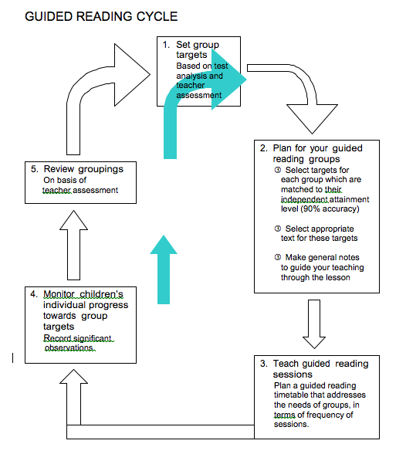

Adapted from: “A Guide to Progression of Reading Skills”, the Manchester City Council and Educational Partnership

**Teaching Guided Reading**

**YCIS Pudong Primary**

WHY GUIDED READING?

Guided reading provides an opportunity for the teacher to teach reading in relation to the differentiated needs of the pupil groups and their level of achievement.

‘Guided reading should be a more effective and efficient way of teaching as well as being enjoyable for the pupils.’

Source: ‘Guided Reading Key Stage 2 – A handbook for teaching guided reading’. Angela

Hobsbaum, Nikki Gamble and David Reedy; Institute of Education, University of London. Pub.

2002

WHAT IS GUIDED READING?

Small group – usually between 3 to 7 pupils at a similar level of achievement

Individual copies of the same text – it is essential that pupils have their own copy of the text to allow for independent reading

Unfamiliar text – so that pupils are encouraged to apply, reinforce and extend taught strategies during the reading process

Instructional level – each member of the group should be able to read and readily comprehend the text at or above 90% accuracy

Lower level of support than in shared reading – teacher structures the task and then encourages individuals to apply strategies already introduced and practised in shared reading

Pupils reading independently at their own pace (not reading aloud around the group) – pupils read to themselves following an introduction with the teacher facilitating.



THE CHANGING ROLE OF THE TEACHER

In the earlier stages, the teacher:

prompts the child to use the most effective reading strategies;

focuses on the use of a range of reading strategies;

places planned and incidental emphasis on word level work including phonics;

draws attention to unfamiliar ideas, making links with experience where possible;

draws attention to key vocabulary including high frequency words and new words or structure;

probes understanding and encourages reading for meaning;

monitors and assesses individuals;

encourages response to the book through discussion or follow up activities;

supports attempts to read independently and self-correct;

promotes enjoyment and appreciation;

observes, prompts and praises the use of the range or reading strategies.

As children develop as readers, the teacher revises and develops the above and:

teaches strategies to further develop comprehension;

encourages self-regulated comprehension;

uses opportunities to teach and reinforce decoding where appropriate;

encourages reciprocal teaching;

enables pupils to identify and comment on the structure, features and organisation of texts

probes understanding and interpretation of texts by promoting the use of deduction, inference and interpretation of ideas or events;

enables pupils to explain, comment on and respond to a writer’s use of language;

teaches strategies to enable pupils to summarise, generalise and develop an overview of the text.

Source: ‘Guided Reading: supporting transition from Key Stage 1 to Key Stage 2’



THE TEACHING SEQUENCE FOR GUIDED READING

There are seven steps in the teaching sequence for guided reading:

1. Decide on the learning objectives for the group

• which reading strategies are established

• which reading strategies need to be practised and consolidated

• which reading strategies need demonstration and development

2. Select a text

Select a text which the children can read at instructional level, that is one that they can read with understanding and at between 90% and 94% accuracy. A guided reading

text shouldn't be too difficult because the children may lose both meaning and motivation. If a text is too easy it simply won't be challenging enough. Choosing the text must be considered carefully as difficulties can lie in the book's concepts, vocabulary, language structures, organisation and cultural references.

3. Introduce the book/strategy check

The introduction and strategy check is where the teacher:

• sets a purpose for reading;

• encourages links with previous experience and draws attention to important ideas;

• give opportunities for children to talk about new vocabulary;

• reminds children of the repertoire of strategies they can use. This ensures that by the time the children read the text they:

• know that the reading will inform and interest them;

• have certain questions in mind which they will expect to answer;

• have some knowledge of how to solve problems within the text.

4. All guided reading sessions should include independent reading

Following the introduction and strategy check each child reads the text independently. The teacher may intervene to deepen a child's understanding, ask questions or focus on a teaching point, giving praise for use of specific strategies where appropriate.

5. Returning to the text

This is an opportunity to review the use of particular strategies and to revisit the questions discussed at the start of the session. Encourage the children to identify issues requiring clarification or discussion.

6. Responding to the text

This is an opportunity to talk about personal preferences and to develop and justify opinions.

7. Next Steps

Assessment of the children's learning during guided reading will inform the next steps for your planning. This will involve the selection of appropriate objectives for the next session in the context of the reading targets.

Source: ‘Guided Reading Key Stage 2 – A handbook for teaching guided reading’. Angela Hobsbaum, Nikki Gamble and David Reedy; Institute of Education, University of London. Pub. 2002

|  |  |
| --- | --- |
| **Phase of Guided Reading** | **Teaching Prompts** |
| **Book introduction**   Identify teaching objective   Establish text type   Encourage reader to make links to existing knowledge and experience   Discuss expectations for title, cover, blurb and a brief scan of book   Generate questions for discussion/resolution   Name/identify characters   Identify setting   Identify specific features of text (vocabulary, grammar, punctuation) | Today we are going to read a… (name text type)  and we are going to learn (teaching objective).  What is the title? Look at the cover (or the first few pictures).  Does anyone know any other books about…? Read the blurb and tell me what the book is about. Does anyone know what … means?  We are going to focus on …, e.g. effective story openings, plot development, use of appropriate vocabulary etc.  Look at the title, cover, blurb and glance through the book. Can you predict what the book is likely to be about? (record predictions)  Look through the book – what is happening? Name another book like this one. |
| **Strategy check/Comprehension focus**   Recall recently introduced reading strategies   Identify points of potential difficulty   Prompts for the use of a broad range of reading strategies and for reading with expression   Generate questions for resolution during independent reading   Generate questions to motivate independent  reading | There are some new words in this book. Can you  find…? What does it begin with/what is at the  end? Can you see a word within that word that  you know? There are… syllables in this word.  Can you identify the syllables at the  beginning/middle/end?  What other ways are there of working out new words?  Scan the first few pages and find a new/unknown word. How could you work the word out? (list strategies)  Remember to read with expression and to use the full stops.  Read … and find out why… did…  Read the first …pages and find out where the story takes place/identify a main character.  What are the main points?  During are reading, consider these questions…(write focus questions on flipchart) |
| **Independent reading**   Support individual readers selecting from a range of prompts   Careful use of specific praise   Prompt for phrased and fluent reading   Generate questions to monitor understanding   Teacher assesses individuals as they read aloud, providing appropriate support and feedback | Re-read that sentence and look right through  the word.  It could be…now look at the middle of the word. Re-read the sentence and think what would make sense and look right. Now re-read the whole sentence.  Read that again, read on, and think what would fit and make sense.  Re-read the sentence and make it sound more like talking.  Is there part of a word you know? Show me the hard part of the word?  What part of that word do you know? Now look at the other syllables at the beginning/middle/end and think about what would fit and sound right.  Were you happy with that? Read it again, use the commas and check your reading makes sense.  Read page … to page…silently and think about… |

|  |  |
| --- | --- |
| **Phase of Guided Reading** | **Teaching Prompts** |
| **Return to text**   Answer questions posed and generated earlier   Summarise   Praise use of appropriate reading strategies and successful problem solving   Generate questions to identify successful problem-solving strategies   Question to develop understanding at the word/sentence and text levels   Discuss any difficulties encountered in the text at word, sentence or text level   Refer back to predictions   Teacher demonstration of effective reading  (expressive, phrased and fluent)   Ask individual children to select short passage to read aloud | Who can tell me the story so far?  I liked the way you were reading…this part. (Naming a specific example).  Who had difficulty with a word? How did you solve it? Who can find…(word)? Request/demonstrate how to  blend phonemes; clarify use of full stops.  Can you find a word on page…that links two sentences?  Look on page…Can you find any rhyming words? What is the definition of…? What is the singular of…?  Why did the author use commas on page…?  Why did the author use subheadings on page…? What happened at the beginning/end…?  Where would I look in the contents/index/glossary to find…?  Where and when did this…take place? How do you know?  Turn to page…Discuss how the dialogue has been presented. Why has the author used…?  You read this part…(name specific example) very  well.  Did anyone find a new/unknown word?  Were there any problems in understanding the text? We thought…would happen. Were we correct?  The questions we asked were…(refer back). Can we answer them now? (Discuss their responses)  Listen to me read this part, what do you notice? |
| **Responding to text**   Prompts for personal response to text   Return to teaching objectives | What will you remember most about the story?  Which part did you like best? (Extend responses)  Tell me about…(name/character). Find a part of  the book that tells us about him/her.  Which character did you like best? (Extend responses)  Which character made you feel sad/cross/happy? Why? What was their behaviour like?  What part of the dialogue do you think created impact? How did the author achieve this?  Was the use of subheadings/diagrams/photographs effective?  How did the author develop the theme? Did it reach a climax?  What might happen next?  Which part of the poem is funny? Why?  What can you tell me about…? What more have you learned about…?  I want you to think about (name a specific reading strategy or behaviour) next time you read.  What have we learned today? |